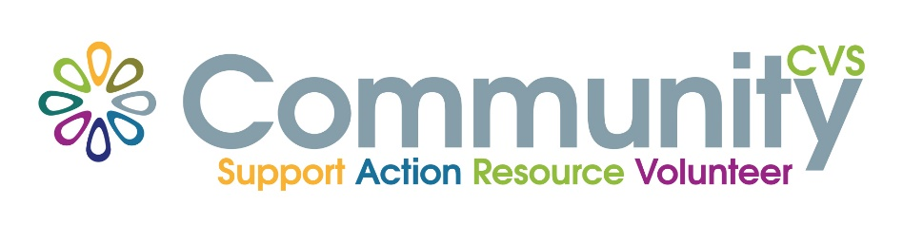

Community CVS Disability Network

Draft Terms of Reference

Meeting purpose
- Quarterly network meetings where anyone and everyone from organisations working in the field of disability in the borough, come together. Our aim is to improve and promote the consistency and quality of services that support disabled residents in Blackburn with Darwen and to foster and improve partnership working. We will focus on creating positive change and addressing local priorities and local issues.

- Those attending the network will become better informed about opportunities and developments in the borough, across Lancashire/Nationally, make useful contacts for peer support, share ideas and resources, learn from other groups, gain access to training opportunities and sources of support for their service users and volunteers.

- The meetings involve a combination of presentations, round robin updates, networking, discussion and training. They take place quarterly in the Conference Room at the Boulevard Centre

Responsibilities
Community CVS:
- Organise and host meetings
- Promote meetings
- Produce minutes and distribute to all members
- Keep everyone update via mailing list

Attendees
Practitioners from:
- VCSFE organisations
- Community groups

Frequency and duration
- Quarterly
Our vision of Equal Opportunities for all residents in BwD is to ensure that:
All citizens who have a disability live longer, healthier lives and are supported to participate fully in all aspects of society, to prosper as individuals and are valued contributors to a fair and equal borough.

