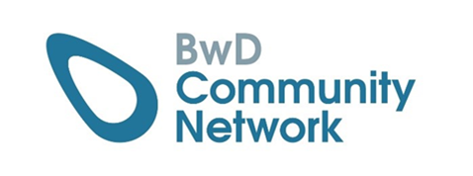  
**BwD Community Network**

**Disability Network Group – BwD**

Thursday 23rd October 2025

1:30pm – 3:00pm

Room D – The Community Hub

Agenda

1. Welcome & Introductions – James Hadleigh
2. Terms of Reference and scope of membership
3. Common themes / issues. What can we work together on?
4. Future agenda items
5. Partner updates
6. AOB

Date of Next Meeting Thursday 22nd January 2026

Room D the Community Hub, 35 Railway Road Blackburn BB1 1EZ

For more information, please contact Donna Talbot

[Donna.talbot@commuitycvs.org.uk](mailto:Donna.talbot@commuitycvs.org.uk)

