**Minutes of the CVS Peer Network Meeting**

**Thursday 26th June 2025**

Donna Talbot – CVS [donna.talbot@communitycvs.org.uk](mailto:donna.talbot@communitycvs.org.uk)

Paul Walker – BwD Diabetes Peer Support Group – [BwDdiabetesgroup@outlook.com](mailto:BwDdiabetesgroup@outlook.com)

Jessica Farrow – DWP – [DEA.Blackburn@DWP.GOV.UK](mailto:DEA.Blackburn@DWP.GOV.UK)

Sarah Cewe – Rainbow Families/Rainbow Café – [rainbowcafe.bwd@gmail.com](mailto:rainbowcafe.bwd@gmail.com)

Gill Moloney – DWP – [gill.moloney@dwp.gov.uk](mailto:gill.moloney@dwp.gov.uk)

Janine Bradley – Chip In [janine@chipinbwd.gov.uk](mailto:janine@chipinbwd.gov.uk)

Chelston Phillip – Community CVS: Business & Skills Team – [Chelston.phillip@communitycvs.org.uk](mailto:Chelston.phillip@communitycvs.org.uk)

Vicki Davies – Bumble Bee Conservation Trust – [volunteering@bumblebeeconservation.org](mailto:volunteering@bumblebeeconservation.org) / [stebirtwistle@icloud.com](mailto:stebirtwistle@icloud.com)

Patrick Howard- Deeth – BwD Integration, Community Engagement – [Patrick.howard-deeth@blackburn.gov.uk](mailto:Patrick.howard-deeth@blackburn.gov.uk)

Cathie Hartley – Blackburn College – [Cathie.hartley@blackburn.ac.uk](mailto:Cathie.hartley@blackburn.ac.uk)

Hafiza Patel – Lancashire Council of Mosques – [admin@lancashiremosques.com](mailto:admin@lancashiremosques.com)

Alex Clayton – Shelter – [Alexandra_Clayton@shelter.org.uk](mailto:Alexandra_Clayton@shelter.org.uk)

Georgina Wright – BwD Environmental Education – [Georgina.wright@blackburn.gov.uk](mailto:Georgina.wright@blackburn.gov.uk)

Shamim Abbas - BwD Environmental Education [-Shamim.abbas@blackburn.gov.uk](mailto:-Shamim.abbas@blackburn.gov.uk)

Delta Whalley - BwD Environmental Education – [Delta.whalley@blackburn.gov.uk](mailto:Delta.whalley@blackburn.gov.uk)

**Apologies:**

Ben Talbot (BwD BC) Lisa Pollitt (NEA) Paula Middlemas (Blackburn College) Jo Barker-Gosling (Rummage Rescuers) Zainab Dhukai (New Ground) Zaynab Jogi ( Zee’s Defence Academy)

**Chelston Phillip Community CVS Business & Skills Team**

Community CVS are delivering Skills Bootcamps in Health and Social Care Leadership for aspiring leaders in the Health and Social care sector across Lancashire.

**Develop key management skills, including:**

* Understand artificial intelligence
* Understanding mission, vision and values
* Identify your leadership style
* Improve your communication skills
* Become an effective team manager
* Understand coaching, mentoring and advice
* Tools and methods of project management

**Funding Criteria**

* We require maximum attendance from learners. Eligibility is as follows:
* 100% funded for self-employed learners
* 90% funded for SMEs (up to 250 full-time employees) – £345 plus VAT per learner, payable by the employer
* Approximately 80% funded for non-SMEs (more than 250 full-time employees) – £750 plus VAT per learner, payable by the employer

**Post-Course Evidence Requirements:**

* Employed learners: Evidence must be provided that learners have taken on a new role or responsibility within the organisation (e.g. new project, AI use, project management tools, leading a new team, etc.).
* Self-employed learners: A business plan must be submitted outlining how a new opportunity will be secured (grant, commercial income, etc.) along with evidence once secured (e.g. proof of grant, paid invoice, confirmation letter).
* Unemployed learners: A job offer in written form and/or a payslip.

[Aspiring Leaders in Health and Social Care – Community CVS](https://www.communitycvs.org.uk/resource/aspiring-leaders-in-health-and-social-care/)

**Vicki Davies – Bumble Bee Conservation Trust**

* I’m the only volunteer for the Bumble Bee Conservation Trust within Blackburn with Darwen
* The trust was set up in 2006 – initially we worked predominantly with primary and secondary schools – educational visits now we have expanded to linking in with community groups etc
* I run bee Safari’s during the summer – we go outdoors on slow walks looking at the bees in their habitat
* The bee safari is very hands on – we observe the bees in their natural habitat; we have little pots were we can look at the bees more closely – we do ensure the welfare of the bees – contrary to popular belief the bumble bee is very placid
* In the winter it’s a power point and conversation indoors
* We offer lots of info and freebies
* It’s a great opportunity for people to be at one with nature – in the moment
* We l talk about bees’ lifestyle, what flowers and plants they like and how we can help to look after them
* I volunteer @ Whitehall Park so it’s a great location for people to come to, last week we had a group from Darwen Heritage Centre come along
* We can actually set up anywhere – in a car park, on a street – I need space to set up a table with lots of info etc
* The sessions are free – but we do encourage donations

Q: Do you offer mixed groups?

A: Yes absolutely – the sessions are open to everyone

Q: Can you go to the group?

A: Happy to go to a group I just need a space to set up, we have a community park @ Whitehall Park we have access to cabin (if it’s raining)

[The UK's bumblebees are in crisis - Bumblebee Conservation Trust](https://www.bumblebeeconservation.org/?gad_source=1&gad_campaignid=20710850779&gclid=EAIaIQobChMI5bOFi5mbjgMVE49QBh1KbhVdEAAYASAAEgLgJPD_BwE)

**Cathie from Blackburn College Skills for Work Hub**

* Back in 2011 we were just a small department for adult training – now due to our success we have become so much bigger and better
* Al the team are very passionate and focused in helping people into work to achieve what they want
* We offer free courses to learners over 19+ earning less than £25,000 or claiming in-work benefits
* All our courses are very flexible – aimed to build confidence, gain skills and help people on their career path
* Many of our courses are a mixture of classroom and work placements
* We have worked with EE and in July we will be working with Checks and Grey with catering students
* The mixture of classroom and work placements breaks down barriers and builds the confidence of the students with many going on to employment
* Coming up we have an IT academy – for those looking to improve their computer skills and digital literacy
* We have the Future Forward project for 19 – 24-year-olds which is a short high impact course to build confidence, career skills and community connections
* We also have lots of courses for early years work, teaching assistants, SEND and many more
* We are a very fluid team always ready to adapt – we have worked with the Billy Project looking at sports etc
* We work closely with Newground and happy to work with others

[Skills for Work](https://blackburn.ac.uk/study/adults/skills-for-work)

**Sarah and Andy – Rainbow Café**

* Rainbow café has been running for a number of years – I took over about a year and half
* We meet every week on a Wednesday 12:00pm – 2:00pm @ The Blackburn Rovers Community Hub
* We have a brew and a chat; we invite along services to talk to our members
* We are now excited to announce that we finally have Rainbow Café after hours group – Saturday evenings 7:00pm – 9:00pm @ The Phoenix Hub, Clayton Street Blackburn BB2 2ED
* For many years we have ben looking to hold an evening group as many of the LGBTQ community work and haven’t always been able to come during the day
* This new group – we meet at the Hub have a brew a chat etc and then those that are inclined to, will go out for a drink in a local pub
* Its very intimidation going out on your own, so we hope to support our members to socialise, make friends and build their confidence

[rainbowcafe.bwd@gmail.com](mailto:rainbowcafe.bwd@gmail.com)

[rainbowcafeafterhours@gmail.com](mailto:rainbowcafeafterhours@gmail.com)

**Alex – Shelter**

* We are celebrating 25 years of Shelter in Lancashire
* We are holding a celebration event @ The Library – mixture of celebrations, show case – everyone is welcome
* Starts @10:00am tomorrow
* We do offer support in the community so we would be more than happy to come along to groups
* We do offer lots of support especially when people are facing eviction – we frequently have people turning up at the library with their suitcases – evictions are a slow process and there’s lots we can do before it actually gets to the point of people being homeless
* Please sign post any of your clients in pour direction we are more than happy to help

[Shelter services in Blackburn - Shelter England](https://england.shelter.org.uk/get_help/local_services/blackburn)

**Donna – CVS**

* Nominations are now open for this Community volunteer awards 2025
* 6 new categories:
  + People
  + Prosperity
  + Planet
  + Peace
  + Place
  + Participation
* We do have young person and lifetime awards
* Volunteer of the year will be chosen by the panel
* Closing date for Nomination Friday 1st August – please note that this earlier than previous years

[Community Volunteer Awards – Community CVS](https://www.communitycvs.org.uk/volunteer/volunteer-awards/)

**Janine – Chip In**

* We are still looking for volunteers to come and help out at the festival of making
* We need people to help with workshops, sign posting etc
* Volunteers need to be 16 + we will accept younger volunteers if they are accompanied with an adult
* Even if you cannot volunteer, please come along – it’s a great day and you will enjoy it

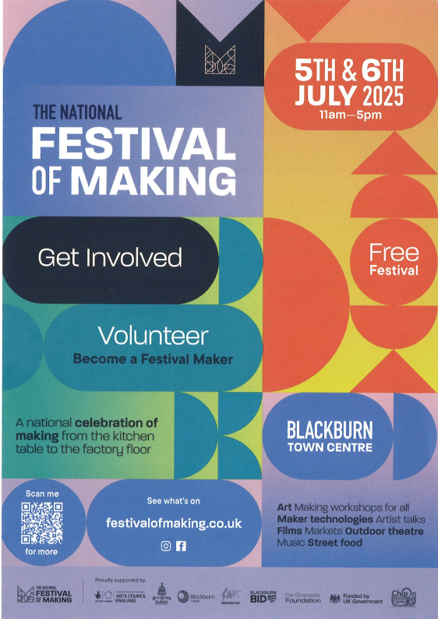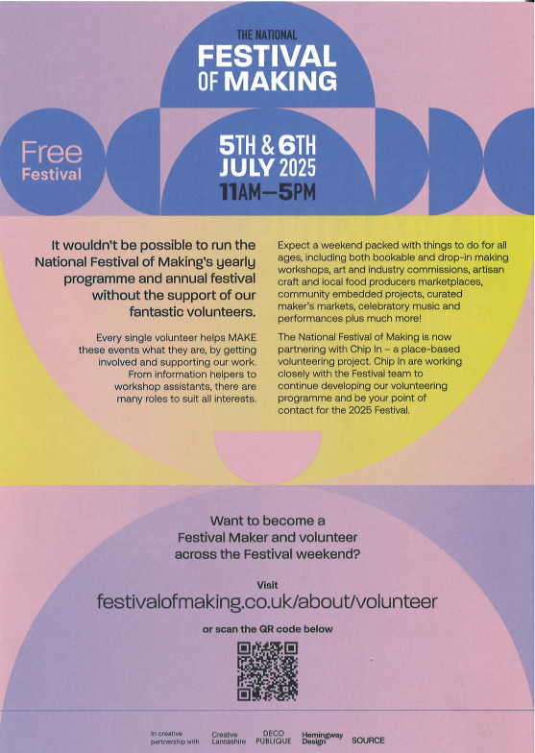

[Festival of Making](https://festivalofmaking.co.uk/)

**Next Meeting**

**Thursday 31st July 2025**

**9:30am – 11:30am**

**The Boulevard Centre**

**45 Railway Road, Blackburn BB1 1EZ**

**For more info, please contact Donna Talbot 01254 583957**

[**Donna.talbot@communitycvs.org.uk**](mailto:Donna.talbot@communitycvs.org.uk)

**Parking is now free for 2 1/2 hours on Morrisons Carpark**