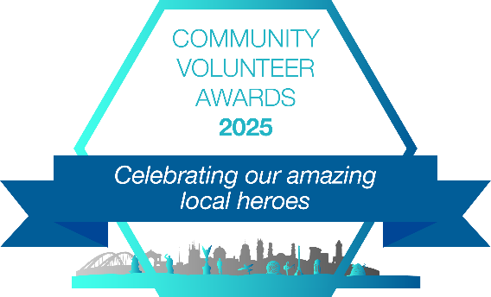

Community Volunteer Awards 2025

Nomination Form

**Your Details:**

Name:

Email Address:

Contact Number:

**THE PERSON/GROUP OR ORGANISATION BEING NOMINATED**

Which are you nominating? please tick:

Group Individual

Individual or Group Name:

If a Group Name of Main Contact:

Contact Number of individual or Group Main Contact:

Email Address:

***Criteria for nomination for individuals – Important please read***

• The person you are nominating Needs to be a volunteer NOT paid staff

• The person being nominated needs to have given their permission to be nominated and to share their details

• You must supply all contact info – Full Name, Email Address and valid phone number

Failure to adhere to the criteria will result in a non-valid nomination and as such will not go to the judging panel



Please tick which categories you would like to nominate your candidate for:

**People**

This category applies to any volunteers or groups/organisations supporting:

* Young People
* Older people
* People experiencing Multiple disadvantage
* Carers
* Disabled People (including long term physical and mental health conditions)
* Minority Groups (asylum seekers, refugees or Ethnic minority groups)

**Prosperity**

This category applies to any volunteers or groups/organisations supporting:

* Employment
* Enterprise
* Eradicating poverty
* Growing Civil Society Organisations

**Planet**

This category applies to any volunteers or groups/organisations supporting:

* Mobilising People, Communities, VCSFE Sector
* Climate Change
* Parks, Open Spaces and the natural world
* Recycling, Reuse, Repair and circular economy

**Peace**

This category applies to any volunteers or groups/organisations supporting:

* Community Cohesion
* Community safety, community resilience and security
* Individuals impacted by Domestic Abuse

**Place**

This category applies to any volunteers or groups/organisations supporting:

* Any Neighbourhoods, especially from deprived areas
* Heritage and Culture
* Housing and homelessness

**Participation**

This category applies to any volunteers or groups/organisations supporting:

* Arts & Culture
* Digital inclusion
* Heritage & Natural World
* Physical Activity, Recreation and Sport



Please tell us a little about the background relating to the individual or group being nominated for the award:

Please tell us about the volunteering relating to the individual or group being nominated for the award. Please include what have they done and how long have they volunteered, how frequently, how many hours, etc:



If the individual volunteer under 25 years old, would you like to nominate them for the Young Persons Award?

Yes No

If the individual volunteer has volunteered for 20 years plus, would you like to nominate them for the lifetime achievement?

Yes No

What impact has the volunteering or voluntary effort made to the community? What difference has it made particularly relating to the award category heading?

**Please note the deadline for entries is Early this year: *Friday 1st August 2025 - 5.00pm***

**You can return via email to Donna Talbot** [**donna.talbot@communitycvs.org.uk**](mailto:donna.talbot@communitycvs.org.uk)

**Post or hand in your form to Donna Talbot, Community CVS, The Community Hub,**

**35 Railway Rd, Blackburn BB1 1EZ**

**Thanks to our Wonderful Sponsors**

