**BwD Community Network and Community CVS**

**Annual Conference 2025**

Thursday 29th May 2025

DACA Sudell Road, Darwen BB3 3HD

Delegate information

**Free Parking**

You can park on DACA carpark free for the

whole event

Once you have parked for entrance to the

event you must go to the Main Entrance to sign in

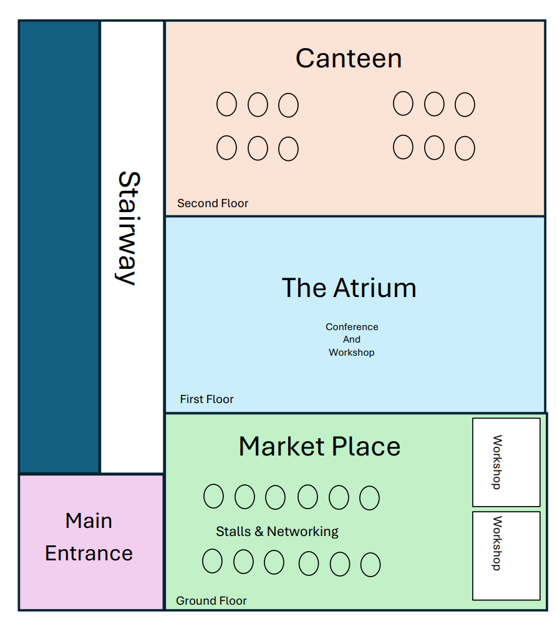

**Floor Plan of DACA**

Please note that there is a lift available for anyone with mobility issues

**Important information**

* Doors open at 9:00am
* We need all delegates to sign in then set up their stall (if required) between 9:00am – 9:30am
* Refreshments in the canteen will be available between 9:00am – 9:30am Tea & Coffee are free (There will be cakes, chocolates etc on offer at a cost please note that DACA can only accept card payment)
* Please ensure that you are seated in the Atrium for a prompt start at 9:30am
* Workshops – if you have chosen ONE specific workshop you will automatically be booked on – If however, you have chosen all 3 workshops we will allocate you a place on a workshop
* Please ensure you are back in the Atrium for the feedback and close for a prompt start at 12:40pm
* Lunch (Vegetarian) will be provided at no cost from 1:00pm onwards – please ensure that if you have any special dietary requirements, you let me know prior to the event

NB: During the entire event we will have a photographer taking pictures if you do not want to be photographed, please let me know