**Meeting Minutes – Flying Start Business Network**  
**Date:** 11/02/2025

**Speaker 1**: **Steve Foden, Community CVS – Community and Asset Team**

**Speaker 2**: **Mike Walker, Co-Founder of Stop Press**

**Speaker 3**: **Alison Daniels, Iris Therapy Services**

|  |  |  |
| --- | --- | --- |
| Name | Organisation | Email |
| Leah Harrison | **Community CVS** | [**Leah.harrison@communitycvs.org.uk**](mailto:Leah.harrison@communitycvs.org.uk) |
| Dee Gough | **The Pacific Institute** | [**dee.gough@pacificinstitute.co.uk**](mailto:dee.gough@pacificinstitute.co.uk) |
| Yvette Holden | **Selnet** | [**Yvette@selnet-uk.com**](mailto:Yvette@selnet-uk.com) |
| Helen Hartley | **Helen Hartley Services Ltd** | **helenw32@hotmail.com** |
| Chris Wilson | **CJW Catering (t/a The Curry Pincher)** | **cjwcatering@cjwilson.email** |
| Mike Walker | **Stop Press** | **mike@stoppress.co** |
| Salim Chaudhry |  | [**salim_c_uk@yahoo.co.uk**](mailto:salim_c_uk@yahoo.co.uk) |
| Steve Foden | **Community CVS** | [**Steve.foden@communitycvs.com**](mailto:Steve.foden@communitycvs.com) |
| Humaira Badhir | **Eagle Threads Ltd** | [**humaira_opt@yahoo.com**](mailto:humaira_opt@yahoo.com) |
| Allan Harle | **Harle Tech** | **allan@harle.tech** |
| Alison Daniel | **Iris Therapy Services** | [**alison@iristherapyservices.co.uk**](mailto:alison@iristherapyservices.co.uk) |
| Hannah Smalley |  | [**hannah1smalley@gmail.com**](mailto:hannah1smalley@gmail.com) |
| Paul Conlin |  | [**Paul@conlinfilms.co.uk**](mailto:Paul@conlinfilms.co.uk) |

**Speaker 1: Steve Foden, Community CVS – Community and Asset Team**

**Overview:**  
Steve Foden introduced the **Community Asset Fund**, a partnership initiative with Calico that supports grassroots groups and individuals in recovery from drug and alcohol dependency. The fund focuses on aiding community-led projects that encourage positive engagement and rehabilitation.

**Key Points Discussed:**

* The fund provides **grants of up to £2,000** for community projects, ranging from boxing clubs to gardening initiatives.
* Monthly funding rounds, with applications reviewed by a service user group to ensure community involvement.
* Support available for setting up **bank accounts, constitutions, and volunteer recruitment** for new groups.
* Businesses encouraged to engage in corporate social responsibility by offering skills and mentorship to those in recovery.
* Training and awareness sessions, including **alcohol awareness and Naloxone training**, available for organisations interested in supporting recovery services.

**Next Steps:**  
Businesses interested in supporting the initiative or accessing training can contact Community CVS for more details.

**Speaker 2: Mike Walker, Co-Founder of Stop Press**

**Overview:**  
Mike Walker shared insights into **storytelling in business marketing** and the importance of effectively communicating a company’s message to its target audience.

**Key Insights:**

* **Power of storytelling**: People connect with businesses through stories rather than facts alone.
* The importance of **identifying an ideal customer** to tailor communication effectively.
* Exercises on defining **target audiences** and shaping messages to resonate with them.
* Businesses should focus on building trust by offering **value upfront** and using testimonials to reinforce credibility.
* The role of **marketing platforms** (social media, websites, print) in reinforcing brand stories.

**Next Steps:**  
Attendees were encouraged to reflect on their **ideal customers** and how to communicate their value proposition more effectively.

**Speaker 3: Alison Daniels, Iris Therapy Services**

**Overview:**  
Alison Daniels introduced **Iris Therapy Services**, which provides mental health and well-being support through various therapeutic approaches.

**Key Takeaways:**

* The **importance of workplace well-being** and mental health support for employees.
* Offering **holistic therapy services**, including counselling, mindfulness, and stress management.
* Benefits of **early intervention** in addressing workplace stress and burnout.
* How businesses can **integrate well-being initiatives** to create a healthier work environment.

**Next Steps:**  
Businesses can explore **employee well-being programs** and contact Iris Therapy Services for tailored support.

**About the Boost and Flying Start Programme**

**Overview**

The Flying Start service is for early-stage businesses that have traded for less than three years, and aspiring individuals with a great business idea. It is aimed at leaders who have a bright and growing vision for their new business. This service will focus on building business and financial acumen and the core skills to establish a new business and drive sustainable growth.

The advisers on the Flying Start programme have a wealth of experience helping early businesses and entrepreneurs and can provide helpful advice across a wide range of areas including business structure, financial management and bookkeeping, sales and marketing and business planning.  
  
This service is available to businesses within the following partner local authority areas: Blackburn with Darwen Borough Council, Burnley Council, Chorley Council, Fylde Council, Hyndburn Borough Council, Pendle Borough Council, Preston City Council, South Ribble Borough Council, West Lancashire Borough Council and Wyre Council.

**Next Steps**:

* Interested individuals can contact Boost / Selnet for a consultation and guidance on starting or scaling their business.  
  -Link: [Welcome to Boost Flying Start](https://selnet-uk.com/welcome-to-boost-flying-start/)
* Flying Start Business Surgery sessions for those who wish to attend:  
  -The Business Advice Surgery, is a free drop in service available to anyone.  
  -The next session will be held on the 06/02/2025, 9.45am-11.45am at the Community CVS Boulevard centre in Blackburn.   
  -Where attendees will be seen on a first come first serviced basis, for a maximum of half an hour with one of our Business Advisors.  
  - Link: [Boost Business Advice Surgery](https://www.boostbusinesslancashire.co.uk/events/boost-business-advice-surgery10)

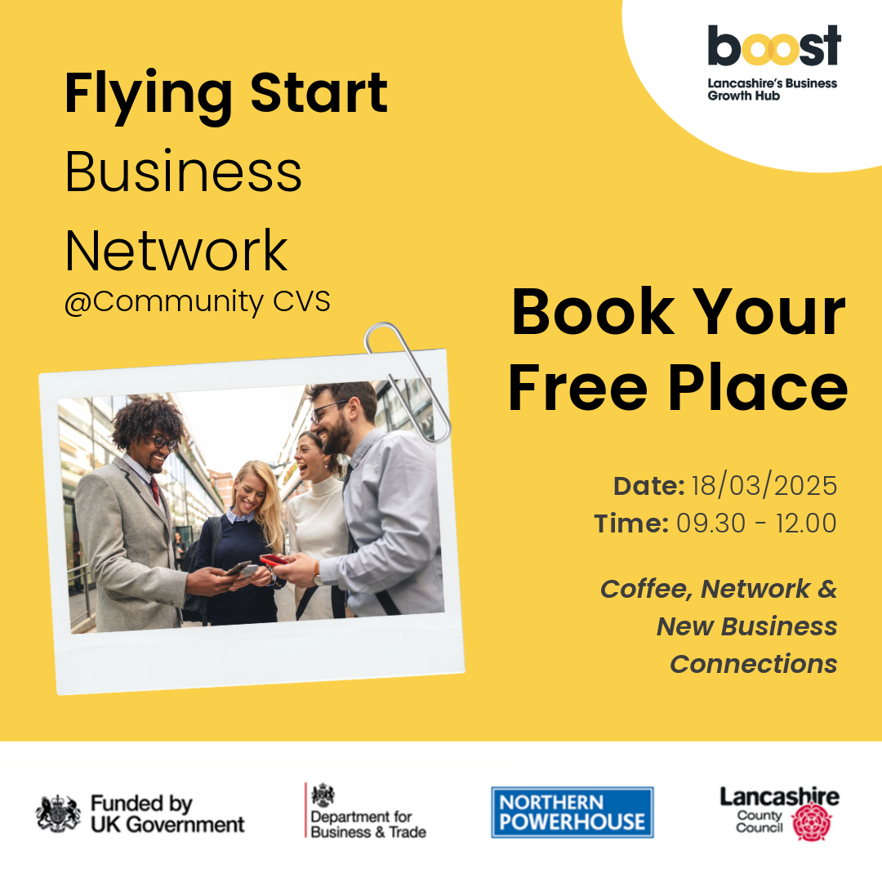

**Additional Information**

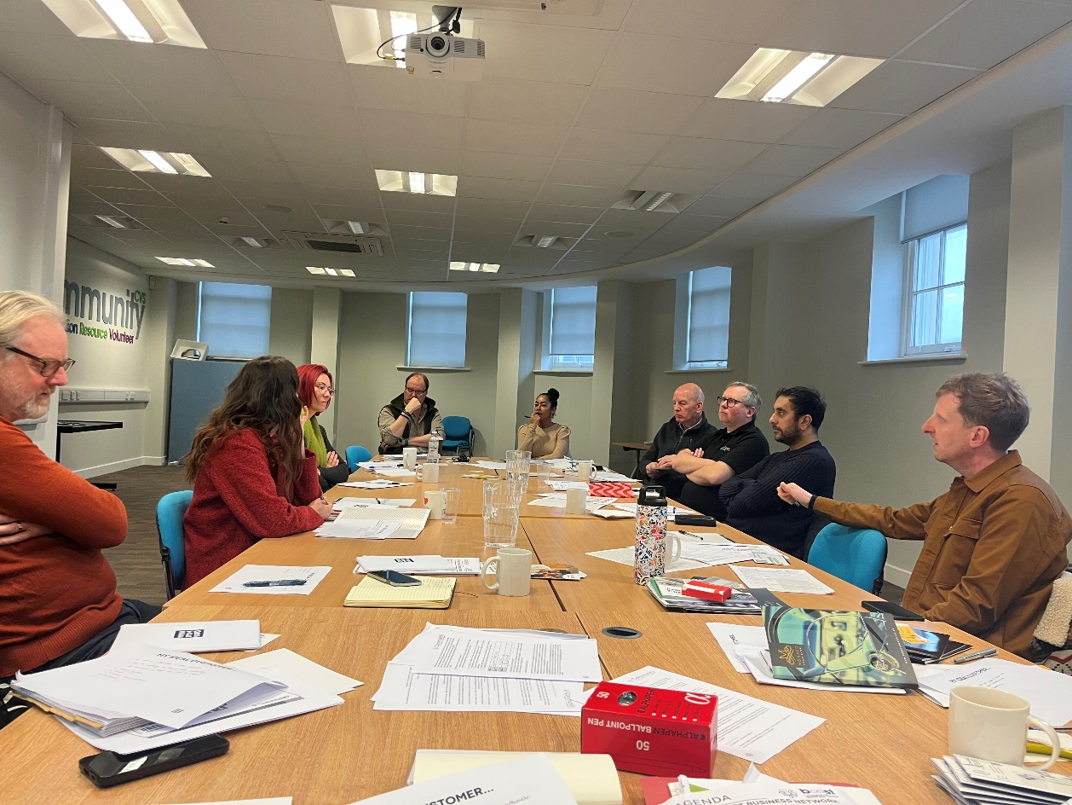**Business Card Raffle Winner:** Alison Daniels **Don’t forget your Business Cards for the Next One!**

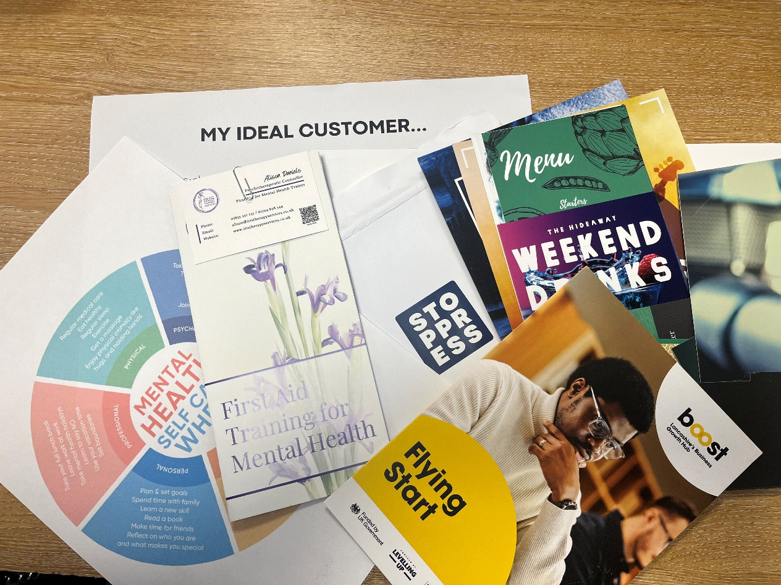**Photo:**

**Next Meeting:** 18/03/2025  
- To attend the next Flying Start Business Networking Event, please email [Leah.harrison@communitycvs.org.uk](mailto:Leah.harrison@communitycvs.org.uk)   
  
Or register via the Link: [Events | Boost Lancashire](https://www.boostbusinesslancashire.co.uk/events?page=2)

**-If you would like to speak at our next event, please get in touch with the email provide above or call 01254 503043**  
  
  
**Location:** Community CVS Boulevard Centre, Conference Room, 45 Railway Road, Blackburn BB1 1EZ  
**Prepared by:** Leah Harrison

**PARKING – please do NOT park on the car park next to the Community Hub – this is a private carpark, and you will be fined.**

**You can now park on Morrisons for Free for 3 hours on any floor. For longer than 3 hours, you can park and pay on the top floor.**

