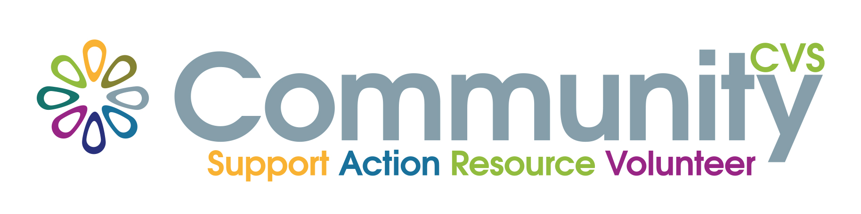

May 2024

Dear CVS Member

Annual General Meeting – Community CVS

The Annual General Meeting of Community CVS will be held on:

Tuesday 4th June 2024
at
Blackburn Central Library
Hornby Lecture Theatre
Blackburn.
at 2.15pm

There are vacancies on the CVS Executive Board to which a nomination form is attached which should be returned to us by noon on Friday 31st May 2024. All vacancies will be serving up to a 3-year term.

In the event of receiving more than 4 nominations, the vacant Executive places will be decided by a secret ballot at the AGM.

Please note that retiring members are also eligible for re-election.

I look forward to receiving your nominations in due course.

Please find all corresponding paperwork on the CVS website www.communitycvs.org.uk

Yours sincerely

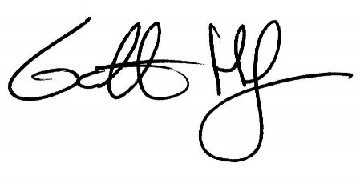

Garth Hodgkinson
CEO
Community CVS

