**Minutes of the Community CVS Network Meeting**

**Thursday 28th March 2024**

Donna Talbot – CVS [donna.talbot@communitycvs.org.uk](mailto:donna.talbot@communitycvs.org.uk)

Lisa Couperthwaite – McPin Foundation - [lisacouperthwaite@mcpin.org](mailto:lisacouperthwaite@mcpin.org)

Georgia Naughton – McPin Foundation – [georgianaughton@mcpin.org](mailto:georgianaughton@mcpin.org)

Bushra Ali – Lancashire Women - [Bushrah.Ali@Lancashirewomen.org](mailto:Bushrah.Ali@Lancashirewomen.org)

Emma Bolton – Bolton HR – [emabolton550@gmail.com](mailto:emabolton550@gmail.com)

Sajida Sidat – IMO - [Sajida.Sidat@imocharity.org](mailto:Sajida.Sidat@imocharity.org)

Nazia Khan – 1Voice Blackburn – [nazia@1vblackburn.org](mailto:nazia@1vblackburn.org)

Samina Saddique – Youth Action - [Samina.Saddique@youthaction.org.uk](mailto:Samina.Saddique@youthaction.org.uk)

Margaret Jepson – Samaritans – [margaret.jepson05@btinternet.com](mailto:margaret.jepson05@btinternet.com)

Faxi Assi – Lancashire Fire & Rescue – [fakharassi@lancsfirerescue.org.uk](mailto:fakharassi@lancsfirerescue.org.uk)

Alan Scholes – Gecko Games Club - [geckoscholes@gmail.com](mailto:geckoscholes@gmail.com)

Anthony Carr- BwD Refresh - [Anthony.Carr@blackburn.gov.uk](mailto:Anthony.Carr@blackburn.gov.uk)

Shaf Ahmed – PHX Training - [ShafAhmed@phxtraining.co.uk](mailto:ShafAhmed@phxtraining.co.uk)

Allen Evans – Net Academy - [allenevans1312@gmail.com](mailto:allenevans1312@gmail.com)

Philomena Strickland – Care Network [philomena.strickland@carenetwork.org.uk](mailto:philomena.strickland@carenetwork.org.uk)

Shelley Whittle – L&SC NHS ICB – [shelley.whittle@nhs.net](mailto:shelley.whittle@nhs.net)

Aggie Kwiecień – [kwiecien.agn@gmail.com](mailto:kwiecien.agn@gmail.com)

Beverly Ormerod – Neurodynamix – [neurodynamix23@gmail.com](mailto:neurodynamix23@gmail.com)

Karen Pickles – Neurodynamix – [neurodynamix23@gmail.com](mailto:neurodynamix23@gmail.com)

Paul Walker – BwD Diabetes peer support Group – [bwddiabetesgroup@outlook.com](mailto:bwddiabetesgroup@outlook.com)

John McCann – LSSA – [SAILLSSA@AOL.COM](mailto:SAILLSSA@AOL.COM)

Clare Rigby – BwD ILS – [clare.rigby@blackburn.gov.uk](mailto:clare.rigby@blackburn.gov.uk)

Kiran Sadiq – BwD Carers – [kiran.sadiq@bwdcarers.org.uk](mailto:kiran.sadiq@bwdcarers.org.uk)

Tamara Hitchen – BYZ – [tamara.hitchen@blackburnyz.org](mailto:tamara.hitchen@blackburnyz.org)

Samina Talaty – BYZ – [samina.talaty@blackburnyz.org](mailto:samina.talaty@blackburnyz.org)

Verity Gardner – Lagans Foundation - [Verity.Gardner@lagans.org.uk](mailto:Verity.Gardner@lagans.org.uk)

**Apologies: Jon Travena – Duke of Edinburgh Awards, Leroy Philbrook – PAC Trudi Wilkinson – Inspira, Rachel Beck – 180 Project**

**Ant – BwD Re:Fresh**

* I run the out door offer under the BwD Re:Fresh offer – walks, cycling, cycle centre down at the revamped Witton Hub
* Our new Active Outdoors Hub in Witton Park will act as a central point for our walks, cycling and volunteering activities that span across BwD,
* a hub for local partners to get involved with what we offer, to deliver workshops from and to access the free training our team can provide.
* We want to build a network of outdoor activities – so that we have the knowledge, we know Whats going on and we can signpost individuals easily to other activities and vice versa
* Andy runs the Greenhouse and works with lots of individuals who need support etc and the onus is on the individual to go and find out Whats happening – we want to take that pressure off the individual and create a one stop shop with lots of different providers
* The idea is to have not just a council facility the Witton Hub will become the centre for all outdoor activities in Blackburn with Darwen – we also have lots of amazing small pockets of funding for groups wanting to participate in outdoor activity who currently may not be able to afford it as we know funding can be a barrier for many groups
* We want to offer activities that are not currently offered, we want to increase accessibility for all
* The ICB/NHS are seeing the value of outdoor activity on wellbeing and are looking to fund green social prescribing as they have done in the past
* We offer training for groups that want to start walking groups
* We are also working on a local cycling and walking plan which looks at the next 5-10 years – we know that the roads are atrocious and there have been many accidents involving cyclists – I’m a cyclist myself and I’m well aware of the dangers of BwD Roads
* The feedback regarding transport is that many of those who need to access the activities, don’t drive and depend on taxi’s which can be very expensive and in the current cost of living crisis people just cannot afford to go out and improve their mental health – its at the bottom of their list, its simply not their priority
* Initially we want to start the conversations with local groups and build on from there

Q: Where can I find out what’s going on, there is info in dribs and drabs everywhere?

A: Exactly – this is why we want to create a hub with all the info – drop in sessions for clients and the general public

Q: How will other communities I.E the polish community access these things?

A: We are in the process of having a programme printed, going forward we will have the programme in other languages etc

Q: Are you part of the Local Offer?

A: Yes, we have a lot of work going on behind the scenes and we are planning to create a collective accessible facility for adults with Autism, Neuro Diversity

Q: Are you providing non-English speaking materials?

A: Yes absolutely, hard copies, digital all systems – we will also be linking in with LCC, Adult Learning to provide English courses etc

Q: Do you link in with the residents and representation from the community groups?

A: We had a launch event last week with lots of local partners – there have been lots of conversations going on around barriers etc and one of the biggest problems is transport, we all know that BwD Transport isn’t the best. We do however have access to a mini bus – and we want to increase capacity to help groups travel to the hub etc. We are working closely with the Highways department we are working towards a much more collaborative way of working within the council and moving away from working in Silo’s

Q: Cycling sessions do you offer all different levels? Where do you take them on the rides, do you take them out of the park?

A: We offer all levels from the very low level going around the track, then for the stronger more confident they can ride around the park – it really is up to the individual to decide what they want to do, what they are comfortable with doing.

Q: Can you access the LCC minibus?

A: We do actually have our own mini bus

Q: One of the big problems is the cost of sports wear too, trainers etc can be costly and if you have to choose between Heating and eating sportswear isn’t going to come in to the equation can you help with the costs of clothing /equipment?

A: What we are aiming to do is that the hub at Witton will generate an income through room rental etc (for those who can afford) we are also looking at lottery funding and we would like to create a community fund that will fund things just like you said – sports equipment etc

[Refresh Blackburn with Darwen (refreshbwd.com)](https://refreshbwd.com/lets-get-active/active-outdoors/active-outdoors-hub/)

**Bev from Neuro Dy-Na-Mix**

* I’m Bev and I’m the CEO of Neuro -Dy-Na-Mix we work with adults with Autism, ADHD, ODD, Dyslexia, turret’s, learning difficulties, mental health anyone and everyone
* We support families with EHSP for their children (Education, Health and Social Care Plan) so we attend CAF meetings, meet up with the SENCO/Head teachers – to ensure that the child’s needs are met from nursery school all the way through to university – not that it always does due to school staff/budgets/facilities etc
* I’m also a designated – Appropriate Adult – so if someone has been charged with a criminal offence – I will get a call and be asked to support them in their interview and if it goes to court then I will support them through the entire process, I’m there to explain the process etc to ensure the individual understands what going on
* I also run arts and crafts groups in BwD – I am currently working with Youth Action, Care Network, we plan on working with the Madrassa and Humraaz after Easter
* I also offer training for staff to understand how to work/support adults with neuro diversity – we will be doing some work with the mosques and madrassa
* We will be working with BwD carers after Easter – training staff around Neuro- Diversity
* We will be introducing sessions for young people around a mindful journal – we will also be offering drama sessions – really anything anyone needs we will try and offer it
* We run a group at Audley Community Centre which is really well attended

Q: What is the referral process?

A: Email

Q: What do the Drama sessions entail?

A: Not sure as it will be my colleague who will be running the sessions – however it will include Improvisation, Dance and acting games etc lots of things to increase the young people’s confidence

[neurodynamix23@gmail.com](mailto:neurodynamix23@gmail.com)

**Alan from Gecko Games**

* I’m Alan and I am the CEO of Gecko Games – we started a group back in 2012 in a church in Blackburn where we invited families to come along and play board games – I’ve always loved board games, me and my kids played lots of games when they were younger, So many children spend so much time on electronic devises away from the family that I thought it would be good to create something different
* We created a Facebook Page and I linked in with other board game groups across the country – in Rossendale they held an event where over 90 people attended and I wanted to replicate this in Blackburn
* I was then diagnosed with Parkinson’s and I lost my job because of it so I was side-lined from the Games group as I was fighting my employer, coming to terms with my diagnosis during this time playing board games helped
* Once I was in a better place I wanted to get the group back up and running – I approached the Blackburn Central Library and Waterstones – they sell the games but if anyone asked how to play would they know how to explain – my idea was that if we had a game group in store then we could explain how to play – unfortunately they just didn’t have the space
* Then I contacted Community CVS and they are helping me with funding etc which I was successful and I have been able to buy new games, and I now have found a new location – Mill Hill Community Centre (New Chapel St, Mill Hill, Blackburn BB2 4DT)
* We run a session every second Friday of the Month 7pm until late its open to all families – it’s a great way for a family to spend a Friday evening
* We do play the usual board games – scrabble monopoly etc however there are so many more interesting board games that are quite complex, it’s a great opportunity for families to come together and learn about different games but spend quality time together

Q: How much does it cost?

A: Annual Membership is £5 and £2 for every session

Q: How many members do you have?

A: Between 30-40 members at the moment

[Facebook](https://www.facebook.com/GeckoScholes)

**Shelley – NHS Comms team**

* I’ve come to talk to you today about /MMR & Measles jabs – as you may be aware both are on the rise and in the North West it is getting quite serious
* Its really infectious and can spread very quickly – you could easily spread it to 15 – 20 people and you may not even be aware that you have it – it takes 4 days after you have got Measles for the rash to appear
* Those most at risk are children, pregnant women, those immunosuppressed
* Measles can cause hospitalisation even death
* We are encouraging those who haven’t been vaccinated to get vaccinated as soon as possible
* There are 2 clinics one in Blackburn and one in Darwen for kids aged 5 yrs. – 11 you can just drop in you don’t need an appointment
* The free vaccines are available from Aston Pharmacy in Blackburn (95 Accrington Rd, Blackburn BB1 2AF) and Everest Pharmacy in Darwen (21 Cemetery Rd, Darwen BB3 2LZ)
* If you are sure whether or not you have had the vaccine – please contact your GP they can let you know
* Public Health have done lots of work on this and have written out to lots of residents
* If you go onto the Lancs ICB website there is lots of information – in lots of different languages, audio files, leaflets, videos – we have lots of resources
* Please share this info amongst your contacts – friends, family, colleagues, clients etc
* Halal versions of the vaccine are available on request

Q: What do you do if you think you have it?

A: Do NOT go to your GP’s its far too infectious - if you think you have it ring your GP

Q: Is it different in children than adults?

A: Yes, if you are a healthy adult you can fight it better

Q: What if you have already had measles?

A: If you have already had measles then you are immune and protected – most adults born from 1966 are the most likely to be protected

Q: There was a lot of stigma around the MMR Vaccine – is it still as bad? And why is that fear there?

A: People believe the hype, the idea of MMR jabs causing Autism is totally inaccurate and has caused things like MMR and Measles to come back

Q: How does the pharmacist know if you have been vaccinated?

A: The walk ins are for young people who haven’t been vaccinated – If you are older go through your GP as they have all of your records

**Sajida – IMO**

* IMO are providing SEND sessions for young people in Blackburn, we are based at Blackburn Youth Zone
* We currently have around 81 young people using our service
* We run sessions on Sunday for ages 8 up to 21 and Monday for 11 -16 yrs. old
* We have lots of activities going on, gaming, refreshments – unfortunately at the moment we don’t have anything going on outdoors but that’s something we want to do
* We are open to working with other partners – we are in the Local Offer
* We have been running a long time and many of our youngsters are now volunteering and supporting other young people – its really good to see them enjoying being part of something so positive
* We have a holiday programme we are based at Blackburn Central High School – just because the facilities are larger
* We do not currently offer 1-2-1 support however carers can come along with the young people
* Everyday we want young people to come in and we are working with schools - SEND children’s come in for an hour once a week with their teachers – just to do something a little bit different – a change of scenery
* We held our first Send Day we had 141 families come along, the atmosphere was relaxed and calm and the young people had a great time- amazingly it wasn’t that noisy!! The parents also had the opportunity to talk to other parents

Q: What does IMO stand for?

A: Inspire Motivate Overcome

[IMO Charity](https://www.imocharity.org/home/)

Faxi – Lancashire Fire and Rescue Service

* The fire service provides a specialist SEND package
* We work with young people who like starting fires – we do a lot more than putting fires out and rescuing people
* A lot of our work is around prevention – we currently cannot afford Fire Engines but we do have money for community work
* I will come along and talk about the things we do in the future

[SEND | Lancashire Fire and Rescue Service (lancsfirerescue.org.uk)](https://www.lancsfirerescue.org.uk/education/send)

**Lisa from the McPin Foundation**

* We are currently working with Kings College on a study called STOP (Successful Treatment Of Paranoia)
* We only have 4 months left – we have had lots of take up in London however we have struggled to recruit people in the North West
* We are looking for people with lived experience of paranoia (Lower Level) to test out a new app – the app is designed to help challenge your thoughts of paranoia in different situations and help you overcome them
* The project is over 12 weeks and we ask for 40 min every week – this includes checking in with the app, completing questionnaires, word tasks and also talking to our researchers
* The project has been running for 3 years and we want to give it a final push for the North West – if anyone knows anyone who may want to participate I have leaflets or just go onto our website
* Any one who partakes in the study will receive up to £100 for their time
* There are some criteria to meet in order to qualify to take part in the study – individuals must be 18 yrs. +, they must be able to speak and write in English, (we do appreciate this could be a barrier but it’s a small team with a small budget)
* Any individual cannot be going through CBT/DBT as this may interfere with the use of the App and the research, Individuals cannot be addicted to any substance and must not be high risk – Suicide etc
* So please if you know anyone who may be interested in taking part please refer them to our website and they can refer themselves

Q: Can you partake in the study if you have had CBT before?

A: Yes, just as long as you are not currently receiving CBT therapy

Q: Once the research is done what will happen with the findings?

A: Kings College will publish their findings and they will be posted on our website

Q: Is it imperative for the individual to have a smart phone or can they complete their tasks online – on teams?

A: Yes, the individual will definitely need a smart phone

[Home | The McPin Foundation](https://mcpin.org/)

**Nazia from 1Voice Blackburn**

* WE are currently working with year 8 pupils (12-13 yrs.) on the HPV vaccination we are going into schools and talking to the young people and their parents
* HPV is a sexually transmitted disease

[Human papillomavirus (HPV) - NHS (www.nhs.uk)](https://www.nhs.uk/conditions/human-papilloma-virus-hpv/)

* Girls have received vaccines from 2008 and Boys form 2019 – the virus can cause cancers and usually the symptoms are too late
* We are working towards Herd Immunity by 2040
* We find that we do not have much take up from SEND young people as their parents don’t consider their children as sexual beings

[One Voice Blackburn – One Voice Blackburn is a Charity that aspires to create an inclusive, cohesive and vibrant community in Blackburn with Darwen. (1vblackburn.org)](https://www.1vblackburn.org/)

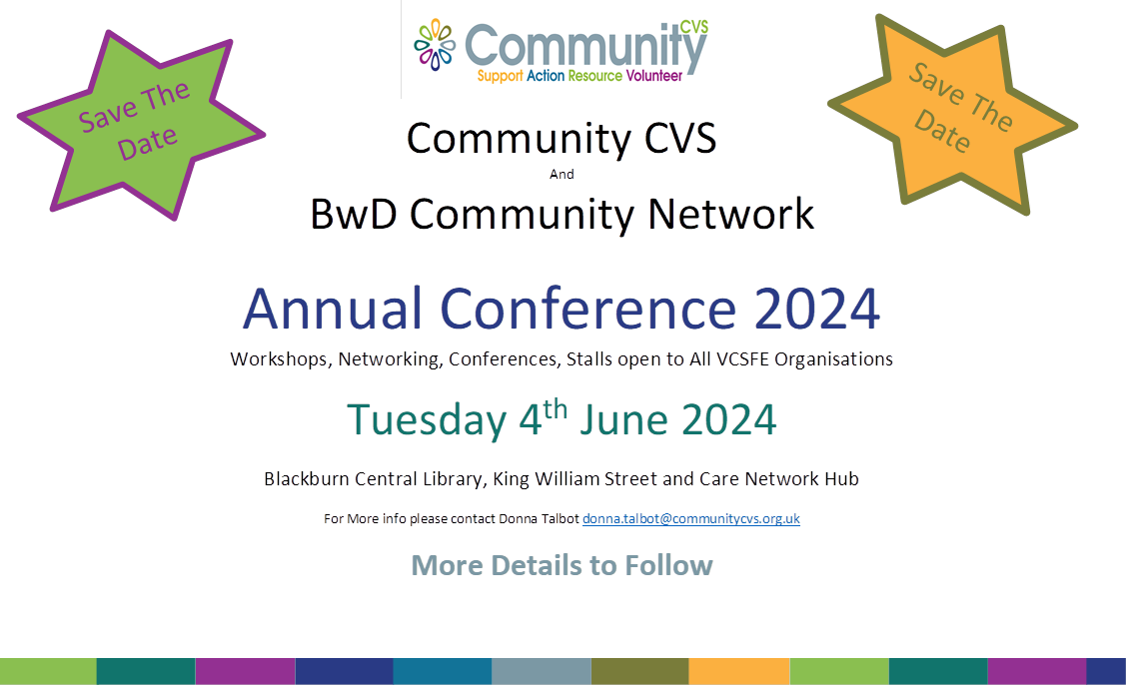

**Next Meeting**

**Thursday 25th April 2024**

**9:30am – 11:30am**

**The Boulevard Centre**

**45 Railway Road, Blackburn BB1 1EZ**

**For more info please contact Donna Talbot 01254 583957**

[**Donna.talbot@communitycvs.org.uk**](mailto:Donna.talbot@communitycvs.org.uk)

***Parking – please do NOT park on the car park next to the Community Hub – this is a private carpark and you will be fined***