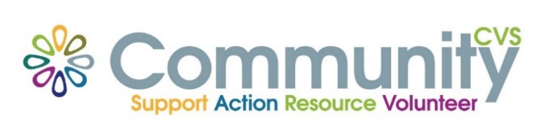

Community CVS Network Meeting
April 25th 2024
9:30am – 11:30am
The Boulevard Centre, 45 Railway Road, Blackburn
BB1 1EZ
Agenda
9.45am Introductions
10.00am Sarah from Maggie’s Still Birth Legacy
10:10am Pearl from Offload Northwest
10.20am Lian from Shine Coaching
10.30am Mariyam from Roots and Wings
10.40am John from Lancashire School Sailing Association
10.50am Mubashar from NSPCC
11.00am Louise from Health Everyone
11.10am - Updates
11.15am – Networking
Date of Next Meeting Thursday 23rd May 2024
for more information please contact Donna Talbot 01254 583957
donna.talbot@CommunityCVS.org.uk

