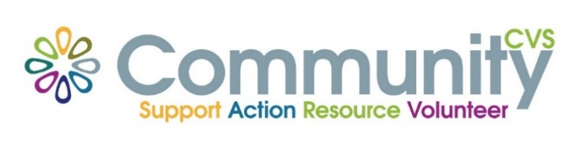

Community CVS
Network Meeting
Thursday March 28th 2024
9:30am – 11:30am
The Boulevard Centre, 45 Railway Road, Blackburn
BB1 1EZ
Agenda
9.45am Introductions
10.00am Anthony from BwD Health & Well Being Team
10:10am Bev from Neuro Dyna-mix
10.20am Alan From Gecko Games
10.30am Shelly from NHS Lancashire and south Cumbria ICB
10.40am Sajida from IMO
10.50am - Updates
11.00am – Networking
Date of Next Meeting Thursday 25th April 2024
for more information please contact Donna Talbot 01254 583957
donna.talbot@CommunityCVS.org.uk

