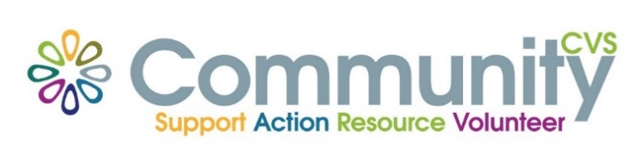

Community CVS
Network Meeting
Thursday February 22nd 2024
9:30am – 11:30am
The Boulevard Centre, 45 Railway Road, Blackburn
BB1 1EZ
Agenda
9.45am Introductions
10.00am Paul Walker from BwD Diabetes Support Group
10:15am Ruksana Ali from Their Stories
10.30am Zainab Dhukai from New Ground Together
10.35am Kelly Shaw from Team Champions
10.50am Angela Allen from Bags for Strife
11.05am - Updates
11.15am – Networking
Date of Next Meeting Thursday 28th March 2024
for more information please contact Donna Talbot 01254 583957
donna.talbot@CommunityCVS.org.uk

