Minutes of the Community CVS Network Meeting
Thursday 26th October 2023

Donna Talbot – Community CVS – donna.talbot@communitycvs.org.uk
Lisa Rawcliffe – Community CVS - lisa.rawcliffe@communitycvs.org.uk
Amanda Fletcher – Nightsafe – Amanda.fletcher@nightsafe.org
Kiran Sadiq – BwD Carers Service – kiran.sadiq@bwdcarers.org.uk
Shelley Whittle – L&SC ICB (NHS) – shelley.whittle@nhs.net
Karen Livesey – No Whispers CIC – info@no-whispers.co.uk
Jasmine Bampton – BwD Carers Service – jbampton2@ucan.ac.uk
Vinitha Kumaran – BwD Carers Service – vinitha0109@gmail.com
Natasha Shah – Purple Souls/Ayup Sultan Trust/Vacare – 786natashashah@gmail.com
Nancy Kinyanjui -Kairos Housing
Zainab Dhukai – New Ground – Zainab.dhukai@newground.co.uk
Denise Hayhurst – CVS & LACVS – denise.hayhurst@lacvs.org.uk
Stuart Parker – Canalside Activity Centre – canalsideblackburn@gmail.com
Eddie Owen – BRCT – eddie.owen@brctrust.co.uk
Rich Pommile – Business Tree UK – pommilerich@gmail.com
Aggie Kwiecien – Polish Community Connection – kwiecien.agn@gmail.com
Holly Morgan – Arc – holly.morgan@arcblackbubrn.org.uk
Shabnam Saifi – Arc – Shabnam.saifi@arcblackburn.org.uk
Lisa Norcross – Kairos Housing – lisa@kairoshousing.org.uk
Fiona Scott – Probation – Community Payback - Fiona.Scott1@justice.gov.uk
Saima Khonat – DWP - SAAIMA.KHONAT@DWP.GOV.UK
Robina Khan – DWP - ROBINA.KHAN2@DWP.GOV.UK

Apologies:
Anthony Carr – BwD Re: fresh, Clare Rigby – BwD BC, , Julie Moran – Herbert Parkinson, Sheila Feilding – Christians Against Poverty, Syka Quraishi – Community CVS, David Rogers - NHS LANCASHIRE AND SOUTH CUMBRIA ICB, Rachel Davies – Together Housing, Catherine Parsons – Guinness Housing, Pam Holgate – Age UK BwD, Dilwara Ali – Healthy Living BwD, Dawn Treanor – IMO, Lisa Cowperthwaite – McPin Foundation,

Natasha Shah – Purple Souls/Ayup Sultan Trust & Vacare
Purple Souls is a LGBTQ Muslim support group
- We support both adults and young people
- Many LGBTQ Muslims find it very difficult when they come out, many have to leave home – families turn their backs on them – many have no choice but to leave their community and find they are not welcome in other communities either
- We are ther to support them in any way we can – a number of the LGBTQ community struggle with their mental health, suicide, self-harm etc we help them find the support they need
- The Organisations is very controversial as the Muslim community do not talk about it or acknowledge it and we hope to start the conversations, help educate and teach that being LGBTQ means you can still be Muslim
Ayup Sultan Trust is a Domestic Violence support group
- We help with housing, benefits etc
- We also help for spouse visa applications which can be really complicated
- Again, we offer hand holding support, sign posting etc
Vacare is a project working with adults with disabilities
- Offering physio and support for those who have had a stroke to ensure a quick and speedy recovery
- We also offer day trips and exercise routines etc

Q: is there a charge for your service?
A: no everything is free

Eddie Owen - Blackburn Rovers Community Trust
Community Wellbeing Hub:
Aims & Objectives
- First Wellbeing Hub of its kind at a professional football club’s stadium
- Providing free to access space for organisations, partners and specialist charities
- Promoting positive mental & physical health in the community
Health Outcomes
- Tracking health outcomes, including academic evaluation
- Proving the concept & developing a sustainable model
- Establish referral pathway across programmes, supporting internal & external projects
Community Wellbeing Hub: Phase One & Two
Phase One:
• Opening of Darwen End facilities
• Brand new permanent Community Wellbeing
Hub reception & office space
• Develop internal timetable and promote provision
Phase Two:
• Enhance health & wellbeing projects as part of
opening our refurbished facilities
• Develop new health & wellbeing strategy

Q: When can we drop in?
A: every Wednesday 9:00am – 5:00pm

Please contact Eddie eddie.owen@brfctrust.co.uk 01254 924890

https://www.rovers.co.uk/community/

Stuart Parker – Canalside Activity Centre
- In spring 2016, St. George's Mill Hill Scout Group took out a lease on the plot of land which was to be developed into the activity centre you see today.
- We planted hundreds of trees, created a pond, it took hundreds of hours to get the plot looking like it does today.
- Canalside is an Outdoor Activity and Environment Centre based in Mill Hill Blackburn. The centre is run by a small team of volunteers.
- The centre has been developed for use by local Scout, Guide and other Community Groups to ensure people have affordable access to learn and have fun outdoors in a safe environment.
- Thousands of young people from across the Borough use the facilities which enable groups to give young people access to the outdoors in an affordable way.
- We have lots of activities on offer: bush craft activities – Fire pit (Wood Provided) Flint & Steels, Shelter Building, Backwoods Cooking, Axe Throwing, Branding, Archery.
- Water Sports – Canoeing
- Canalside Activity Centre work in partnership with Sporting NRG Ltd to offer schools access to a wide range of activities at the activity centre.
- From September 2022 to September 2023 we have had 5500 site users, and 1000 accessed water sports from site.
- Q: If we book a session is there any extra charges?
- A: For all activities we charge just £2 per person, volunteers and staff are free

Q: Are you based at the bottom of Bonsall Street?
A: Yes, we are

Q: How DO you finance everything charging only £2?
A: We ask for donations, we are cheeky, we apply for grants – we have received Community CVS grants in the past, because we are all volunteers a little money goes a long way – our latest application for the CVS funds is to build an outdoor shelter so that up to 60 school children can have an outdoor classroom
https://canalsideblackburn.wixsite.com/2016

Fiona Scott – Probation Community Payback
- We work with offenders who are on a community payback order – this is unpaid work that has to be carried out as part of their sentence
- We are always looking for placements – warehouses, shops etc
- We have worked with Canalside – helping to clear pathways, trees, litter etc
- We have had lots of projects in the past: Churches, pathways, graves etc, Witton Park – our team builds the bonfire then clears it all away the day after,
- We do mass litter picks in the parks – Queens park, Witton Park – if you need our help with a local litter pick please just contact us and we will help out if we can
- We have done indoor projects – painting etc
- Schools and Children Centres – many got overgrown during covid and we helped to get them back to looking their best
- We have worked with ARC on their allotments – doing all the clearing etc
- We work closely with the canal and river trust – from Burnley to Chorley lots of clearing of the pathways, cutting back the grass and making the areas look good
- If you have any ideas or projects that we can get involved with please let us know, we will come out and do a risk assessment – we provide the labour and the refreshments and the team are supervised all the time
- Q: What other activities have you done for the charities?
- A: we have worked with Sue Ryder, Oxfam, Cancer Research, Barnardo’s and the British heart foundation – some of the individuals do not want to work within in a team so we find them placements within charities where they can help out in the warehouse or in the shop

Community Payback - Lancashire Police Crime Commissioner (lancashire-pcc.gov.uk)

Amanda – Nightsafe
Nightsafe are holding our big sleep out at Ewood Park on Friday 17th November – we have a chap who is attempting to break the world record for pushing a lawnmower, he will be going around the pitch all night long!!

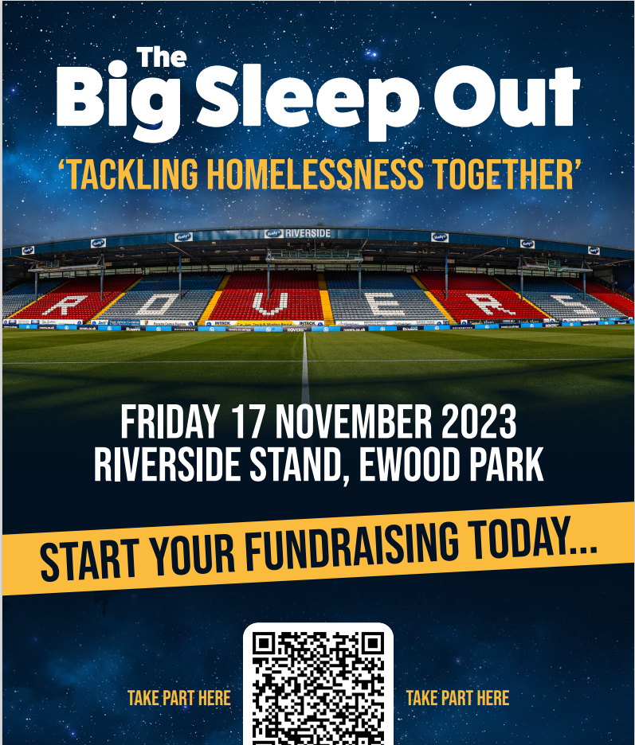

Nightsafe are a local Charity in the Blackburn with Darwen area

Kiran – BwD Carers Service
- Our Vol academy starts next Monday ( 30th October) this is a 6-week accredited training for our volunteers
- We hold the sessions Monday morning – 10:00am – 12:00pm or Thursday afternoon 1:00pm – 3:00pm
- So if anyone is looking to be upskilled and is looking to volunteer please let them know
- The course looks at confidentiality, safeguarding etc

Q: how often do you hold the academy
A: Once every Quarter ( depends on numbers)

Home - Blackburn with Darwen Carers Service (bwdcarers.org.uk)

Karen – No Whispers CIC
We are now offering a new training – child sexual exploitation for children with autism
The first training session went down really well – the audience was multi agency – secondary schools, Ofsted etc – feedback was fab
The course looks at the most vulnerable children – LGBTQ, neuro diverse, autistic
We will be running the course again in 2024 – it will be a full day training, a great opportunity to network, sharing good practice
If you are interested please contact me
CSE & CCE Awareness Training - No Whispers (no-whispers.co.uk)

Shelley – NHS
The NHS winter campaign this year has no money so we are relying on everyone sharing the info – I will be sharing leaflets with Donna who will then share them – so please pass on the message to your clients etc
Me and my team can come along and speak to your clients – listen to their views and collate their feedback

Next Meeting
Thursday 23rd November 2023
9:30am – 11:30am
The Boulevard Centre
45 Railway Road, Blackburn BB1 1EZ
For more info please contact Donna Talbot 01254 583957
Donna.talbot@communitycvs.org.uk

Parking – please do NOT park on the car park next to the Community Hub – this is a private carpark and you will be fined

