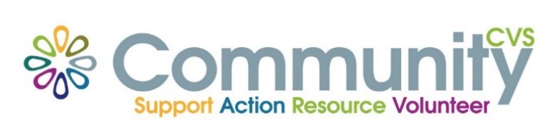

Community CVS
Network Meeting
Thursday 26th October 2023
9:30am – 11:30am
The Boulevard Centre, 45 Railway Road, Blackburn
BB1 1EZ
Agenda
9.45am Introductions
10.00am Natasha Shah from Purple Souls
10:15am Eddie Owen from BRFC Health & Well-being Hub
10.30am Lisa Couperthwaite from McPin Foundation
10.35am Dermot Gallagher from Canal & River Trusts
10.50am Fiona Scott from Community Payback
11.05am - Updates
11.15am – Networking
Date of Next Meeting Thursday 23rd November 2023
for more information please contact Donna Talbot 01254 583957
donna.talbot@CommunityCVS.org.uk

