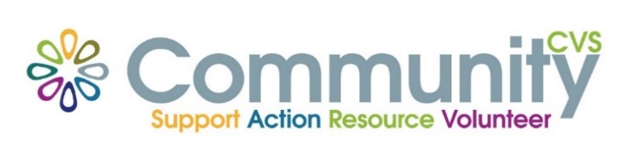

Community CVS

Network Meeting

Thursday 27th July 2023

9:30am – 11:30am

The Boulevard Centre, 45 Railway Road, Blackburn

BB1 1EZ

Agenda

9.45am **Introductions**

10.00am **Dominic** from **CANW**

10:15am **Omar & Zuber** from **Audley Sports Centre**

10.30am **Ryan & Nova** from **Autism Friends**

10.45am **Faheema** from **IMO**

11.00am - **Updates**

11.15am – **Networking**

**Date of Next Meeting Thursday 28th September 2023**

**Please not that the August Meeting is Cancelled**

for more information please contact Donna Talbot 01254 583957

[donna.talbot@CommunityCVS.org.uk](mailto:donna.talbot@CommunityCVS.org.uk)