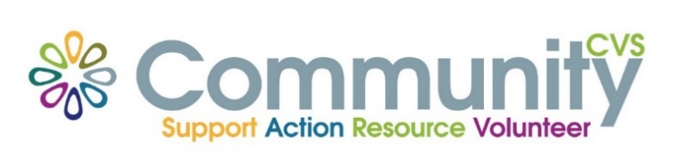

Community CVS

Network Meeting

Thursday 29th June 2023

9:30am – 11:30am

The Boulevard Centre, 45 Railway Road, Blackburn

BB1 1EZ

Agenda

9.30am **Introductions**

9.45am **Omar & Zuber** from **Audley**

10:00am **Pam**  from **Age Uk BwD**

10.15am **ZAC** from  **Turnaround Programme**

10.30am – **David Rogers – NHS**

10.45am – **AOB**

**11.00am - Networking**

**Date of Next Meeting Thursday 27th July 2023**

for more information please contact Donna Talbot 01254 583957

[donna.talbot@CommunityCVS.org.uk](mailto:donna.talbot@CommunityCVS.org.uk)