BACKGROUND INFORMATION FOR JOB APPLICANTS
INTRODUCTION TO THE UPSKILLING THE HEALTH AND SOCIAL CARE WORKFORCE ACROSS LANCASHIRE
***Please note the title and salary is likely to increase we are awaiting a Project Change Request if approved the connecter role will become a Training and Relationships Manager role***
Overview
The health economy within Lancashire and across the country is undergoing a significant change with the creation of a Lancashire and South Cumbria Integrated Care System and five place based Integrated Care Partnerships on the Fylde Coast, Central Lancashire, Morecambe Bay, Pennine Lancashire and West Lancashire. At the geographical level below this are over 40 Primary Care Networks. These changes are happening across England.
The purpose of this project is to upskill the workforce of small and medium sized enterprises, employing less than 250 people across Lancashire, who contribute towards improving people’s health. This involves both the 20% of clinical care that is provided within a NHS Health or Social Care setting - but equally important the 80% that operates outside of the narrow health and social care setting (see diagram on the right). Frequently this 80% is described as the social determinants of health, this goes way beyond simply providing health or social care services - it includes the arts, sport and recreation, adult education and training, community development, employment support, debt advice, housing, welfare support, environmental initiatives and much more. Anything that helps improve people’s health and well-being.
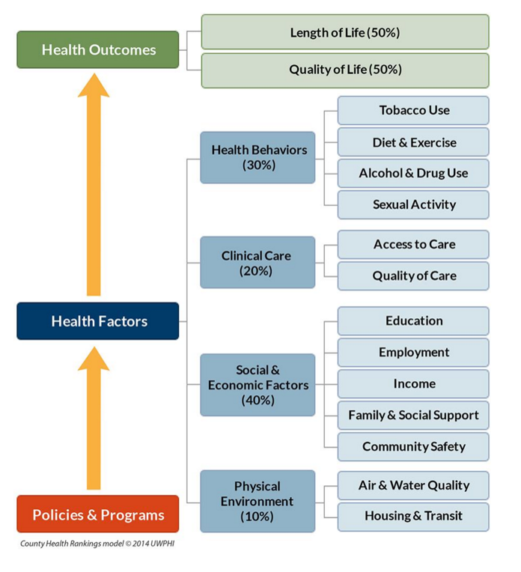
Our main focus is to upskill the workforce within the voluntary, community, faith and social enterprise sector, but we can also support GP practices, care homes and other organisations operating in the private sector within the health economy.
As part of upskilling the workforce, we also plan to help the organisations to change and prepare themselves to be more closely integrated within the system and be ready to seize any opportunities for growth that may present themselves.
If you think you having something to offer, we would love to hear from you.
Background on Community CVS
We are a Blackburn based charity with a core workforce of 26 staff, plus lots of volunteers and sessional staff. Most of our activity focuses on Blackburn with Darwen, but we also do somethings across Lancashire such as the Bowel Cancer Screening Engagement programme, Business Advice and projects such as Action for Jobs and the Upskilling project. Frequently these projects are delivered in partnership with link minded community infrastructure organisations (such as CVSs, Volunteer Centres, CABs, Lancashire BME Network, etc.).
Mission Statement
To support individuals, organisations and communities
to achieve their full potential
Vision
To create a more prosperous, more equitable, more active & greener Blackburn with Darwen & Lancashire
Values
- Community Stewardship
We value service to the community over self-interest and believe that everyone with a locality has a responsibility to support positive social change for people living there and for future generations.
- Co-operation
We value co-operation and actively encourage individuals and organisations to work together in partnership for the benefit of the community.
- Fairness
We value social justice, equality and solidarity and strive to achieve a more equal society as a way of supporting the social, economic and environmental well-being of everyone within the community.
- Voluntary Action
We value voluntary action, which is activity that is not pursued for private gain or profit but for social benefit and to put something back into our community. We believe volunteering is a valuable part of life that contributes to well-being. It helps with sociability and providing a sense of community. There are many reasons to volunteer and the rewards from volunteering can be great.
- Willingness to Listen, Learn & Innovate
We value and are willing to try new ways of working. We are interested in listening to people’s ideas and learning from other people in order to improve what we do and the impact we have.
The Community CVS Team

The posts advertised for the Upskilling project are as follows:
Programme Manager
The Programme Manager will have need to have strong project management skills and be target driven. They will be expected to work closely with the Chief Executive, Governance & Compliance Manager and Business & Training Manager to oversee the delivery of this project and work across the partnership to ensure we are meeting our targets.
Experience in business advice, business development or developing organisations will be useful to manage and lead the team of CCDOs (Connecting Communities Development Officer to help develop and support organisations to grow and collaborate to become trusted partners within the overall integrated care system.
Connecting Communities Development Officers (x4)
The Connecting Communities Development Officers will be working closely with organisations across the VCFSE Sector, the public sector and the private sector. Hopefully with a background in helping to develop organisations and experienced in bring partners to work and collaborate together, hosting multi-agency meetings, etc. 2 of the roles will be based in Blackburn and 2 of the roles we are hoping to be based in Preston, but working across Central Lancashire and West Lancashire. These roles are crucial in building trusted relationships with voluntary, community, faith and social enterprise organisations and with public and private sector partners and encouraging organisations and people to sign up for the project, undertaking organisational diagnostics, developing workforce development plans and tapping into the training offer.
Senior Training Advisors (x4)
We expect the senior training advisors, to be experienced of delivering advice and training within the workplace. They should be able to undertake organisational diagnostics/skill audits and be able to advice the organisation on developing workforce development plans. They should also be able to train and assess within the workplace.
It is intended that the senior training advisor roles will be based across Lancashire and will work across Lancashire. There will be opportunities to co-locate within a delivery partner in:
- Blackburn
- Blackpool
- Burnley
- Lancaster
- Preston
You will be expected to work within organisations across Lancashire and on an outreach basis in community venues within
- Fylde and Wyre
- Hyndburn and Ribble Valley
- Pendle and Rossendale
- Chorley, South Ribble and West Lancashire
We expect the senior training advisors to be able to bring their own vocational subject specialism to the team and be able to develop curriculum within any of the following areas:
- Business Management (HR, marketing & communications, IT, finance, governance, organisational development, quality systems, environmental management, etc.)
- Basic Skills (literacy, numeracy, ESOL)
- Health Improvement / Public Health / health and well-being
- Health and Social Care
- Information, Advice & Guidance
- People Related Vocational Areas (e.g. Customer Care, Retail, hospitality, leisure & sport, personal or business coaching, mentoring, etc.)
- Volunteer Management
This list is not exhaustive. If you think you have something to offer, please share your expertise with us.
Key Components of the Upskilling Project

Engagement and Learning Support
Using our partners’ strong local links to the voluntary, community, faith and social enterprise sector and to the local primary care networks, integrated care partnerships and overall integrated care system that helps to make up the health economy. Connecting Communities Development Officers, Community Connectors and Link Workers have important roles to play in bringing organisations and key stakeholders together to collaborate on improving the health of our population. They also have a key role to play in promoting this project and signing organisations and people up to benefit from this project.
Organisational Diagnostics / Skills Audit
Every organisation we support will be required to undertake an organisational diagnostic and skills audit. The intention behind this is to ensure that any skills we develop within the organisation meets the organisation’s needs and priorities and helps to develop the organisation to play a meaningful role as part of the integrated health system in improving the lives of the population of Lancashire.
The Senior Training Advisors, supported by our Business and Training Manager and Programme Manager will undertake these organisational diagnostics and skills audits. Full training will be provided, but it is expected that you will have the necessary experience of working within organisations to help them understand their business requirements.
Workforce Development Plan and Individual Learning Plans
With every organisation we will help them to develop a Workforce Development Plan for their organisation and for every participant on the programme we will help them to develop their own Individual Learning Plan. Again, the Senior Training Advisors are expected to be able to deliver this requirement with the help and support of local Workforce Development Officers and Connecting Communities Development Officers.
Flexible Bespoke Training
We will deliver both non accredited and accredited training in the workplace and at accessible community venues across Lancashire.
Community CVS is an Approved Training Centre with the Chartered Management Institute, the NCFE (Northern Council for Further Education) and the Royal Society for Public Health.
We welcome applications from suitably experienced trainers that can help to deliver our existing provision, but can also use their skills, experience and qualifications to develop and enhance our curriculum offer to meet the needs of organisations within the voluntary, community, faith and social enterprise sector and the wider health economy.
We will aim to develop bespoke customised local training offers that meet the specific needs of organisations within each of the 5 Integrated Care Partnership areas. Our local delivery partners will play a key role in helping to find out what those needs are.
Leadership and Management
We are keen to develop leadership programmes that will equip leaders within the VCFSE sector and across the health economy for the future.
We are also keen to tackle inequalities and would welcome applicants who have particular expertise and experience in delivering ‘women into leadership’, ‘BAME Leadership programmes’ and other leadership, coaching or mentoring programmes that support people from any background that may be under-represented within management and leadership positions to give them the confidence, skills and qualifications to seek out and secure those opportunities.
We are keen to support and encourage changes within the leadership and management of the VCFSE sector and the wider health economy to make it more reflective of the rich diversity that our communities offers in terms of equality profiles.
Potential applicants who can help us with these endeavours are encouraged to apply.
Results
The European Union and the Department for Work and Pensions will measure the success of the project on achieving the following:
- Developing the skills of 2330 participants, who are part of the health and social care workforce.
  - 466 of the participants to be aged over 50;
  - 241 of the participants to come from a BAME background
  - 241 of the participants to be disabled.
  - 175 of the participants to come from single adult households with dependent children
- Supporting at least 375 employees with basic skills (260 of whom will achieve an Entry level qualification)
- Supporting at least 590 employees to achieve a unit towards a level 2 qualification or below
- Supporting at least 285 employees to achieve a unit towards a level 3 qualification or above.
- Supporting at least 405 female employees to make progress in terms of their career as a result of our support
Impact
We will measure the success of the project in terms of the following impact:
- Developing activities and services that better meet the needs of our population to improve their health and well-being and to tackle the health inequalities facing our communities

- Developing a greater acceptance of the major role the VCFSE Sector and SMEs already play within the integrated health system and expanding that role to improve the health and quality of life for residents.

- Encouraging more GPs to make referrals to social prescribing solutions.

- Encouraging and supporting more commissioning of VCFSE sector organisations supported through the project.

- Supporting positive changes to the equality profile for senior roles within the VCFSE Sector organisations supported through the project.

- Improving the qualification profile within the workforce of organisations supported through the project.

- Encouraging greater use of technology within the workforce of organisations supported through the project.

- Improved Personal Well-Being within the workforce of organisations supported through the project.

Delivery Partnership
Central and West Lancashire
Community CVS
Community CVS is looking to rent premises within Preston, from which a small team of 2 to 5 staff will be based. The premises will be used to deliver the Action for Jobs and Upskilling projects. We are looking to rebuild a CVS presence within the Central Lancashire area. We are particularly keen to hear from people with strong VCFSE networks and understanding of the Central Lancashire area, who are encouraged to apply for any of the roles, but particularly those roles that will be based within Preston City Centre.
West Lancashire CVS
West Lancashire CVS will promote the project across West Lancashire. The charity employs 9 staff, who deliver a social prescribing service within West Lancashire and have strong links with the GPs and Primary Care Networks within the area.
http://www.wlcvs.org/
Fylde Coast
Citizens Advice Blackpool / Blackpool Wyre and Fylde CVS
Citizens Advice Blackpool will employ a workforce development officer, who will help to co-ordinate and deliver the training offer within the Fylde Coast. The charity also has strong links with the GPs and Primary Care Networks within the area employing Link Workers and delivering advice sessions within the practices. Blackpool Wyre and Fylde CVS will promote the training offer to the voluntary, community, faith and social enterprise sector across the Fylde Coast.
https://www.blackpoolcab.org.uk/ http://www.cvsbwf.org/
Volunteer Centre Blackpool, Wyre and Fylde
Volunteer Centre Blackpool, Wyre and Fylde will employ a workforce development officer, who will help to co-ordinate and deliver the training offer within the Fylde Coast. The Volunteer Centre are employing LINK Workers supporting Primary Care Networks within the area.
https://volunteercentrebwf.org.uk/
North Lancashire
Lancaster District CVS employs Connecting Communities Development Officers, who help to deliver the Connecting Communities Programme on behalf of the Morecambe Bay Clinical Commissioning Group. They are also part of the Population Health Management approaches being delivered within the Lancaster area.
https://lancastercvs.org.uk/
Pennine Lancashire
Community CVS - based in Blackburn, the charity is the lead body for the Upskilling project and an Action for Jobs project. Leading on the delivery of a Population Health Management approaches within the VCFSE Sector within Blackburn with Darwen. Manages an Approved Training Centre with the Chartered Management Institute, NCFE and Royal Society for Public Health. Delivers business advice to people wanting to start up in business or existing businesses.
http://www.communitycvs.org.uk/
Burnley, Pendle and Rossendale CVS
Based in Burnley with outreach centres in Pendle and Rossendale, the charity has strong links with GP practices throughout the area and employs Community Connectors and LINK workers to support local Primary Care Networks. Involved with delivering Population Health Management approaches within the VCFSE Sector. Partner with Community CVS on the Action for Jobs initiative.
https://www.bprcvs.co.uk/
Hyndburn and Ribble Valley CVS
Based in Great Harwood - but serving the local authority districts of Hyndburn and Ribble Valley. Strong links with GP practices employing community connectors and LINK workers to support local Primary Care Networks in Hyndburn and Ribblesdale. Involved with delivering Population Health Management approaches within the VCFSE Sector. Partner with Community CVS on the Action for Jobs initiative.
https://hrvcvs.co.uk/
Pan Lancashire
Lancashire BME Network
Lancashire BME Network is the leading network for BAME groups operating across Lancashire. We will work with them to develop and promote a training offer that is suitable for BAME groups and also helps to promote the career progression of BAME individuals within the workforce.
http://lancashirebmenetwork.org.uk/
SELNET
SELNET is the leading network for social enterprises across Lancashire. We will work with them to develop and promote a training offer for social enterprises.
https://selnet-uk.com/

Health Links
Healthier Lancashire and South Cumbria
The integrated care system for Lancashire and South Cumbria.
https://www.healthierlsc.co.uk/
Fylde Coast Health and Social Care Partnership
The integrated care partnership for Blackpool, Wyre and Fylde.
https://healthierfyldecoast.nhs.uk/
Our Central Lancashire Partnership
The integrated care partnership for Chorley, Preston and South Ribble.
https://www.healthierlsc.co.uk/central-lancs
Bay Health and Care Partners
The integrated care partnership for Lancaster District, South Lakelands and Barrow-in-Furness.
https://www.healthierlsc.co.uk/morecambe-bay
Healthier Pennine Lancashire
The integrated care partnership for Blackburn with Darwen, Burnley, Hyndburn, Pendle, Ribble Valley and Rossendale.
https://healthierpenninelancashire.co.uk/
West Lancashire Partnership
The integrated care partnership for the West Lancashire area.
https://westlancspartnership.co.uk/

