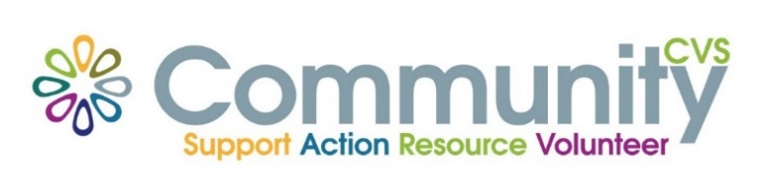

Community CVS
Network Meeting
Thursday 27th October 2022
9:30am – 11:30am
The Community Hub, 35 Railway Road, Blackburn
BB1 1EZ
Agenda
9.30am Introductions
09:45am Presentation from Paul Smithson from MS Society
10:00am Presentation from Ben Bradley-Haworth from Utilita
10.15am Presentation from Rebecca Royce from South Pennines Park
10.30am Presentation from Lynne Goodacre from BwD food Alliance
10.45am Updates
11.00am – Networking
Date of Next Meeting Thursday 24th November 2022
for more information please contact Donna Talbot 01254 583957
donna.talbot@CommunityCVS.org.uk

