STAKEHOLDER BRIEF

Hurstwood Ward Refurbishment at Royal Blackburn Hospital

April 2022
At Lancashire and South Cumbria NHS Foundation Trust (LSCft) we are focused on continuous improvement; putting service users at the heart of everything we do.
As part of this commitment, we have invested £3 million into refurbishing Hurstwood ward at Royal Blackburn Hospital so that we can provide quality mental health provision for our service users.
Hurstwood ward is currently an 18-bed unit treating older adults with acute mental health issues including depression, anxiety, bi-polar disorder, schizophrenia and mild to moderate dementia.
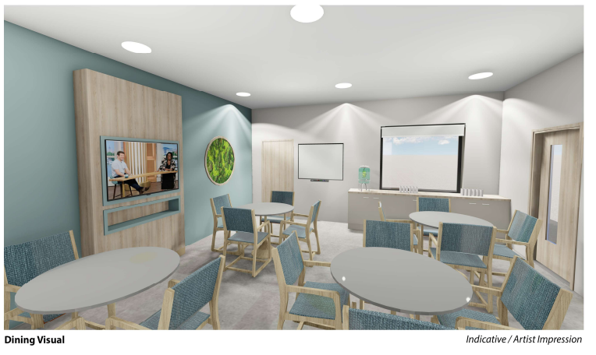
The ongoing work will deliver:
- Replacing all single rooms with en-suite rooms, including a disabled bedroom and assisted bathroom to support the older adults and those with mobility issues
- En-suite rooms gives the ward flexibility and provides a degree of future proofing should requirements change
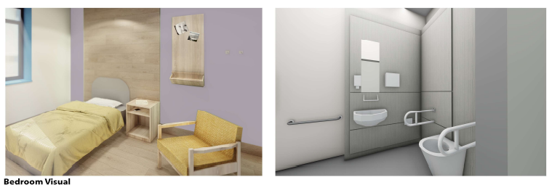
- This will provide 12 modern en-suite bedrooms
- Improved recreational space for leisure and therapeutic activity
- New décor and interiors

By providing safe and comfortable environments, we can ensure privacy and dignity for all those using this facility.
We hope that by improving our facilities, we can help to empower and encourage individuals to strive to reach their full recovery.
We are working to complete the refurbishment by June 6 2022.
ENDS
Notes:
Lancashire and South Cumbria NHS Foundation Trust provides a range of services including secondary mental health care across this area. Specialist provision comprises inpatient child and adolescent mental health services, perinatal mental health and forensic services including low and medium secure care. The Trust also provides a range of physical health and well-being services in the community alongside a range of partners in the Lancashire and South Cumbria area. The Trust was first established in 2002 and employs approximately 7,000 staff who provide care from more than 400 sites.
The Trust uses social media to promote events, involvement and job opportunities as well as general news and updates.
Twitter at: @WeAreLSCFT
Facebook here
Issued by Charlotte Tuohy at Lancashire and South Cumbria NHS Foundation Trust. For more information please email charlotte.tuohy@lscft.nhs.uk

