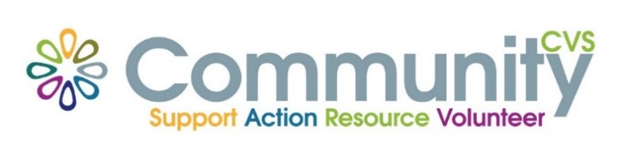

Community CVS
Network Meeting
Thursday 24th March 2022
9:30am – 11:30am
The Conference Room, The Boulevard Centre 45 Railway Road Blackburn
BB1 1EZ
Agenda
9.30am Introductions
9:45am Presentation from Louise Taylor from CANW
10:00am Presentation from Karen Livesey from CSE Awareness
10:15am Presentation from Denise Cottam from Albion Mill
10:30am Presentation from Karen Marsden & Ian Brown from New Ground
10:45am AOB & Networking
11.30am – 12:30pm Modern Slavery Training – Ruth Packwood – Hope for Justice
Date of Next Meeting Thursday 24th March 2022
for more information please contact Donna Talbot 01254 583957
donna.talbot@CommunityCVS.org.uk

