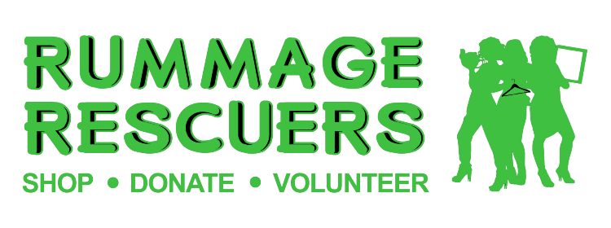
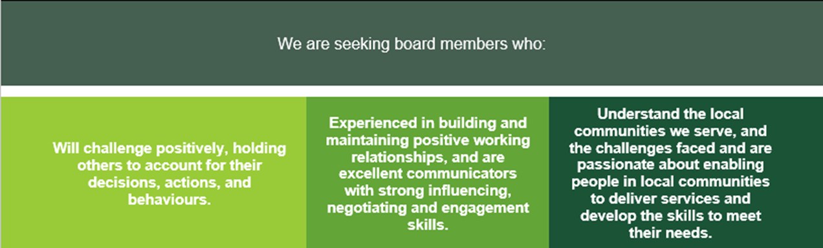
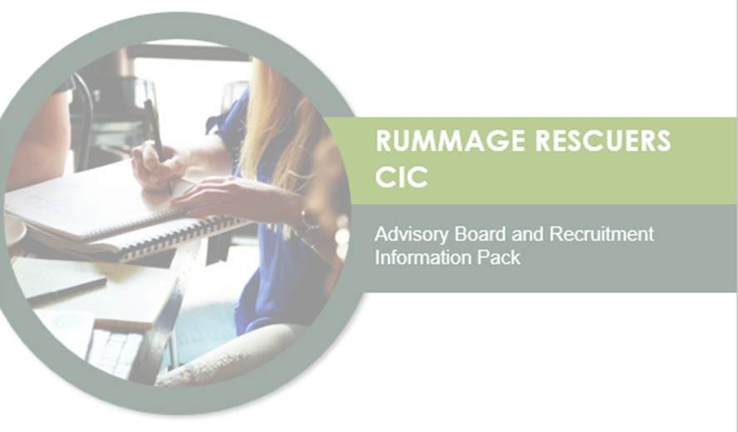
Rummage Rescuers CIC is looking to recruit 6 people to become members of the Board, including 2 volunteer members, and 4 other people with relevant skill sets and knowledge from living and working in the local community. We aim to recruit a range of different backgrounds. This is an exciting opportunity to become involved as Rummage Rescuers looks to consolidate services developed in recent years and plan next steps. We need board members from a wide range of backgrounds and with a mix of skill sets to advise the founder and Managing Director, Liz Crook, and help steer the organisation.

This pack provides details of the Board membership recruitment, contains further background information on the position and details about how to apply. If you would like further information, please contact Liz Crook on 07956120788 or e-mail at info@rummagerescuers.org.uk

RESPONSIBILITIES
The key responsibility of Rummage Rescuers CIC Board members is to prepare for and attend Board meetings. These occur quarterly in public, and last approximately 2 hours plus travel. In addition, special meetings may be called for specific reasons and board members may be consulted outside meetings as required. Meetings will be held in Blackburn. Meeting times and venues will be agreed by members to enable best possible attendance and participation and may be subject to change during the year.
Attend at least 75% of board meetings
Prepare for meetings by reading reports, board papers and other documents
Work with the chair and board members to establish codes of governance

Ensure Rummage Rescuer activities reflect the needs of local communities
Uphold and promote the Rummage Rescuers Code of Conduct
Help develop Rummage Rescuers business plan

Be positive representing the board
Monitor and comment on service delivery and budgetary performance
Undertake relevant training as identified by the board

Promote, enhance, and uphold Rummage Rescuers’ reputation and work
Represent Rummage Rescuers at external meetings and events
Participate in appropriate task groups as and when required

ABOUT RUMMAGE RESCUERS
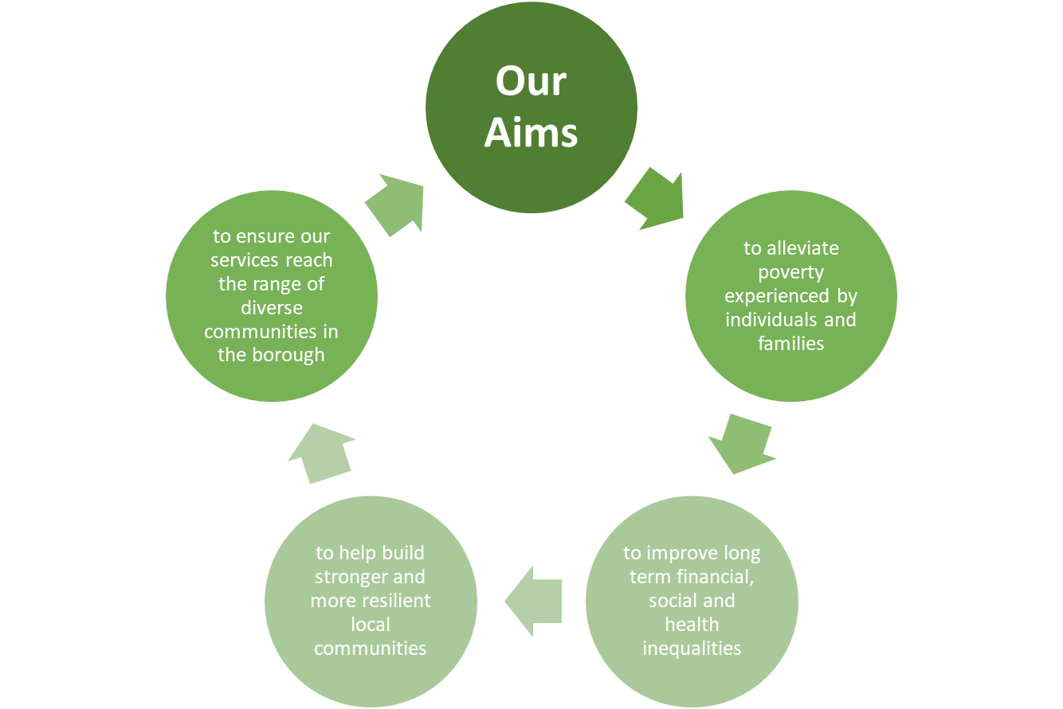

Rummage Rescuers was founded in 2015 and is a community based non-profit organisation aimed at alleviating poverty in the local area through collaborative working partnerships. The organisation is run by a dedicated team of volunteers and is based over several sites; town centre retail and book shops; a local community shop (purposely located to meet the local needs of the community) and two furniture warehouses based within the heart of the Blackburn and Darwen community. Volunteers are supported by a small number of part time staff at the shops and warehouse, and van driver (for furniture delivery and collection). The Managing Director is supported by a finance manager /company secretary.

Rummage Rescuers receives donations of furniture, white goods, general household items and clothing and provides service users, many of whom are excluded from mainstream housing, with good quality affordable furniture packages at below market prices with reduced delivery costs. Some of these goods are provided to support service users through the Blackburn with Darwen Community Care Grant Scheme by way of a Voucher System where the voucher is exchanged for household goods and items.

In addition to the vouchers, a Pound Pending scheme is offered from a donated fund; this enables families or individuals in great need to access ‘free of charge’ furniture, household goods and clothing of their choice from any of the 3 sites. To overcome the stigmatisation of people living in poverty the individuals are given full control to choose their much-needed items. Rummage Rescuers aim to raise the skill levels of our volunteers in the community running the services, expanding the capacity to grow and further develop the services provided.
This will meet the needs of those in poverty throughout Blackburn with Darwen Borough, for affordable furniture, household goods, and clothing; and enable volunteers and service users to move-on to a wider range of training, and employment opportunities.

COMMUNITY LEAD
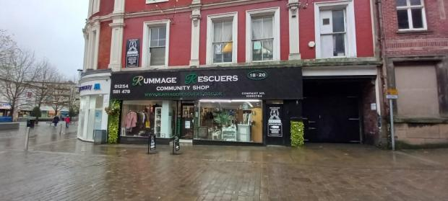
Rummage Rescuers services originate and have been developed by groups of individuals in the local community, starting in the Mill Hill area and expanding within other Blackburn neighbourhoods. The Board includes local people within these communities, and offers a range of experience and skills, further enhancing connectivity with the community. Unlike other providers, the core workforce of Rummage Rescuers are volunteers from the local community.

The local shops and warehouse are embedded in the community, led by local volunteers. The shop and warehouse managers have volunteer staff meetings every week to ensure that they have a say in how the shops and warehouse are run. With the support and enhanced training opportunities provided by the Volunteer Co-ordinator, volunteers will be empowered to have an even bigger role in the running of the business.
All volunteers are highly involved in business development and decision making, so are the community, via staff meetings supervision and social media platforms – information and data is collected and reported back to the board, so all are included in decision making.
Volunteers can use the work experience as a basis for accessing training and employment. The Volunteer Co-ordinator will forge links with local training providers, enabling volunteers to access skills and knowledge, developing their potential within Rummage Rescuers, and enabling access to wider employment. This further training will be provided by Blackburn with Darwen online Training portal, Community Voluntary Services free training seminars and Blackburn with Darwen Adult learning.
The services are accessible to local people in need via social and community networks. Referrals are made by any community member, so they feel they are contributing to the well-being of individuals/community members. Rummage rescuers have social media platforms for making referrals and signposting to other services, dedicated phone-lines and websites which all have open communication channels 24/7. Rummage Rescuers has created a “trusted” brand within the communities, and this is highly valuable in these difficult times. Community services and statutory services all sign- post people to Rummage Rescuers for help.
Household items can be provided for free or at nominal cost, reaching all those in need within the community.
WORKING WITH OTHERS
Rummage Rescuers also generates cohesion within the wider community in Blackburn with Darwen as local people donate financially and via donations of household goods and furniture. It is essential that the community remains in the lead as Rummage Rescuers consolidates and grows and develops.
As well as accepting self-referrals from within the local community Rummage Rescuers also works closely with a range of public agencies in supporting people in need locally including the Council's Adult Social Services, Safeguarding, Homelessness and Community Care Grant services, and Lancashire Probation Trust. Referrals are also taken from other local voluntary sector organisations including Care Network Hub, MEAM (Making Every Adult Matter) which supports the most chaotic and vulnerable people locally, and the Foodbank.

In some cases, people accessing Rummage Rescuers services are not receiving support or service from agencies, and referrals are made to the relevant agencies including Housing Needs/Homelessness, Credit Union, DWP/Job Centre, Adult Social Services, Carers Service, Foodbank, and Blackburn Vineyard Church (supplying baby and young children’s clothes and equipment to low-income families in need). Over 100 referrals per year of this sort are made. As needed Rummage Rescuers advises staff of public agencies of the full range of support and services available from the voluntary sector, so they are enabled to signpost people directly to what is available.
Rummage Rescuers services are particularly valuable in resettling vulnerable people and moving them from temporary to permanent accommodation. Rummage Rescuers also provides clothes and sleeping bags for rough sleepers and has proposed the project to identify them and provide initial community support.
Rummage Rescuers accepts volunteer placements e.g., from Department of Work and Pensions, Lancashire Probation Trust, Blackburn Rovers Community Trust, and Blackburn College of Higher Education. Volunteering placements equip people with skills, work experience and confidence.

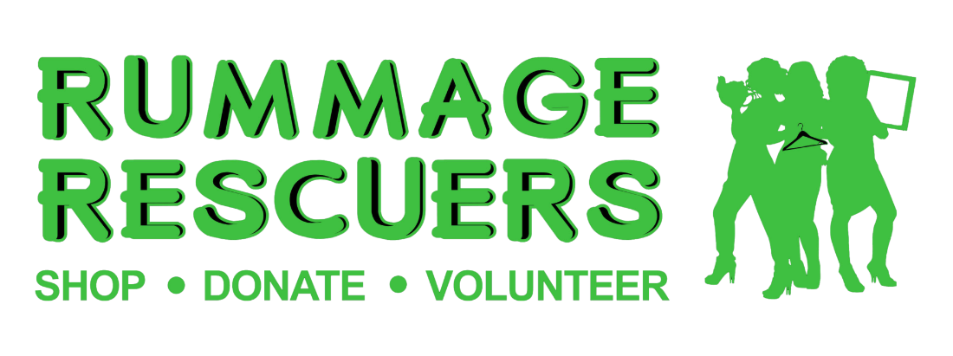
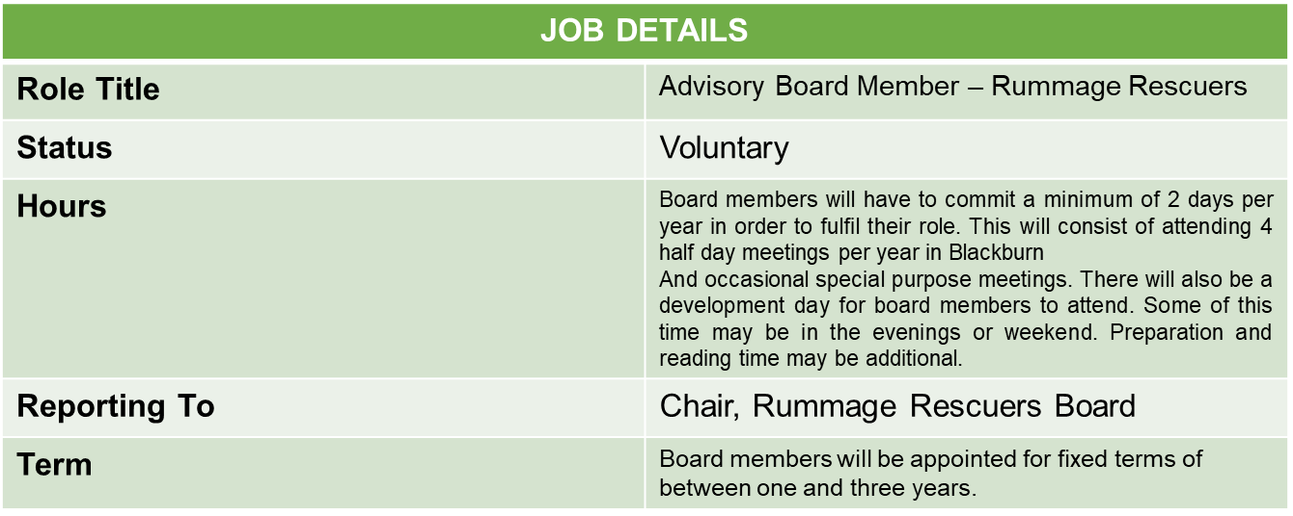

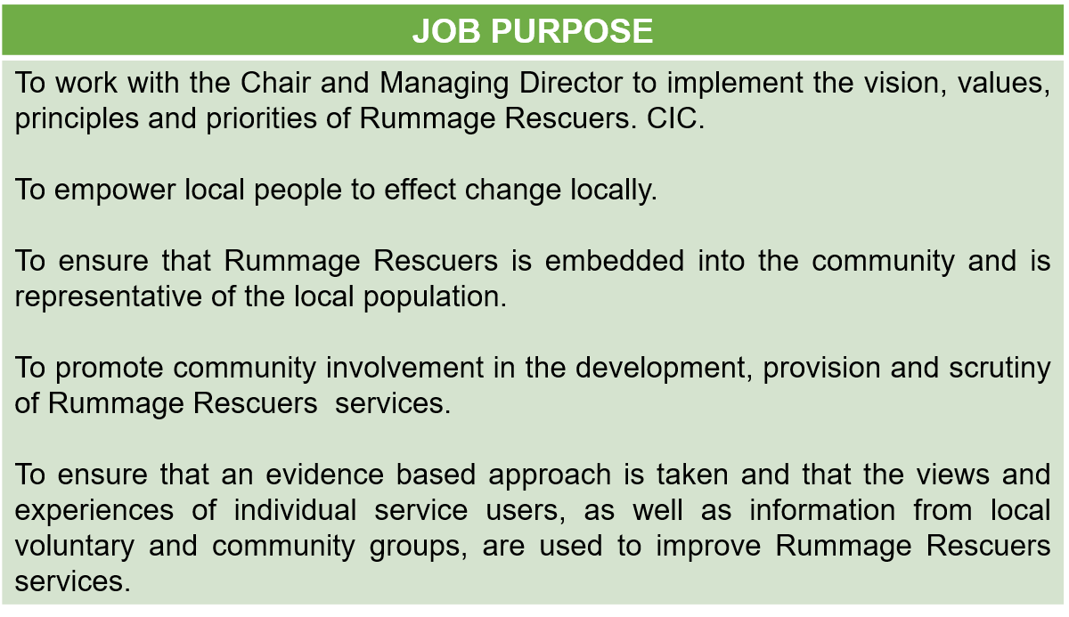

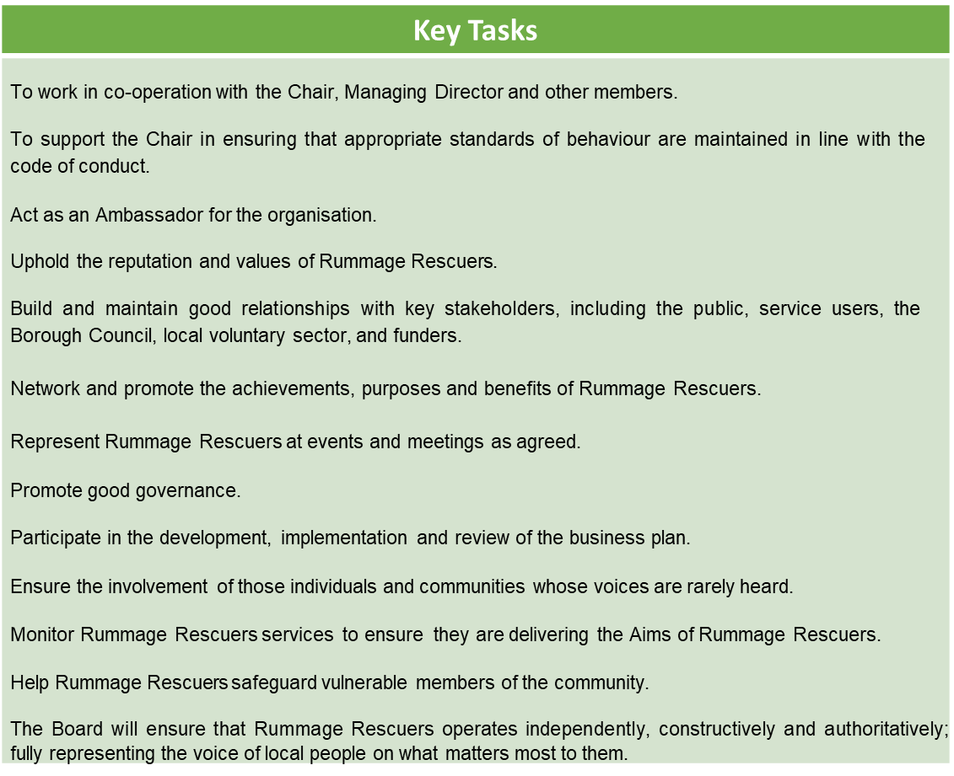
SUPPORT AND TRAINING
Board members will receive induction training, along with further training and support throughout their appointment to enable them to fulfil their role to the best of their abilities.
Members will be expected to commit to undertaking training during their time on the Board.
There will be a system of regular review and support for all board members to ensure that the Board performs to the highest standards.
CODE OF CONDUCT
Members should not place themselves in situations where their honesty and integrity may be questioned, should not behave improperly and should on all occasions avoid the appearance of such behaviour.
Members should offer advice and make decisions on merit.
Members should be accountable to the public for their actions and the way they carry out their responsibilities and should co-operate fully and honestly with any scrutiny processes.
Members may take account of the views of others but should reach their own conclusions on the issues before them and act in accordance with Rummage Rescuers business and work plans.
Members should respect the impartiality and integrity of the Rummage Rescuers staff team. Members should uphold the law on all occasions.
Members should do whatever they are able to ensure that resources are allocated prudently and in accordance with the law.
Members should act in a way that secures or preserves public confidence.
Members should be aware of their roles and responsibilities, and work in accordance with both to the best of their abilities.
A member may be asked to stand down if they are seriously failing in their role or in violation of this code of conduct.
A member must not use or attempt to use their position improperly to confer on or secure for themselves or any other person an advantage or disadvantage.
Members should identify individual learning and development needs and participate fully in training opportunities provided.
Members should be open in all decision making and be prepared to give reasons for their decisions.
NOLAN PRINCIPLES
Selflessness – Holders of public office should act solely in terms of public interest. They should not do so to gain financial or other benefits for themselves, their family or friends.
Integrity – Holders of public office should not place themselves under any financial or other obligation to outside individuals or organisations that might seek to influence them in the performance of their official duties.
Objectivity – In carrying out public business, including making public appointments, awarding contracts, or recommending individuals for rewards and benefits, holders should make choices on merit.
Accountability – Holders of public office are accountable for their decisions and actions to the public and must submit themselves to whatever scrutiny is appropriate for their office.
Openness – Holders of public office should be as open as possible about all the decisions and actions they take. They should give reasons for their decisions and restrict information only when the wider public interest clearly demands.
Honesty – Holders of public office have a duty to declare any private interest relating to their public duties and to take steps to resolve any conflicts arising in a way that protects the public interest.
Leadership – Holders of public office should promote and support those principles by leadership and example.

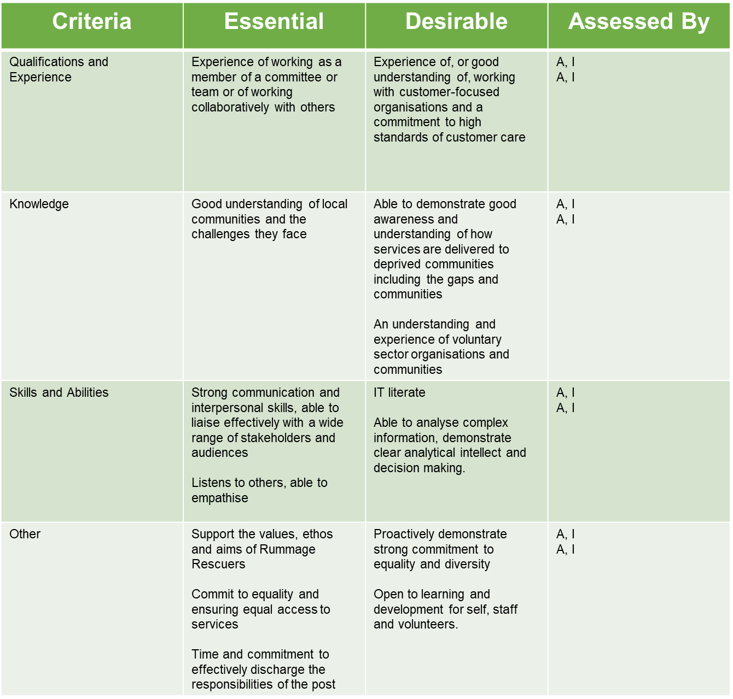
PERSON SPECIFICATION

If you have any questions or would like further information, please contact us in one of the following ways:
Telephone: Liz Crook on 07956120788
To apply please complete the enclosed application form and send it to: info@rummagerescuers.org.uk
or post to:
Managing Director, Rummage Rescuers, Unit 6 Harrison Street, Whalley Banks, BB2 1NR

