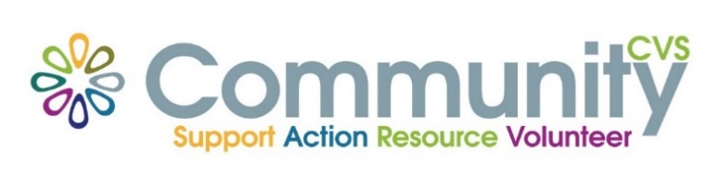

Community CVS
Network Meeting
Thursday 24th February 2022
9:30am – 11:30am
The Conference Room, The Boulevard Centre 45 Railway Road Blackburn
BB1 1EZ
Agenda
9.30am Introductions
09:45am Presentation from Mary Manning from Rummage Rescuers
10:00am Presentation from Clare Rigby from In-partnership Project
10:15am Presentation from Leanne Proctor from The Billy Project
10.30am Update from Shamim Razaq from Blackburn College – IT Students needing placements - social media etc
10:45am AOB & Networking
Date of Next Meeting Thursday 24th March 2022
for more information please contact Donna Talbot 01254 583957
donna.talbot@CommunityCVS.org.uk

