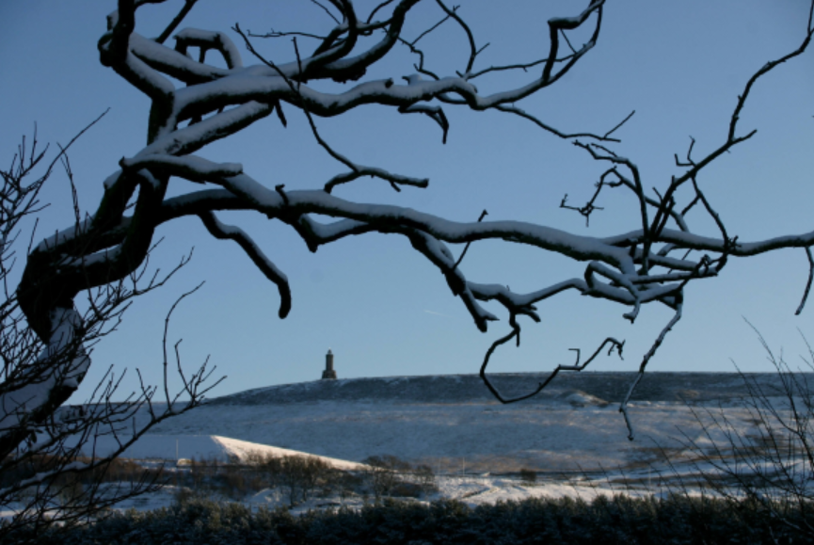

Blackburn with Darwen Community and Voluntary Sector

Winter Planning

Winter Planning - Severe Weather

The cold weather plan for England
This plan helps prevent the major avoidable effects on health during periods of cold weather in England and remains unchanged for winter 2020 to 2021. Additional actions may be needed due to COVID-19. The cold weather plan can be found on the gov.uk website alongside other useful documents. The cold weather plan is accompanied by the Cold Weather Alert Service, commissioned by the UK Health Security Agency (UKHSA) and operated by the Met Office.

The following action cards help to reduce the risks to health from severe cold weather:

Action Cards

Level 0 - Long-term planning

All year
- Work with partners to agree how the community and voluntary sector can contribute to the local community resilience arrangements
- Develop a checklist to:
  - identify those most at risk from seasonal variations
  - assess the impact severe weather might have on the provision and use of usual community venues
  - agree support/resources/training to maximise effective use of volunteers
  - support recruitment of volunteers
  - agree mechanisms for distributing food, fuel, emergency heating, health, social care and other provision to vulnerable people
  - ensure a local, joined-up programme is in place to support improved housing, heating and insulation, including uptake of energy-efficient, low-carbon solutions
- Agree arrangements with other community groups to maximise contact with vulnerable people
- Identify available services for vulnerable people and agree signposting arrangements with providers
- Work with partners and staff on risk reduction awareness (e.g. flu vaccination for staff in September/October), information and education.
- Follow COVID-19 guidance
- Sign your organisation up to Severe Weather alerts via the Met Office - https://www.metoffice.gov.uk/weather/warnings-and-advice/uk-warnings#?date=2021-10-27
- Check weather travel advice from Met Office https://www.metoffice.gov.uk/weather/warnings-and-advice/seasonal-advice/travel

Level 1 - Winter preparedness and action

1 November - 31 March
- Communicate public health media messages (re-tweet/share on Facebook etc)
- Set up rotas of willing volunteers to check on vulnerable people and neighbours
- Support the provision of appropriate advice about the health risks of cold weather/cold housing, especially with vulnerable people
- Ensure that your organisation has a ‘business’ continuity plan for severe winter weather to ensure support can continue to be given to vulnerable people
- Make sure emergency contacts are up to date
- Ensure that pavements and public walkways are cleared of snow and ice in the local community*

*Clear snow from a road, path or cycleway - GOV.UK (www.gov.uk)

Level 2 - Severe winter weather is forecast

Alert and readiness
Mean temperature of 2°C and/or widespread ice and heavy snow are predicted within 48 hours, with 60% confidence

- Continue to communicate public health media messages
- Engage with Local Authority to liaise with Adult Social Care/Neighbourhoods Teams to support the vulnerable community
- Actively engage vulnerable people known to be at risk and check on welfare regularly.
- Activate your ‘business’ continuity plan

The cold weather plan for England remains unchanged for winter 2020 to 2021. Additional COVID-19 resources are available on the collection page.

The cold weather plan is accompanied by the Cold Weather Alert Service, commissioned by Public Health England and operated by the Met Office.

Level 3 - Response to severe winter weather

Severe cold weather action
Severe winter weather is now occurring: mean temperature 2°C or less and/or widespread ice and heavy snow

- Continue to communicate public health media message
- Contact vulnerable people at risk to ensure they are safe and well
- Ensure volunteers are appropriately supported
- Implement your ‘business’ continuity plan

Level 4 - Major incident

Emergency response
Central Government will declare a Level 4 alert in the event of severe or prolonged cold weather affecting sectors other than health

- Continue level 3 actions during a Level 4 alert, unless advised to the contrary
- Implementation of national emergency response arrangements by central government
- Ensure volunteers are appropriately supported

Winter Planning Checklist

Property | Servicing &  maintenance date | Comments
Carry out Building risk assessments and implement safe working procedures.
Increase the frequency of property inspections (internally and Externally) to make sure there are no problems and identify any issues early
Heating system – check and service regularly
Plumbing (internal and External) – check regularly
Electrics - check and service regularly
Electrical appliances and equipment – ensure all electrical appliances and equipment is PAT tested.
Provide adequate outside lighting
Grit and salt – for pathways and car parks (including removing wet and decaying leaves).
Cleanliness of communal areas – are they clean and dry
- storage for wet umbrellas
- storage for wet coats and boots
- provision of a warm area for rest breaks for those working outdoors

Vehicles | Servicing &  maintenance date | Comments
Make sure all vehicles are regularly serviced as often as the manufacturer recommends, and have an up-to-date MOT (if required)
Prepare vehicles before journeys, including any additional equipment that might be needed, and explaining any actions to take in an emergency or breakdown situation.
e.g. keep a blanket / bottle of water/flask of hot drink/snow shovel / high viz tabard
Consider developing a ‘winter driving policy’. This should include the central question of whether the journey needs to be made during adverse weather conditions and, if it does, what actions can be taken to make it as safe as possible e.g. altering schedules, providing more time to make appointments so employees can drive at safe speed etc.
Review Met Office – safe driving –travel advice above

Staff | Staff briefed /  Picked up by whom | Comments / Follow up / Contingency
Regular meetings to prioritise workloads / system or service issues.
Consider the recruitment, development and retention of staff over the winter months (Develop a system that is able to utilise staff to support a resilient system)
Identify critical functions and prioritisation of services / functions to be agreed.
Put Rotas in place / consider Out of Hours provision. (Fewer issues for staffing rotas over winter period / over Christmas period)
Ensure all your staff are aware of the strategies so they know what is expected of them and what they need to do if they are unable to make it into the office / work because of the weather.
Ensure all your staff are aware of the staff sickness policy - communicate absence promptly
Review and update your business continuity plan – make sure everyone is aware of the plan and escalation procedures.
- What to do if you have a lot of staff off at the same time
- What to do if the power goes off to your main building(s)
- What to do if you lose your IT connections etc
- What to do if you lose access to your buildings
Put together a ‘battle box’ containing important documents and items to keep your business running, in case you have to relocate with little or no notice
Inform staff how to access weather warnings and travel advice - see links above.
- Discuss travel routes with staff
Can staff work remotely from home
Do staff have access to IT equipment (laptop, screen, mouse, keyboard )/ internet /company servers / work software / telephone /mobile phone
Consider data security e.g. cyberattack or a data breach.
Lone working – provision of a mobile phone / torch / warm clothing / provide suitable personal protective equipment (PPE) / educate workers about recognising the early symptoms of cold stress.
Promote flu vaccination for all staff
Staff to be reminded of procedure for self-isolation and testing for COVID-19 and the need to stay away from the workplace for 48 hours after episodes of diarrhoea and vomiting.

Partners / Contractors | Picked up by whom | Comments / Follow up / Contingency
Check that all partners / contractors have Business Continuity Plans / contingency plans in place

If an incident occurs
If an incident should occur, make sure the incident has been recorded in line with your Health & Safety policy.
This will help determine what occurred and will help if / when submitting a claim.
Photograph the incident scene with a digital camera. Capture the exact area where the incident occurred — such as on a step, concrete slab or pavement, and the area leading up to the spot of the incident.

