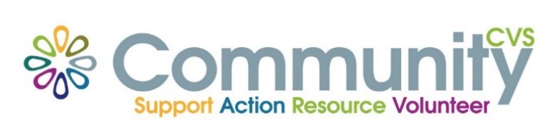

Community CVS
Network Meeting
Thursday 25th November 2021
9:30am – 11:30am
The Conference Room, The Boulevard Centre 45 Railway Road Blackburn
BB1 1EZ
Agenda
9.30am Introductions
9:45am Presentation from Joanne Lever from CANW
10.00am Presentation from Louise Whiteside from Lancs Women
10:15am Presentation from Kathryn Creech from Re:fresh
10:30am Presentation from Hannah from Hope for Justice
10:45am Presentation from Mischa Russell from ELHT Breast Feeding Support
Date of Next Meeting Thursday 27th January 2022
for more information please contact Donna Talbot 01254 583957
donna.talbot@CommunityCVS.org.uk

