Book HARRI
HARRI is also available to attend health events and campaigns. It is the perfect vehicle to promote the local services to a wide audience in just a few hours, allowing services to highlight their initiatives, raise awareness and discuss concerns. If you would like to hire HARRI for your next event, please get in touch for availability.
Venue/Event | Date | Times
Lancaster Musuem Market St, St Nicholas Arcades, Lancaster LA1 1HT | Tues 2nd Nov | 10:00 – 3:00
Army Weeton Barracks Preston PR4 3JQ | Weds 3rd Nov | 10:00 – 3:00
Hesketh Bank Community Station Road Hesketh Bank Preston PR4 6SR | Thurs 4th Nov | 09:30 – 2:00
Woodland Suite Ribby Hall Ribby Road Kirkham PR4 2PR | Sat 6th Nov | 09:30 – 4:30
Barrow venue TBC | Mon 8th Nov | 10:00 – 5:00
Flag Market 4 Cheapside, Preston PR1 2AP | Tues 9th Nov | 10:00 – 6:00
Morecambe Library Morecambe  LA4 5DL | Mon 15th Nov | 10:00 – 3:00
Layton Institute30 Westcilffe Drive  Blackpool FY3 7HG | Fri 19th Nov | 11:00 – 3:00
Longton health centre Liverpool Rd, Longton, Preston PR4 5HA | Sat 20th Nov | 10:00 – 3:00
Booths Carnforth Scotland Road  Carnforth LA59JZ | Mon 22nd Nov | 10:00 – 3:00
Nelson morrison Pendle St, Nelson BB9 7UZ | Fri 26th Nov | 10:00 – 3:00
Blackpool Carers Centre, Beaverbrooks House, 147 Newton Drive, Blackpool FY3 8LZ | Sat 27th Nov | 12:00 – 2:00

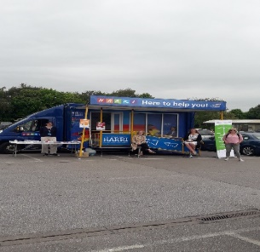
 Call us on 01772 695 365 to speak to one of our friendly support team
 Email us at HARRI@lscft.nhs.uk
@HARRILSCFT
@LancashireCare

