What is the Harnessing Diversity Grant Fund?
We have put aside a modest sum, per annum, to fund small community activity/projects to promote diversity and community cohesion within Together Housing Group’s or Pendleton Together’s operating area.

The fund is open to residents, staff and members of the community. The minimum amount you can apply for is £100 and the maximum is £1,000. We can allocate no more than £10,000 of grant per year.

Who can apply?
Any group or organisation that operate and/or deliver projects within Together Housing’s or Pendleton Together’s area. Together Housing Group staff members who are not part of a formally constituted group can also apply.
For external groups/organisations the following the following criteria apply:
- The group is constituted and/or has agreed terms of reference
- Can demonstrate compliance with statutory requirements e.g. Disclosure Barring Service (DBS) for work with children etc.
- If the group or organisation is based outside of Together Housing/Pendleton Together’s operating area then they will have to provide evidence of work in or to the benefit of the area and/or our customers.

Priorities
Projects must meet at least one of the priorities and aim to make a real difference to the group/organisation and/or the wider community:
- People – Activities and projects which bring people together from different backgrounds, ages, and neighbourhoods;
- Diversity – Activities which celebrate the rich diversity of the communities in which we operate e.g. local festivals or celebrations; and
- Partnerships – Activities which encourage partnerships between Together Housing and various minority groups e.g. Black and Minority Ethnic (BAME), disabled or Lesbian, Gay, Bisexual and Transgender (LGBT+).

What we will not fund
- Organisations or activities that support a political party or political policies
- To meet debts or liabilities
- Funding in retrospective i.e. when the activity has taken place, before funding has been awarded
- Statutory functions of public organisations e.g. Local Authority, Police etc. Note that work with the community may be considered
- Individuals or individual projects: funding is only available to groups but if a Group isn’t constituted and has a bank account then we will work with them to establish how the money will be managed.
- Organisations or individuals who we do not believe meet the Together Housing’s corporate objectives or values.

Step-by-Step guide to completing the application form
- We do not want the process of applying to be overly complicated, however, here’s is a list of the information you will need before starting the application procedure:
- Standard contact details
- A name for your project, a date or timescale you expect it to be in place and an outline of your idea/project e.g. How did the project come about, what the project will do, who will be involved and what outcome you expect
- Choose one or more of the priorities – people, diversity or partnership. You must demonstrate how it will meet the chosen priority – e.g. you should consider how it will maximize the benefit to the group/organisation and/or the wider community
- Please state which specific neighbourhood area(s) will be included and/or benefit
- Give information about which age group(s) you will engage or involve in your project
- Please tell us how much grant you are applying for and the total cost of the project. Give a breakdown of the items you will spend the grant on and include any funding your group/organisation is contributing, any other funds you are applying for or have secured from other potential funders.
- Give a start and completion date and be as realistic as possible. Do not put a start date within a month of your submission of your proposal, this will enable the panel to consider and make a decision. All applicants will be informed of the decision whether your project is successful or unsuccessful.

Please provide as much details as you can. We will check your application and will contact you if we have any queries.

Your Obligations
In accepting a grant award, you are agreeing to:
- Provide feedback of 50 to 100 words, together with at least one photograph, on how your group/organisation has benefited from the funding.
- Give your permission to include this on our website – Together Housing https://www.togetherhousing.co.uk/ or via our social media. We may also promote the project to the press and media. We will talk to you about how we will use this information prior to it being used.

Contact details
Tahir Idris, Equality & Diversity Manager
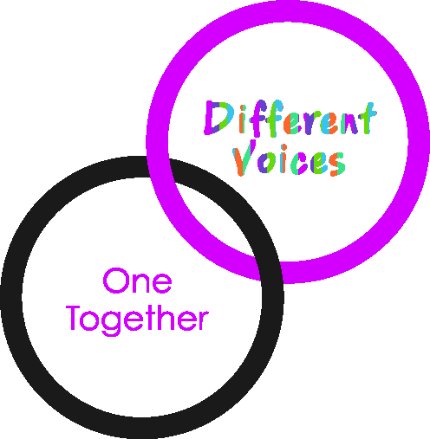
tahir.idris@togetherhousing.co.uk

This table to be completed by Assessor
Date received |  | Reference number
Decision |  | Date applicant advised of decision

- Name of Person completing form
- Address

- Telephone Number
- Email address
- Name of Group submitting bid
- Short description of your project –
- Provide a breakdown with estimated costs of what you will spend the grant on and when.
- Have you applied for/secured any match funding for this project? If so please tell us where from and how much?

- Location of Your Project
- Themes -Tick any of these themes which your bid fits in with
- How will your project :-

- Meet our criteria?

- Benefit the wider community?

- Establish good practice or long-term benefits?
Signature of person completing form
Date of application

Now submit to this form by email to tahir.idris@togetherhousing.co.uk

