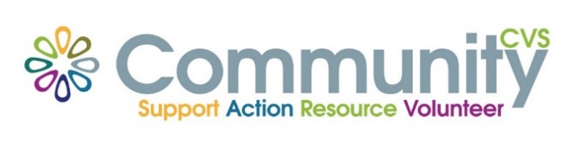

Community CVS
Network Meeting
Thursday 21st October 2021
9:30am – 11:30am
The Conference Room, The Boulevard Centre 45 Railway Road Blackburn
BB1 1EZ
Agenda
9.30am Introductions
09:45am Presentation from Gabrielle Aspin from Community Buds
10:00am Presentation from Chris Trickett from CVS
10.15am Presentation from Zaynab Jogee from Age UK
10:30am Presentation from Heather Hook from Kooth
10:45am Presentation from Hannah & Lily from Hope for Justice
11:00am AOB & Networking
Date of Next Meeting Thursday 25th November 2021
for more information please contact Donna Talbot 01254 583957
donna.talbot@CommunityCVS.org.uk

