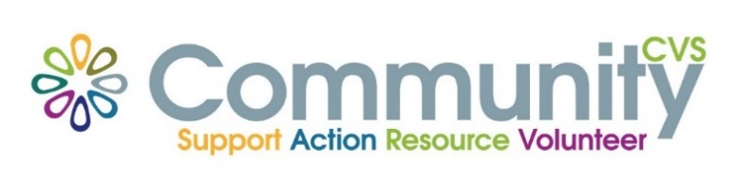

Community CVS
Network Meeting
Thursday 23rd September 2021
9:30am – 11:30am
The Conference Room, The Boulevard Centre 45 Railway Road Blackburn
BB1 1EZ
Agenda
9.30am Introductions
9:45am Presentation from Natalie White from Princes Trust
10:00am Presentation from Rebecca Billington from Sightline
10.15am Presentation from Dilwara Ali from Bwd Healthy Living
10:30am Presentation from Ian Cran from Blackburn College
10:45am Presentation from Denise Cottam from Albion Mill
11:00am Presentation from Amanda Greenhalgh from Public Health
11:15am AOB & Networking
Date of Next Meeting Thursday 21st October 2021
for more information please contact Donna Talbot 01254 583957
donna.talbot@CommunityCVS.org.uk

