Minutes of the Community CVS Network Meeting
Thursday 17th June 2021

Attendees:
Donna Talbot – Community CVS - donna.talbot@communitycvs.org.uk
Mimi El – Khattam - Our Lancashire - omaima.el-khattam@lancashire.police.uk
Kiran Sadiq – BwD Carers - Kiran.Sadiq@bwdcarers.org.uk
Callam Barnes – Community CVS – callam.barnes@communitycvs.org.uk
Lisa Rawcliffe – NWAA – lisa.rawcliffe@nwaa.net
Amanda Fletcher – Nightsafe - amanda.fletcher@nightsafe.org
Chris Bell – Mind - ChristopherBell@lancashiremind.org.uk
Zoe Alimeri – ICANN - zoea@i-cann.org.uk
Rachel Davies – Together Housing - Rachel.Davies@togetherhousing.co.uk
Davy Bayliff – Active Lancashire - dbayliff@activelancashire.org.uk
Alan Kenyon – Active Lancashire akenyon@activelancashire.org.uk
Bhawna Patel – BwD Adult Learning - bhawna.patel@blackburn.gov.uk
Hannah Mitchel -Hope for Justice - hannah.mitchell@hopeforjustice.org
James Lannon – BwD Community Connector - James.Lannon@blackburn.gov.uk
Asia Malik – Blackburn College - Asia.Malik@blackburn.ac.uk
Lilyana – Hope for Justice - lilyana.slavova@hopeforjustice.org

Apologies: Tracy Davies – BwD BC, Maggie Asquith – Lancs & South Cumbria ICS, Bev Marsden – Lancashire Women, Tayyibah Masood – Positive Smiles, Sheralee Turner- Birchall – Blackburn Foodbank, Dilwara Ali – BwD Healthy Living, Gail Barton – Our Lancashire, Shen Mulla -Humraaz, Aggie Kwiecien – Polish Support

Presentation Callam Barnes -Upskilling Project Community CVS
- The new upskilling project @ Community CVS is all about future proofing charities and SME’s that provide predominantly health and social care services
- This means basically any organisation who contributes to the health and well being of the community will qualify
- The offer is for professional and organisational upskilling – we offer accredited and non-accredited courses for keyworkers through to management
- We offer all different levels of courses upto Level 5
- We have a long list of courses available for keyworkers from Level 3 onwards – substance misuse/public health/ customer service
- Our main focus is to upskill the workforce within the voluntary, community, faith and social enterprise sector, but we can also support GP practices, care homes and other organisations operating in the private sector within the health economy.
- We will come and have a look at your organisation and identify and skills gaps – in the third sector there are a number of people who have been promoted because they have done a good job however they don’t always have all the skills needed to fulfil their new role – that’s where we can help
- The Criteria :
  - SME under 250 staff
  - All individuals must be employed
  - Less than £200 million funding in the last year
  - Less than £50 million turnover
Upskilling the Health & Social Care Workforce Project – Community CVS

Presentation Zoe Alimeri – ICANN Advocacy
- We are based in Penwortham in Preston however we cover the whole of Lancashire and we also work in Blackburn with Darwen
- We offer Welfare and Benefits Advocacy – we support clients who need to attend tribunals and assessments
- We offer support to those dealing with Child protection issues
- We work in Lancashire but we can offer our services further afield – there would be a charge for these services (£50 per hour)
- In Blackburn with Darwen we work in partnership with Shelter – Shelter help clients complete the relevant forms then they refer to us and we attend the meetings/assessments with the clients
- Referral can be done by an individual however we do take professional referrals
- We offer training around – Benefit Awareness/mental health/completing forms
- We also ran a telephone befriending service during Covid – all over Lancashire at the moment we can only offer this service in Preston due to the funding coming to an end, we are looking for additional funding so we can continue to offer this service
- We also train medical students from UCLAN we help them to complete the DS1500 form which entitles someone with a terminal illness to benefits,
- We also train social worker students on advocacy
- We currently have 10 members of staff and lots of volunteers but we are always looking for funding to secure our service and expand

Independent Community Advocacy Network North (i-cann.net)

Presentation Asia Malik – Blackburn College
- I work as a placement co-ordinator at Blackburn College – my role is to source good quality work placements for our students
- I work primarily with business/A level and Engineering Students
- We currently offer a new qualification a T Level which is the equivalent to 3 A levels and includes an industry placement
- Placements are really beneficial to students studying certain topics as they can experience the practical and put what they have learnt into practice
- We will engage with any employer we liaise with different colleges
- We are also looking for professionals to come along and talk to the students about your roles and projects
Q: Are the work placements Assessed?
A: No – with the extended placements for the T Level there will be 3 reviews over the course of the placement however with the one-week placement there are no reviews
Q: Does this include Health and Social Care students and could they travel to Preston?
A: Yes and if they have the means to travel, absolutely -Yes
Q; If the organisation is still predominantly working from home can the students do a digital/virtual work experience?
A: Yes that could work – however GDPR and data protection would have to be considered
https://www.blackburn.ac.uk/work-placements-for-employers/

Presentation Bhawna Patel – BwD Adult Learning
- We engage with all learners who are looking to build their confidence at the beginning of their journey
- We offer Employability and bespoke courses
- We have a brochure for term time courses
- Courses are free to learners 19+
- We offer digital ICT – to build confidence with zoom, shopping online, teams etc
- If clients are struggling with equipment we can lend them the necessary equipment
- If clients are equally struggling with WIFI – we can help find a solution dependant on eligibility
- We are here to support residents of Blackburn with Darwen
- Digital Buddies – Covid has forced many things online and not everyone has the skills so the digital buddies are there to hand hold until the clients are confident with ICT
- During Covid we have offered online learning
  - Employability
  - Customer Service
  - Health and social care
  - Infection control
- In the Autumn we will be offering Level 2 courses
- We can offer bespoke courses to organisations – if you have an idea just contact me
- We offer Functional Skills – English and Maths – both level 1 & 2
- ESOL classes are available
- We now offer family learning online
- Positive Minds Courses are available for those who are not well mentally and allows them to partake in courses where they feel safe
- We also offer a volunteering training pack
Q: What criteria has to be met for people to access the courses?
A; 19 + historically you had to earn less than £16,000, receive benefits – however with the pandemic we haven’t been as stringent
Q; Is there an E version of the brochure?
A; Yes, I will send it to Donna and ask her to circulate it
Q: Are the courses exclusive to BwD?
A: Yes this is due to funding
Adult Learning Courses in Blackburn with Darwen (bwdlearning.org)

Presentation form Lilyana Slavova & Hannah Mitchell – Hope for Justice
- We are a global charity and our mission is to end modern slavery
- We offer advocacy and training
- We have just received funding for a new Hub in Lancs
- We work with:
  - Police
  - Local Councils
  - Volunteers
  - Charities
  - DWP
- To offer protection to vulnerable people who are open to exploitation
- We meet up with clients and have a chat, give advice on their rights, entitlements, sign post to health services, advocacy etc
- We offer fully funded training across Lancs to staff and volunteers for people working with vulnerable adults
- We teach you how to look for signs of slavery and exploitation
- How to respond to exploitation – appropriately
- We can offer remote training – if covid restrictions lift we will be able to offer live training
- The course is 2 hours long
- We need a minimum of 12 people and a max of 30
- Smaller organisations could come together for training sessions

Change lives. End slavery. | Hope for Justice

Presentation from Rachel Davies – Together Housing
- We are currently delivering energy redress
- This is a fund that has been pulled together for households experiencing fuel poverty
- They can access vouchers for gas and electricity – there is a maximum they can have – 3 vouchers per utility per household
- For Single people - £35 and for Families - £49
- Criteria for the vouchers
- People claiming need to disclose if they have already received the vouchers elsewhere – we need them to be honest and transparent
- Referral through a 3rd party – we do struggle with private renting
- Prepayment meters – with a top up key or card
- Referral forms ( donna will send these out)
- If you start the referral form but do not manage to collate all the evidence – don’t worry – send it through to us and we will do all the chasing
- Covid – anyone impacted by Covid – home schooling, working from home – increase in fuel needed – referrals don’t necessarily need to be in debt – just struggling to afford fuel
- This project isn’t just Lancs wide we work as far as Yorkshire
- We have 3000 vouchers – this round of funding finishes in August

Q: will you email referral form?
A:Yes, I have sent it to Donna and she will send it out

AOB
Corporation Park Bowling Open Day – Saturday 10th July

- We’d like to invite you to the Corporation Park Bowling Club Open Day on Saturday 10th July.
- The aim is to get more people aware of bowling as a great form of gentle exercise, social interaction and strategic thinking for mental and physical well-being for all ages and abilities.
- We also want to familiarize the local community with the space, location and activities of the Bowling Club and CPSG to help reduce antisocial behaviour and increase positive activities in this area of the park.
- There will be space on the community garden space for you both to have a pop-up gazebo or similar, if you have one, to promote activities.
- If you are interested please contact Nic

nic_bes@icloud.com

Virtual Work Experience – Maggie
- if you get chance can you ask if anyone is willing to support virtual work experience for year 10s at school in Accrington. I want to give them insight to working in VCFSE sector as career option. Would mean probably an hour of people's time shadowing on Teams etc. I'm trying to get a range of options/activities for w/b 28th June to 2nd July....
- If anyone can help - ping me.
margaret.asquith@nhs.net

Community Volunteer Awards
- Community Volunteer Awards 2021 have now been launched

- We are looking for Volunteer nominations – does your organisation have an amazing team of volunteers that deserve recognition?

- Good Neighbour nominations –If you know of anyone deserving acknowledgment for their wonderful deeds

- Community Involvement – If you know of any business that have gone above and beyond for your organisation, your local area?

- If so please nominate them today

- Please find attached a nomination form – simply complete and email back to me, please note that the deadline for nominations is 5:00pm Friday 27th August 2021

- All winners will be announced at a special evening of celebration On Wednesday 3rd November 2021 @ King Georges Hall (main Hall) from 6pm onwards. (invitation only)

- Everyone nominated will receive a signed certificate, all shortlisted nominees will receive an invitation to the ceremony, and all winners will receive a trophy.

- If you need any more info please do not hesitate to contact me on 01254 593857 or email me donna.talbot@communitycvs.org.uk

Community Volunteer Awards – Community CVS
“Action for Jobs”
- New project where we can offer support to anyone who is currently unemployed or economically inactive including those with long term health conditions.
- We have key workers ready and in place who can support people in-person on a face-to-face basis, close to where they live (or digitally if they prefer).
- The Action for Jobs Project consists of a 12-week programme of support for individuals who are unemployed/ economically inactive and wish to take steps towards;
- Finding employment
- Enrolling in Education and or formal training to improve their employability
- Moving from being economically inactive and out of the labour market to preparing and supporting them to actively search for work
- Our support is bespoke and tailored for each individual, appropriate for their circumstances, needs and goals. Participants will also be able to access additional group sessions of their choice, focusing on these specific support areas;
- For more information – you can contact Donna donna.talbot@cmmunityCVS.org.uk
- Please find attached a copy of our leaflet with the minutes

Community Wall
- Please do not forget we have the Community Wall in The Mall - so if you have any upcoming events/training you would like to promote?
- Are you looking for new volunteers?
- Are you delivering new services?
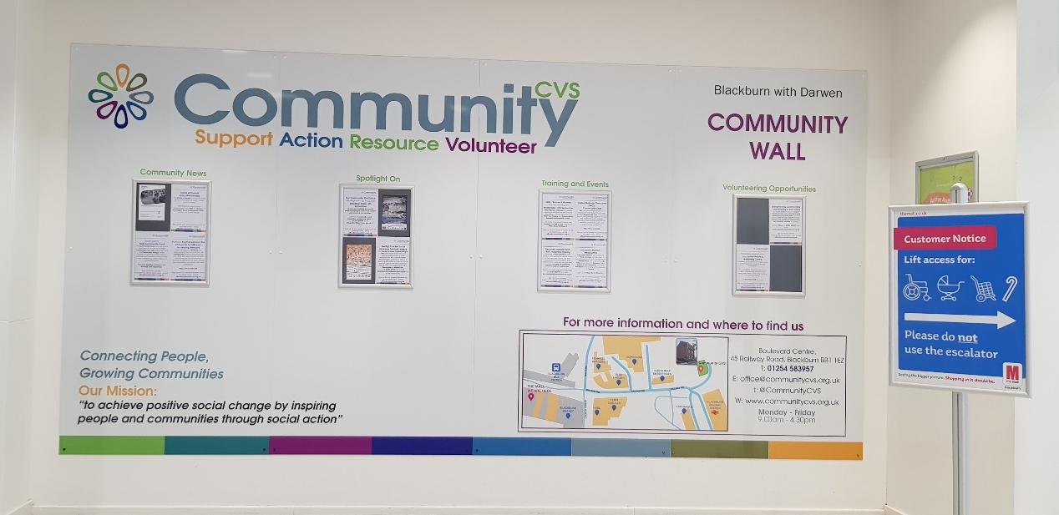
- If so please feel free to forward posters/leaflets to me and CVS will get the information on the new Community Wall in The Mall – Blackburn

Date of next Meeting
Thursday 22nd July 2021
9:00am – 11:00am
Via Zoom (invitation will be sent out)
For more info please contact Donna Talbot 01254 583957
Donna.talbot@communitycvs.org.uk

