Minutes of the Community CVS Network Meeting
Thursday 25th February 2021

Attendees: Donna Talbot – Community CVS, Maggie Asquith – ICS (Integrated Care Systems) Healthier Lancashire & South Cumbria, Lisa Rawcliffe – NWAA, Beverly Marsden – Lancashire Women, Sheralee Turner-Birchall – Blackburn Foodbank, Andrew Brown – Newground, Gail Barton – Our Lancashire, Mimi El – Khattam - Our Lancashire, Chrissie Spencer – BWD Borough Council, Kiran Sadiq – BwD Carers,
Apologies: Tracy Davies - BwD Borough Council, Jo Corbett – BwD Borough Council, Eloise Howarth – Inspira, Daniel Barry – Inspira,

Presentation Maggie Asquith – ICS ( Integrated Care System) Healthier Lancashire & South Cumbria
- I am currently working on a project to integrate volunteer services across Lancashire and South Cumbria – bringing together all sectors.
- Reduce boundaries – pathways project – focusing on Carers (unpaid) – we want to create an attractive pathway for carers from unpaid unskilled to employment
- The project is there to help the carers see their own potential – through their experiences of being a carer they have gained many skills – that they are not aware of
- By creating a clear pathway with wrap around support – many carers are not educated and have unfortunately never been in employment.
- The plan is to create training accompanied with a placement in a care home – ensuring a standardised level of values and skills
- The Care sector is a sector that is growing currently employing 46, 000 people – by 2035 this number will be double.
- We will be piloting this at Easter in Fleetwood and Blackpool
- If successful this will be carried out across – Domiciliary Care/Prisons
- Regulated care needs good motivated workers
- There will be a webinar presentation on Friday 26th February at 2pm – if you would like to join I will email Donna the invitation and she can send it out
- Secondly there is the workstream – Digital IT passport
- The idea behind this is that once a volunteer has been recruited and gone through the recruitment process – they can then go onto volunteer for other agencies without needing to go through the recruitment process all over again
- All info of recruitment will be held on a QR Code – similar to the project in Blackpool where they are creating a staff digital passport for all staff
- All info including DBS check – training all info will be collated in one place – similar to what LVP are implementing at the moment
- The pilot will be in Lancaster and Cumbria
- The whole project is based on a federation of trust – If I recruit a volunteer and then they come to volunteer with you – you need reassurance that all checks have been done and the volunteer has received appropriate/adequate training
- I will be holding a workshop on Tuesday 2nd March
- The idea behind the project is to reduce the cost of volunteer recruitment across all sectors – the potential barriers will be getting everyone on board
- There is a liaison between NHS Volunteers – National Scheme and ICS which is a local scheme
- There will be an evaluation piece of work – there will be 2 surveys – one for stakeholder volunteers and residents
- One collective voice – Adam Pearson who lives in Pendle is a great researcher who will be pulling all the info together
- So please if you can please take part in the survey
- In the past we held 4-5 volunteer manager sessions – which were very good, the volunteer managers were a mix of NHS, public sector and third sector
- We looked at things like – safer recruitment, many other topics and the idea was to learn together from each other
- We are looking to re-introduce these volunteer manager sessions – every month there will be a session on a different topic
- We need volunteer managers from the third sector – we have plenty from the NHS etc
- This collaboration could be useful in applying for funding etc
- The link will be sent out – I will send it to Donna – please come along and be part of it – share your info on the impact of the work you do, where you do it – how you do it
Q: What time will the meeting be on the 2nd of March?
A: 11am
Presentation from Beverly Marsden from Lancashire Women
- Raising Aspirations is in its first year and we have 2 more years of funding left
- We offer support to individuals from 14years plus we work with both females and males, we have 4 case workers, counsellors, group sessions
- We link in with 180 – they are commissioned to work with us and our clients – We have support sessions on a Tuesday and Thursday
- Its been proven that exercise is good for people’s mental health – our clients can access this service for free
- The exercise sessions are adapted for different levels of fitness, people’s different circumstances etc
- By changing the mind-set of the individual we try to encourage individuals to compete against themselves, strive to do better
- We look at how the individual can overcome their own barriers
- We offer outreach – so we meet up with our clients in cafes, parks etc – we build up a relationship in order to achieve the individual’s goals – there is no time frame, we work at the client’s pace
- Signing up to the project is not a fast track to access counselling services – these are in great demand
- Individuals can refer themselves or professionals can refer ( I will send the referral form to Donna and she can send it to you guys)
- We have a waiting list for the project at the moment somewhere between 6-12 weeks,
- We have a gym that is exclusive to women (many women feel uncomfortable training with me) which hopefully we will be able to access soon – however at the moment we are offering training sessions via zoom
- Many of the ladies have seen a massive increase in their training – initially completing the workout, then knocking time off – they surprise themselves with what they have achieved and its great to be part of that journey.
- We link into other services in the borough – Mind, CVS, Shelter etc – dependant on what the individual needs
Q: Working with young people 14 yrs. plus – is this just in BWD at the moment or is it available elsewhere?
A: At the moment just in BwD – but clearly there is a gap in services for 14 year plus so this may be something we look into developing
Presentation from Donna Talbot LOCAL project – Community CVS

- LOCAL – Locally Organised Communities Across Lancashire
- CVS are Working with the Voluntary Sector North West and other voluntary sector leaders across Lancashire – we have today launched the LOCAL Campaign.
- We are trying to develop a shared vision that all voluntary, community, faith and social enterprises across the sub region can get behind to help our communities develop and prosper as we come out of the COVID 19 Pandemic.
- We would love for Staff, volunteers, residents to get involved with LOCAL Lancashire – you can do this in a number of ways – Join one of the Zoom sessions that CVS are organising
- Go directly to the webpage and have your say on each of the priorities, Vote on other people’s ideas, comment on people’s ideas
- Local Lancashire

- CVS are inviting everyone to have their say on a number of suggested priorities
  - Equality, Poverty and Disadvantage
  - Active Communities – Arts/sports/social activities
  - Employment, Enterprise and Skills
  - Greener Safer Communities
  - We are also offering Open Sessions – individuals can raise questions and suggest priorities

- If you would like to book on any or all of the meetings please contact Clair Bloomfield clair.bloomfield@communitycvs.org.uk with your name, the organisation you are from (if applicable) and the e-mail address which she will use to send out the invite to the zoom session.
  - Zoom Session 1: Tuesday 2nd March 2021 10.00 am to 11.30 am: Equality, Poverty and Disadvantage – what do we need to do to develop a fairer society?
  - Zoom Session 2: Tuesday 2nd March 2021 1.00 pm to 2.30 pm: Active communities – what do we need to do in terms of community development, the arts, sport, social activities, etc. to build active healthy communities?
  - Zoom Session 3: Wednesday 03rd March 2021 10.00 am to 11.30 am: Employment, Enterprise and Skills – what do we need to do to develop a more inclusive economy?
  - Zoom Session 4: Wednesday 03rd March 2021 1.00 pm to 2.30 pm: Open Session for participants to raise any questions and suggest any priorities that they want to?
  - Zoom Session 5: Thursday 04th March 2021 10.00 am to 11.30 am: Greener, Safer Communities – what do we need to do to develop a more sustainable environment?
  - Zoom Session 6: Thursday 04th March 2021 1.00pm to 2.30 pm: Open Session for participants to raise any questions and suggest any priorities that they want to?
- Please take part – it really is an opportunity for you to have your say

Andrew Brown – New Ground
- Newground have been involved with the new Energy poverty project covering Lancashire and Yorkshire
- The aim of the project was to redress energy poverty – we have been issuing Gas and Electricity vouchers
- We have been working in partnership with Burnley/Pendle CVS – massive thanks to Susan and Alison
- In the first week we issued 268 vouchers at a value of £9942,00 and in the last month we have issued 130 vouchers – we have reached over 450 households which has ensured that families and children haven’t gone cold and have managed to nice and warm through the latest very cold spell.
- So Thank you CVS (Burnley/Pendle) for all your help with this project

Any other Business

Donna Talbot – Action for Jobs

- Community CVS is delivering a new “Action for Jobs” project where we can offer support to anyone who is currently unemployed or economically inactive including those with long term health conditions.
- We have key workers ready and in place who can support people in-person on a face-to-face basis, close to where they live (or digitally if they prefer).
- The Action for Jobs Project consists of a 12-week programme of support for individuals who are unemployed/ economically inactive and wish to take steps towards;
• Finding employment
• Enrolling in Education and or formal training to improve their employability
• Moving from being economically inactive and out of the labour market to preparing and supporting them to actively search for work

- Our support is bespoke and tailored for each individual, appropriate for their circumstances, needs and goals. Participants will also be able to access additional group sessions of their choice, focusing on these specific support areas;
1. Job Search and CV development
2. Social media, Internet, Digital Technology for jobs
3. Employment and Job Agencies
4. Pre-Recruitment, Interview skills and Communication tips.
5. Further Education and Training
6. Personal development and confidence-building
7. Volunteering opportunities
8. Business Start Up and Self-Employment support

For more information – you can email Donna

Donna Talbot – Community Wall
- Please don not forget we have the Community Wall in The Mall - so if you have any upcoming events/training you would like to promote?

- Are you looking for new volunteers?

- Are you delivering new services?

- If so please feel free to forward posters/leaflets to me and CVS will get the information on the new Community Wall in The Mall – Blackburn

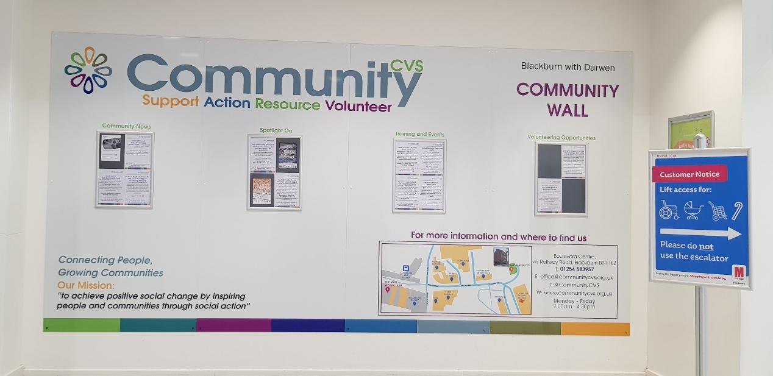

All Network meetings will be via zoom for the foreseeable future
The date of the next Meeting is Thursday 25th March 2021 9.30am – 11am
I will send out the invitation closer to the date

