Minutes of the Community CVS Network Meeting
Thursday 23rd January 2020

Attendees: Donna Talbot – Community CVS, Chloe Dobson – Healthwatch BwD, Liz Moxham – Thomas, Brian Holiday MBE – Whitebirk & Intack TARA, Nancy Kinyanjui – Arise, Natasha Morris – Inspire/Go2, Nafeesa Kovariwala – NYAS, Jackie McGrew - Whitebirk & Intack TARA, Bhawna Patel – BwD Adult Learning, Salma Saleh – Humraaz, Rowena Pailing – Blackburn Cathedral, Kiran Sadiq – BwD Carers, Zeba Sadhan – BwD Carers, Nicola Henshall – NatWest, Chloe Dobson – Healthwatch BwD , Caroline Sharkey – East Lancs Hospice, Jade Gregory – Haselden – Lancashire Mind, Denise Hayhurst, John Verity – Age UK, Alan Reid – Diocese of Blackburn, Jeremy Sharples – CLCRC Probation,

Presentation Caroline Sharkey – East Lancashire Hospice
- I’m the finance lead @ East Lancs Hospice (ELH)
- Firstly, I would like to dispel the myths and misconceptions about the Hospice – it’s not just for cancer patients and its not just somewhere people go to die!
- We offer so much more, we offer support to patients, cares and families, we do offer palliative care
- Palliative care isn’t just for cancer but covers lots of life limiting illnesses – Ms, COPD
- Dr Merton Siegelman founded ELH in 1984 – we are now in our 36th year, we were originally part of the NHS – as it was recognised that there was a need for more specialised palliative care
- In 2008 we became an independent charity we wanted people to make the most of their life
- I joined in 2009 to support the restructure
- As a charity we rely heavily on public donations and volunteers we call it Time, Treasure & Talent
- The next 3-year strategy consists of 2 key areas – to sustain our services
- 1) Our patients – especially community services, patients at the centre of all we do
- 2)Income generation – sustainable future/cover ever increasing costs
- Income generation
    - Hospice lottery – legacies in wills
    - 7 shops – 1 warehouse (furniture)
    - Gift Aid – on donations and goods donated to retail
    - New Café retreat – open to the public please go to our website – packed with info
- Ultimately, we are all here for the same purpose – to help people
- Other services we offer
    - Support – counselling etc
    - Holistic approach – spiritual needs etc
    - Creative therapies
    - Counselling
    - Complimentary Therapies
    - Bereavement support
- Project is now looking at the new donor database – we are streamlining system
- Look at the volunteer database – how do we use this more decision making- more effective
- All encompassing – organisational approach – consistency throughout the organisation – so everyone is doing the same thing – working in the same way
- Looking at the recruitment and retention of volunteers – we need to think how do we support them?
- Last year we organised a Big Thank you event and everyone really enjoyed their afternoon tea – we had a photobooth etc
- Looking at recruitment of volunteers – we now have a generic poster that we are sharing with everyone (Community Wall – CVS Bulletins)
- Electronic – to be sent out by Donna with Minutes
- Q: Do you have generic mandatory training then specialist training?
- A: Role specific – what skills are needed for the role, but we also look at enhancing volunteers’ skills – we do offer training that is paid for, we also offer education/training that the vols can access for their own personal development
- Q: Looking at retention – how are you going about it?
- A; many of our volunteers are elderly and unfortunately won’t be with us for ever – we are looking at how we attract younger volunteers with the same commitment
- Q: Do you do all this at Park Lee Road? (services etc) do you need other spaces in the community?
- A: that would be good and something we could look at
- Q: Is the bereavement counselling open to anyone?
- A: Yes – you can be referred by a professional to some services but we also have a self-referral system to

Presentation Bhawna Patel – BwD Adult Learning

- BwD Adult learning is free training for anyone aged 19 yrs. + who live within the Blackburn with Darwen area
- We cater for lots of needs – lots of abilities – for those looking for employability or those just wanting to start learning
- We offer ICT courses – some accredited – some just for beginners, we have courses and drop ins
- We offer online courses
- We offer employability courses, courses for volunteering
- Specialist courses – Food safety, First Aid, Health & Well Being, Complimentary courses, positive minds courses, Talk English courses, Health & Social care courses, reception & customer care courses.
- We can also offer bespoke courses for your learners - please contact us and have the conversation
- Courses are free to those unemployed and those earning less than £16k per annum
- If you are wanting First Aid or Food Safety for your staff – there will be a cost
- Many of the courses aim is to give confidence to the learners, all our staff are trained and experienced at teaching new learners with low confidence, this is how we are successful at achieving community learning
- The positive mind’s courses are very good for learners with anxiety – we do have a min interview with anyone who has been signposted, just to assess where they are at and what their needs are.
- We have been working with Maggie Asquith at Together Healthier Lancashire and we have been helping with the accredited volunteer training and the learning passport
- We would love to work in partnership with you guys – please give me and ring and let me know what you’re learning needs are
- Across East Lancs – there are progression packs to help those who have attended courses
- Q: BwD – If we have a volunteer who doesn’t live in BwD – can they access the training?
- A: The training is offered to anyone who lives/works or studies within Blackburn with Darwen
- Q: Where do you get your funding? What are your outcomes?
- A: Our funding comes from the Education skills, we have to work with 3000 people every year
- (Liz – Thomas) The courses that you offer are brilliant, I have sent a number of clients onto your courses and they have grown in confidence and it has helped them on their way with their recovery.
- Thank you – it really is nice to hear that we are making a difference, it really does make a difference if your staff/teachers have all the skills that new learners respond to especially patience
- Q: Do you achieve your target of 3000 learners every year?
- A: We do achieve it – but by all means please continue to signpost it would be wonderful to engage with new learners.

Presentation from Nicola Henshall – NatWest
- My role is community banker in the Lancashire and Fylde district
- My role is to go out and speak to groups – I attend events and also organise them
- I talk about how to stay safe online, make people vigilant about scams, fraud, we try to highlight that it can happen to anyone and we all need to be vigilant.
- I have 16years experience in banking and over the past 12 months we have seen a massive increase in these scams
- Working in branch – every single day you encounter someone who has been subjected to a postal scam – you are a successful winner etc
- The emotional impact on victims is devastating and can impact on all aspects of their life
- We do try to educate people on how to spot a scam and also how to report a scam too
- We do find that people are very reluctant to open up about being victims of scams – there is an element of the victim feeling like a fool that they have fallen for such a thing – there really is a stigma attached – we really do need to talk about more – hence the purpose of my project.
- All our talks are free and open to everyone
- We offer online support
- Q: Mind clients are vulnerable with complex needs and could be potential victim’s many are in the Chorley and Ribble valley area – can you help?
- A: Yes, we can – it wouldn’t be but it would be my colleague
- We try to keep on top of the scams – but they are constantly changing – when Thomas Cook went under within a couple of days the scam had already started where the scammers were contacting those who had lost their holidays and wanted to “refund” them but needed their bank details and people where giving them.
- Q: Do you have any literature that we can take way to give our isolated clients?
- A: Yes, I have lots of things – please come and see me later
- Jackie: it happened to me over Christmas – fortunately my bank spotted it at the time but I had no money over the Christmas period
- Scammers are unscrupulous and staff in branch are constantly being alert to scams, if you are receiving calls you can contact your phone provider to block the calls – there has recently been an Amazon scam – calling people about problems with their accounts etc – the scammers keep up to date it’s in their interest – its their full time “professional job” to rob people of their money.
- Our main message is – please report it – share your experiences many people feel embarrassed – if you share you could prevent others going through the same thing as you have
- Another scam has been that there are problems with your Tax and HMRC have called – many people out of fear and ignorance of the repercussions of not paying their tax bills think about it after – when it’s too late.
- What we tell people is to just take 5 minutes before reacting to these phone calls – your reaction will be completely different and possibly safer if you just wait 5 min.
- The scams can also be over a long time – where one individual befriends isolated older people and then once they have a profile – someone else will call on them and scam them out of their money.
- Scammers use social media to build profiles of potential victims
- Many older people are afraid of online scams so this affects their willingness to go online – this means that they aren’t keeping in touch with friends etc and they aren’t accessing vital services – many of which are now all online (doctors’ appointments etc)
- We have seen many scams around pensions/investments etc – this is now illegal
- Knowledge is power – by getting the message out, by talking about scams etc and also by learning the skills of how to deal with it this will help fight the battle against financial scams
Presentation –Jade Gregory – Haselden from Mind
- Time to change – local hub in the community – we are looking for champions
- 8 yrs. plus with a personal experience of Mental health – they are not volunteering but campaigners
- Annual time to talk day 6th Feb – we have lots of events organised
- We would like more organisations to get on board and hold events – have a conversation over a coffee – we have free resource packs on line – posters etc
- There are a few events happening in The Mall - Thursday 6th Feb – Time to change cinema
- Leading up to the event there is a crafters group on the 3rd @ Care network hub, something happening on the 4th @ The Coffee Exchange in Fleming Square
- Just to let anyone know the Coffee exchange do offer use of the large room for meetings etc as long as you buy your coffee there
- We have events happening at all the local libraries
- We are always recruiting – always looking to expand the number of champions – you can claim £90 for your event.
- Q: Champions do they have a role description?
- A: No social movement – involved as and when
- Q: How do you train your champions?
- A: a combination of eLearning and face to face

Presentation from Alan Reid – S James Church Lower Darwen

- St James Church is the oldest church in Darwen – built around 1520 so its just about 300 yrs. old
- I work with the Diocese of Blackburn and we are looking to create a space that is not just a church but space that can be used by other organisations/charities
- We are looking at applying for funding but we aren’t sure what we are applying for at the moment – we want to engage with the community and see what people need the space for etc
- We want to do something that will support the community
- We would like to re-establish the church as the heart of the community – during the day there aren’t any buses for the residents to come into Blackburn, many of the residents are elderly and isolated – we would like to bring the services to the residents, as you may be aware lots of people form Darwen do not like travelling to Blackburn.
- Over 2- 3yrs it has been identified there are lots of needs – working with local councillors and the local schools
- We are looking at the needs of the people not the needs of the building
- We have the space and its my job to make you aware of what’s available and help you if we can, during the day there is nothing going on
- We need people to use the church – space it’s just sitting empty – good space with comfy chairs – projectors etc
- We have linked up with John East – looking at solutions of how to engage the community – we are aware that it is a massive challenge
- We also have the shop space which is a good conference facility – this can be accessed at any time – was originally New ground who handed it over to us
- If you have got the need – we have the space – its here to be used
- Q: how much does the space cost?
- A: cost £10 per session – dependant on what you want.

Donna Talbot – Update
Community Volunteer Awards 2020
Community Volunteer Awards 2020 have now been launched

Is your organisation supported by many wonderful volunteers? Do they deserve to be recognised for their contribution to Blackburn with Darwen?

If so please nominate them today 😊

We have a number of categories to choose from, you can nominate individuals or groups and you can also nominate for a number of categories.

All winners will be announced at a special evening of celebration On Thursday 4th June 2020 @ King Georges Hall (main Hall) from 6pm onwards.

Everyone nominated will receive a signed certificate, all shortlisted nominees will receive an invitation to the ceremony, and all winners will receive a trophy.

Please fill in the attached nomination form for anyone you wish to nominate, and return to Donna Talbot by email at donna.talbot@communitycvs.org.uk by 5pm on Friday 17th April 2020

You can also nominate online @ http://www.communitycvs.org.uk/volunteer/volunteer-awards/nomination-form-community-volunteer-awards/

Alternatively, you can post or hand in nomination forms to Donna @ CVS at the Boulevard Centre, 45 Railway Road, Blackburn BB1 1EZ or ring: 01254 583957 and ask for Donna

Community Wall

Do you have any upcoming events/training you would like to promote?

Are you looking for new volunteers?

Are you delivering new services?

If so please feel free to forward posters/leaflets to me and CVS will get the information on the new Community Wall in The Mall – Blackburn

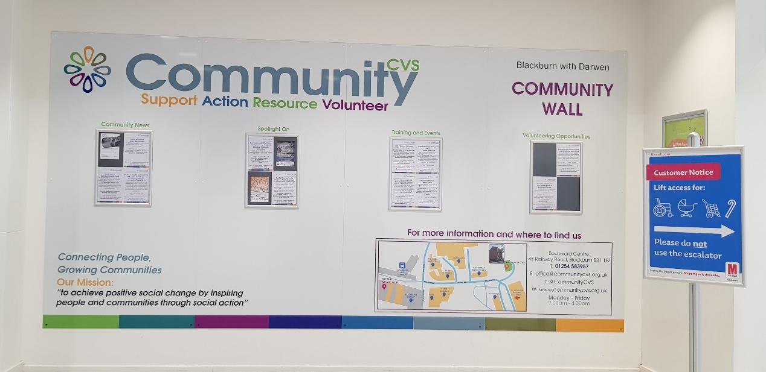

Update form Denise Hayhurst – National Volunteers Week
- National volunteers’ week is 1st – 7th June – we are hoping to launch with a flash mob
- I am hoping to coordinate this flash mob – just looking for someone who can help us
- We have a dedicated Facebook page – so people can put on what they are doing etc
- We are looking at stands in the market/Asda/Morrisons
- Any organisations wanting to promote their volunteering opportunities are more than welcome to come along and man the stalls.
- We are wanting to recruit street ambassadors – to hand out info in The Mall etc
- Possibility of a fund-raising event at Aquamania – stalls etc
- We would like to organise a “Big Thank You” – last year we did something similar to the Macmillan coffee morning – this year we would like to organise a more central event
- We are looking at prestigious places to hold the event – but we have no resources as of yet
Festival Making – 6th & 7th June
- Annual event that takes over Blackburn Town Centre – last year 50, 000 visitors
- Lots of activities – volunteers needed
- We held an event in the Windsor Suite last year – hoping to replicate – so if you would like to hold a stall – it must be around making something
- I will let you know nearer the time if it is going ahead
- Q: could we bring upcycled furniture
- A: Yes of course

Update Jackie – Whitebirk & Intack T.A.R.A
- Our dance school will be performing in July at Thwaites theatre
- Our Mini Olympics – will be held on 16th May – more info on the way

Update Natasha – CGL
- We have just launched our new training programme – free Drug &Alcohol training offered to everyone
- We have two full training dates – one at the fire station and one at Ewood park
- Please book on through Eventbrite/Inspire

