Note to Organisation Lead: this version is for you to edit with your organisation’s specific details and then send to volunteers. See notes in green below for editable areas. It is suggested that organisations edit and then send as PDF versions to their volunteers.

What is the Volunteer Learning Passport?
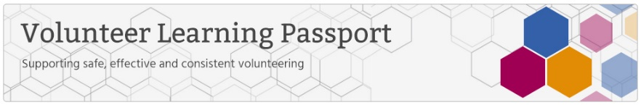

The Volunteer Learning Passport allows you as a volunteer to complete 6 e-learning sessions to enable you to feel confident in your volunteering role. It also enables your volunteering organisation to provide you with consistent training as well as recognising the vital role that you play.

The following e-learning sessions are available:

- Data Security Awareness
- Equality, Diversity and Human Rights
- Fire Safety
- Health and Safety
- Safeguarding Adults
- Safeguarding Children

How do I view the sessions?

Please access via the e-Learning for Healthcare (e-LfH Hub) / insert name of your volunteer training platform.

Note to organisation lead:

Please delete as applicable above. If your organisation has its own Learning Management System and the volunteer can access via this. This can set up using the AICC Links (see details below)

Getting Started via the e-LfH Hub

- Type volunteers.e-lfh.org.uk in your browser

- You will need to register, so click the ‘register’ button on right hand side of screen. (However, If you have been provided with an username and password, then type these in to ‘login’).

- Type in your email address here. If you have an official volunteer email address, then please use this, if not, your personal email address is fine (Please ignore the comment about not using your personal email address as this is aimed at healthcare professionals registering on the system).
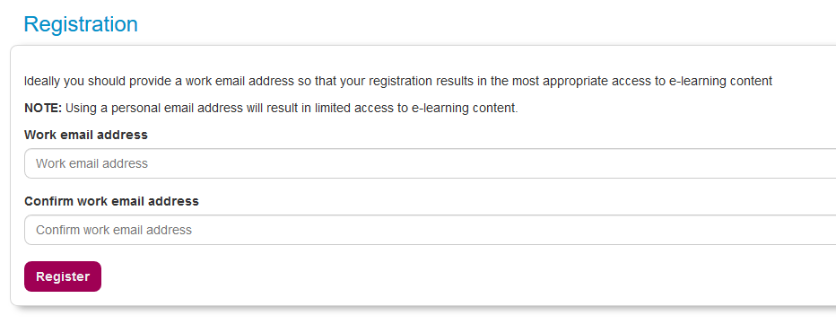

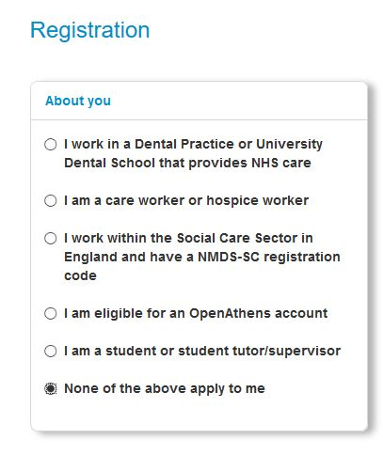
- Next you will be asked a few questions about you. As you are a volunteer, please select the bottom option ‘None of the above apply to me’.

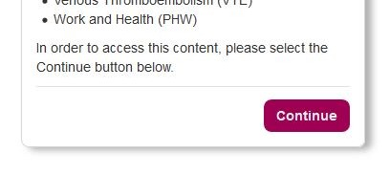
- Then click the ‘continue’ button that appears in the second column like this.

- You will then need to fill in some details about yourself so that the system knows who you are. In ‘Your details’, please complete your ‘first name’, ‘last name’ and ‘country’.

- Then complete the ‘Your current role’ section. Firstly, type in ‘Volunteer’ in the ‘Job Role (Staff Group) section and click ‘search’. You will see a few options here:
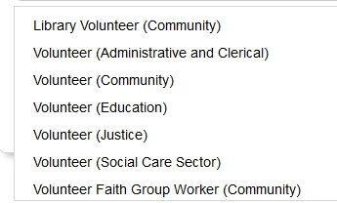
Select which one matches your role best. If you are not sure, then please select ‘Volunteer (Community)’

- Next, insert your organisation name in the free text box. It is important that you correctly complete the ‘Organisation Name’ so that your volunteering organisation can download a report to show if you have completed the sessions.

Please insert the following: < insert organisation name here>

This is a free text box so please type exactly as is shown above. If you are not sure, then please refer to your email from your volunteer organisation, or contact your organisation.

Note to organisation lead: please insert your organisation name above from the list below or your organisation name and then delete the list of organisations shown below.

- Advocacy Focus
- Blackburn Community CVS (Community & Voluntary Services
- Blackburn with Darwen Council
- Blackburn with Darwen Healthwatch
- Burnley, Pendle & Rossendale CVS (Community & Voluntary Services)
- East Lancashire Hospitals NHS Trust
- Families, Health and Wellbeing Consortium
- Hyndburn & Ribble CVS (Community & Voluntary Services
- Lancashire Care NHS Foundation Trust
- Lancashire Volunteer Partnership
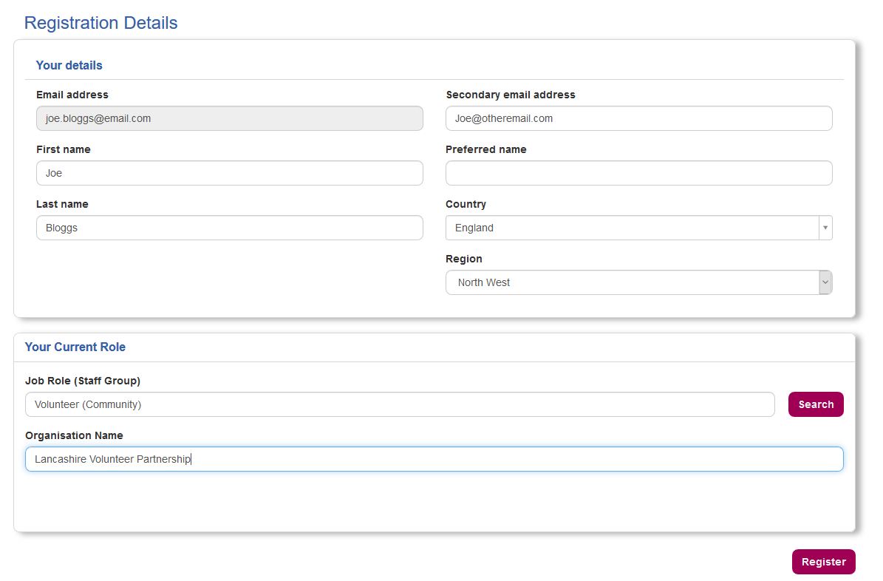
- Now you have registered and can access the Volunteer Learning Passport programme.

- To access the Volunteer Learning Passport, you will need to ‘enrol’ from the list of open access programmes available. Go to ‘regional e-learning’ and select the ‘Volunteer Learning Passport’.

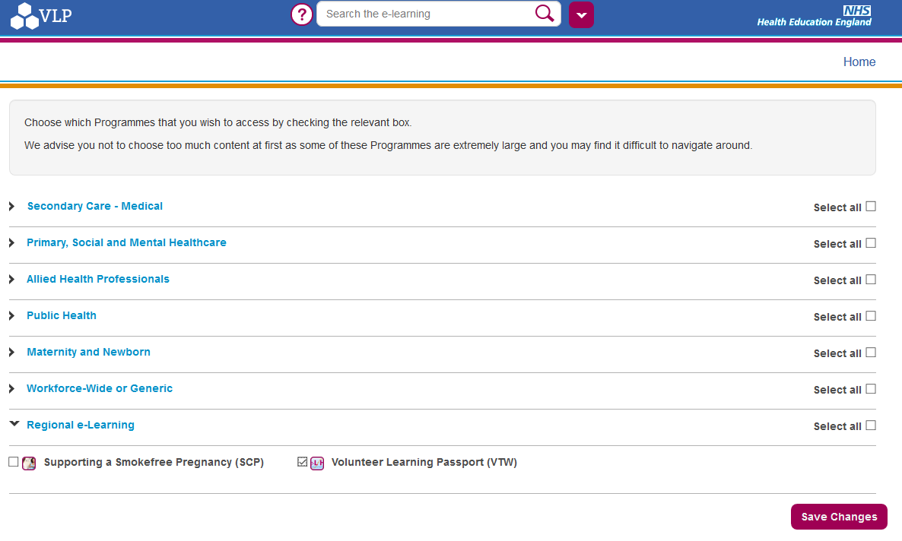

Note that if you have previously logged in and enrolled on any e-LfH programmes, they will also appear here.

- You are now registered and will receive an email with your login details.

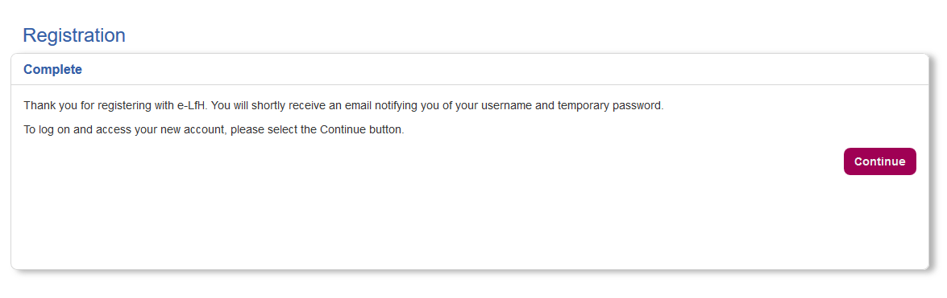

Certificates and Reporting

How do I view my certificate?

Once you have completed your session and passed the Knowledge quiz, you will see a certificate icon that has a yellow seal (see below) next to the relevant folder (not next to the actual session). You can then click on this to open up the PDF document.

You can also see all your certificates by going to ‘My Activity’ and select ‘Certificates’.

Can I save, print or email my certificate?
Yes, it is PDF document so you can save it, email it your organisation and print it if you wish.

For more details go to: http://support.e-lfh.org.uk/my-activity/certificates/

Please email to: <insert email address>

Note to organisation lead: please insert the email address of the person that you would like the volunteer to send their certificate to, if you wish to use this option.

How do I share my session activity with my organisation?

You can choose to share your activity on the e-LfH Hub with your volunteer manager or lead. For more details go to: https://support.e-lfh.org.uk/my-account/reporting-permissions/

You will need to enter the username of the person that you want to share with.

Note to organisation lead: please insert the username of the person that you would like your volunteer to share with. If you do not want to use this functionality, then please just delete this section.

Please insert the following username for our organisation: <insert username here>

Generic guidance
For any other support please click on the Help icon and/or email support@e-lfh.org.uk

See some general guidance below regarding how to navigate and access the e-learning.

