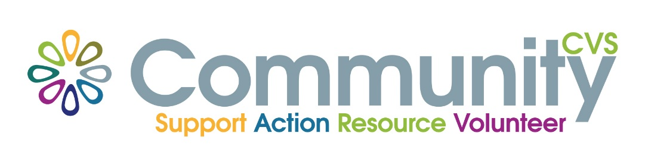
Privacy Notice

Who is responsible for your data?
Community CVS is the Data Controller for the personal information you provide. Community CVS Data Protection Officer Clair Bloomfield can be contacted at clair.bloomfield@communitycvs.org.uk or by writing to the Data Protection Officer, Clair Bloomfield at Community CVS, 45 Railway Road, Blackburn BB1 1EZ.

What Information we need?
If you are an individual requesting information, advice and/or support we will ask you for your name and address, your contact phone number or your email (if you choose to provide this), along with the name and date of birth of the individual, the organisation /settings or placement details. We will also ask you for information regarding the reason for requesting support along with any specific needs the individual person may have.
There is no statutory obligation for you to provide this information but it may limit the range of support we may be able to offer you if you do not provide it.
For certain projects, we may request more information and the form that you complete will explain what information is required and the legal basis for holding the information.
Why do we need this?
We will ask you for this information as it will help us to provide you with the information, advice and support you are asking for. It will also ensure we are able to keep accurate records relating to the information, advice and support that we have provided you with.
Where will we store your information?
All information you have provided will be held in manual and electronic formats and only be used in line with the Data Protection Act 2018. We will keep the information ‘live’ on our information systems for as long as you are registered with us and will keep archived information for the length of time required by funders for audit purposes only. You have the right to withdraw consent to part or all of the above at any time by contacting Clair Bloomfield details above.
Who will we share your information with?
We may share this information, with your consent, with other agencies in order to further support you. We will share this information in the event of any safeguarding concern or if ordered to do so by a Court or if requested to do so during an internal or external audit if required.
Other
We do not transfer your information to any other service inside or outside of Community CVS unless there are any safeguarding concerns. We do not transfer your information to a third country (that is a country outside of the EEA).
Your Rights
You have a number of rights relating to the processing of your information, including the right to access the information we hold about you (via a Subject Access Request), the right to erasure (the right to be forgotten) and the right to have inaccurate data corrected. More information about your rights can be found by contacting Community CVS.
In certain cases – we may hold data about you that we are required to hold and does not qualify under the right to erasure. If this is the case we will let you know under what legal basis we are holding the information and explain why we cannot erase your data.
Complaints
If you are not happy with how Community CVS has handled your personal information, you can complain to Community CVS and give them the opportunity to resolve this with you. You should contact the Data Protection Officer Clair Bloomfield and use our Comments, Compliments and Complaints Form that is available on our website or by requesting a copy from Clair.
If we do not resolve your complaint to your satisfaction you can raise the matter with the Information Commissioner. The contact details can be accessed via the following link:
https://ico.org.uk/make-a-complaint/

Name | CVS Executive Committee
Date approved | 18/09/2018
Review date | Sept 2020

