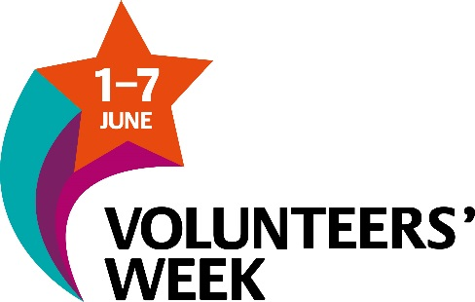
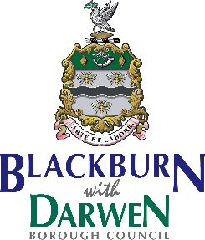

Blackburn with Darwen
“Volunteers Week”
Award Ceremony
Monday 11th June 2018
King Georges Hall
Windsor Suite
6pm – 9pm
Doors Open @ 5.30pm
Recognising and Rewarding the Dedication and Hard work of Blackburn with Darwen’s volunteers

Closing Date for Nominations
Friday 11th May 2018
For more information please contact Donna Talbot on 01254 583957 or via email donna.talbot@communitycvs.org.uk

