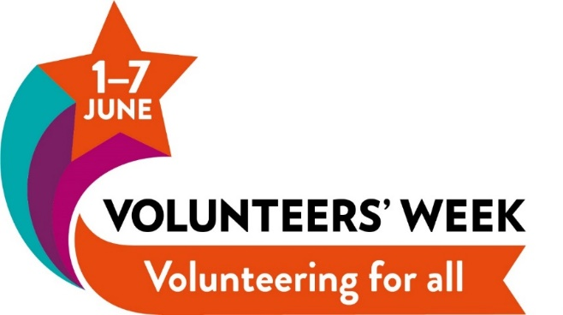

Here at Community CVS the community groups and organisations we work with are always telling us how crucial and valued their volunteers are. We too have Volunteers that we couldn’t do without.
So as a celebration of Volunteers’ Week, which runs from Thursday the 1st until Wednesday the 7th of June, we’re running a photo competition.
In line with the theme of Volunteers’ Week we would like the photos to represent:
Volunteering for all in Blackburn with Darwen.
We don’t want to make it any more specific than that because we don’t want to stifle your creativity!
This competition is open anyone connected to an organisation or group that is a member of Community CVS and involves volunteers. This could be because they are employed or volunteer there, they use the services of a charity or project, or they are a supporter of their work.
If you are not sure if the group or organisation you wish to photograph is a member, or you are a group that would like to find out more about becoming a member of Community CVS, email office@communitycvs.org.uk or phone 01254 583957 and ask for Clair Bloomfield.
The deadline for all entries is 23.59 Friday 18th May 2018
An independent panel will choose the best five photos. The prize for each of the winning photos will be £100.
The panel will judge the picture on – Relevance, Originality, and positive image of volunteering.
Please submit your images (no more than 5 MB per email) to office@communitycvs.org.uk with the subject heading :
‘Volunteers Week Photography Entry’

Please also provide us with the following information:
Name of photographer:
Contact details of the photographer: (name,
address, email, tel. number)
What is the name of the group/ organisation in the image?
Signature of Chair/CEO of the Organisation listed above giving consent/support for the application to the Volunteers Week Photography Competition

What is the volunteer activity in the image?
I confirm that I have the written permission of the individuals in the image or the written permission of their guardians if they are under 18, for this image to be used by Community CVS to promote volunteering in websites, bulletins and publications, events, and social media. | Please state YES if you have this permission:

If you are sending more than one image please state the name of the group/ organisation and the volunteer activity for EACH image. Please ensure you have read the full terms and conditions below before submitting your images.

TERMS AND CONDITIONS FOR THE COMMUNITY CVS PHOTOGRAPHY COMPETITION 2018
The deadline for all entries is 23.59 Friday 18th May 2018
You are limited to entering five photographs in total.
By entering this competition you are accepting the rules on this page and agree to be bound by them.
This competition is open anyone connected to an organisation or group that involves volunteers. This could be because they are employed or volunteer there, they use the services of a charity or project, or they are a supporter of their work.

Community CVS membership
The organisation you are photographing must be a member of Community CVS at time of submission. If you are not sure if your organisation is a member, or you would like to find out more about becoming a member of Community CVS, email office@communitycvs.org.uk
Get permission from…
Your group/organisation
Please make sure to let your group or organisation know, and seek their permission, before entering into the competition.
People in the photo
If there are people in your photographs please make sure you have asked their permission, and if they are under 18, their guardian’s permission for the photograph to be used by Community CVS to promote volunteering, and in the Volunteers Week Award Ceremony. You will need to tick the box on your return form to confirm that you have written permission from the people in the photo or their guardians if they are under 18.
Submit a high-quality image
Please try to send images of at least 1MB in size and that you set your camera/phone to the highest quality setting. Images of a low file size or resolution may not be large enough to print to display. Images which have been shared over social media may not be of a high enough resolution to print – please submit the original image file where possible.
Photos must be original and belong to you
Photos should be your own work. Photos that have been published or used on the website or materials of your charity are fine.
Permission to use your photo
By submitting an entry, you are granting Community CVS the right to use the image to promote volunteering within Blackburn with Darwen.
Taking part
By entering the competition, you are agreeing to participate in publicity about the competition and winners. Prizes cannot be exchanged and the judges' decisions are final.
Data Protection Consent Statement
Data Protection Acts 1998 and 2017. All information you have provided will be held in manual and electronic formats and only be used in line with the Data Protection Act 1998 and 2017. Your contact details will be used to communicate with you relating to the Volunteers Week Photography Competition and the images will be used to promote volunteering within Blackburn with Darwen. We will keep the contact information ‘live’ on our information systems until after the event and the images for a period of five years. You have the right to withdraw consent at any time by contacting Clair Bloomfield details below.
Blackburn with Darwen Council for Voluntary Service is the data controller and is registered on the Data Protection Register (Z1938345). We will not share or divulge your details to any other third parties without your expressed consent. You have a right to access your information by writing to Clair Bloomfield, Community CVS, Boulevard Centre, 45 Railway Road, Blackburn. BB1 1EZ email clair.bloomfield@communitycvs.org.uk Tel: 01254 583957.

I give explicit consent by signing below for Community CVS to hold my personal contact details for the purposes of the Volunteers Week Photography Competition and for Community CVS to use the images for the next five years to use the images to promote volunteering within Blackburn with Darwen.

Name:______________________________Signature_________________________

Date:_______________________________

