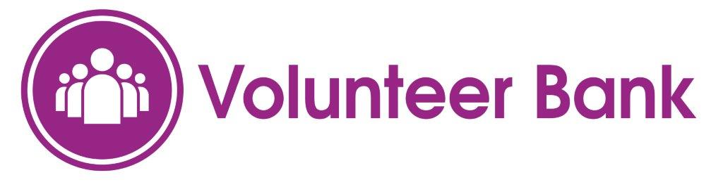
Community CVS, The Boulevard Centre, Cathedral Quarter,
45 Railway Road, Blackburn BB1 1EZ
Organisation Registration Form
The Volunteer Bank is a virtual place where you can pledge to deposit or give a proportion of your spare time to volunteer and help others. Charities, community groups and good causes will be able to call on your time (at your discretion). You will always have the right to say no – but it is a way of making connections and encouraging people and organisations to support each other.
To enable us to find the right volunteers for your organisation, please complete the following questions with as much information as possible.
Volunteer Role (attach additional sheets for more than one volunteer role):
Name of organisation:

Address:

Telephone:

Email:

Name of Contact:

Data Protection Statement
Are travel expenses paid? Yes/No
Will volunteers need DBS Checks? Yes/No
Will volunteers need references? Yes/No

Hours required:

Data Protection Acts 1998 and 2017. All information you have provided will be held in manual and electronic formats and only be used in line with the Data Protection Act 1998 and Data Protection Act 2017. The information will be used to contact your organisation with regards to your organisation’s interest in the Volunteer Bank. We will keep the information ‘live’ on our information systems for as long as you are registered with us and will keep archived information for the length of time required by funders for audit purposes only. You have the right to withdraw consent to part or all of the above at any time by contacting Clair Bloomfield details below.
Community CVS is the trading name of Blackburn with Darwen Council for Voluntary Service, who is the data controller and is registered on the Data Protection Register (Z1938345). We will not share or divulge your details to any other third parties without your expressed consent. You have a right to access your information by writing to Clair Bloomfield, Community CVS, Boulevard Centre, 45 Railway Road, Blackburn. BB1 1EZ email clair.bloomfield@communitycvs.org.uk Tel: 01254 583957.
Statement of Consent
I give my explicit consent for CVS to contact me directly or share my contact details with potential volunteers or other organisations registered with the Volunteer Bank for the purposes of promoting volunteering within Blackburn with Darwen.

Name:
Date:
Signature:
For further information about CVS Members and our Data Protection Policy please refer to our website – www.communitycvs.org.uk

