World Suicide Prevention Day
Working together to prevent Suicide
Friday 10th September

You are invited to mark this day by joining us in raising awareness and reducing the stigma surrounding suicide, in order to reduce instances of suicide around the world.

Join us in Blackburn: (https://www.eventbrite.co.uk/e/walk-a-mile-in-someone-elses-shoes-for-world-suicide-prevention-day-tickets-167298645753)
Time | Activity | To Include:
10am  - 11am | Vigil outside Blackburn Town Hall | Speakers, tribute to Tony Harrison,  40 seconds silence.
 | Mile Walk around Blackburn Town Centre | Candle led procession - 1 mile walk in someone else's shoes.

Time | Activity | To Include:
12.30pm -  1.30pm | Vigil in Darwen Town Hall Square | Speakers, tribute to Tony Harrison,  40 seconds silence.
 | Mile Walk around Darwen Town Centre | Candle led procession - 1 mile walk in someone else's shoes.
Or in Darwen: (https://www.eventbrite.co.uk/e/walk-a-mile-in-someone-elses-shoes-for-world-suicide-prevention-day-tickets-167604145511)
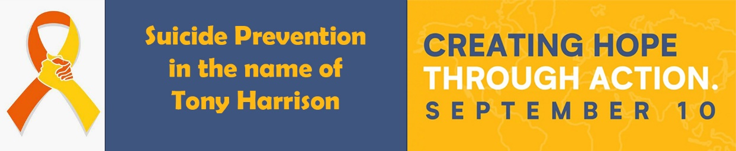
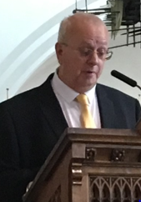
In memory of Tony Harrison a tireless local advocate of World Suicide Prevention Day.

