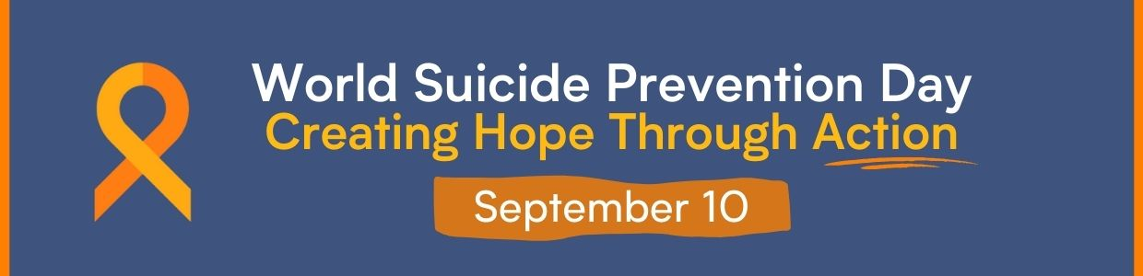
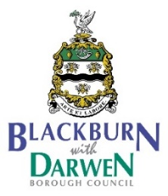
Working together to prevent Suicide in Blackburn with Darwen
Friday 10th September
The BwD Public Health Team and Partners are holding a number of events and activities to CREATE HOPE THROUGH ACTION and challenge the stigma surrounding suicide in Blackburn with Darwen.
What are we doing?
World Suicide Prevention Day is September 10th and we are inviting residents to mark this day by joining us in raising awareness and reducing the stigma surrounding suicide, in order to reduce instances of suicide around the world.
- We are going to be holding vigils in both Blackburn and Darwen Town Centres that will include 40 seconds silence and the lighting of a candle
- We are inviting people to sign up to the ‘Walk a mile in Someone Else’s shoes’ activity either in Blackburn or Darwen
- We will be flooding social media with positive messages of support and advice
- We will be highlighting the opportunities to attend suicide prevention training courses within the borough, in the week surrounding the 10th
- We will also be signposting people to support services and explaining how people can take action to support people at risk of suicide and invite you to join us in doing the same.

Why are we doing this?
33 people took their own life in Blackburn with Darwen between 2017 and 2019. This equates to a rate of 8.3 people dying by suicide for every 100,000 people in the Blackburn with Darwen population (Source: ONS 2021.)
One in every 100 deaths worldwide is the result of suicide.
It can affect every one of us.
Each and every suicide is devastating and has a profound impact on those around them.
However, by raising awareness, reducing the stigma around suicide and encouraging well-informed action, we can reduce instances of suicide around the world.
World Suicide Prevention Day is an opportunity to raise awareness of suicide and to promote action through proven means that will reduce the number of suicides and suicide attempts globally. (https://www.iasp.info/wspd2021/)

There has been a rich history in Blackburn with Darwen of marking this day, in innovative and special ways, and that was mainly down to Tony Harrison. Tony was a tireless, local advocate for this cause. We feel his loss most poignantly, as we plan this day for the first time without him. These events have been planned in memory of him.
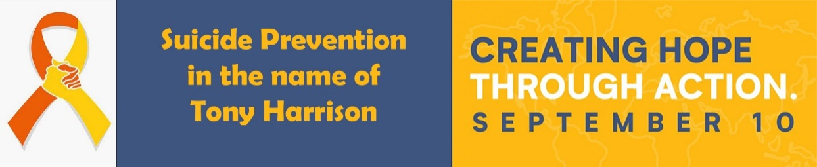
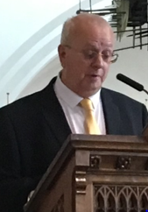

What it will look like?
On Friday 10th September
Start Time | End Time | Activity | To Include:
10am | 10.30am | Vigil outside Blackburn Town Hall | Speakers , Tribute to Tony Harrison, 40 seconds silence, Lighting of the candle.  Acknowledging our Orange Badge holders
10.30am | 11am | Mile Walk around Blackburn Town Centre | Candle led procession - 1 mile walk in someone else's shoes. Meet at the Town Hall.
11am | 12pm | Walk to Darwen | Small representative group of selected walkers will walk the candle to Darwen Town Centre
12.30pm | 1pm | Vigil in Darwen Town Hall Square | Speakers, Tribute to Tony Harrison, 40 seconds silence. Acknowledging our Orange Badge holders
1pm | 1.30pm | Mile Walk around Darwen Town Centre | Candle led procession - 1 mile walk in someone else's shoes. Meet at the Town Hall.

How can your organisation get involved?
- Please join us at either vigil
- Please encourage your staff members to complete Suicide Prevention training and become an Orange Badge holder (Healthier Lancs and South Cumbria :: Orange Button Community Scheme (healthierlsc.co.uk))
- Or complete the online training here https://www.zerosuicidealliance.com/training
- Please join us on the ‘Walk a mile in Someone Else’s shoes’ activity. You will need to sign up here…………………
Blackburn Event - https://www.eventbrite.co.uk/e/walk-a-mile-in-someone-elses-shoes-for-world-suicide-prevention-day-tickets-167298645753
Darwen Event - https://www.eventbrite.co.uk/e/walk-a-mile-in-someone-elses-shoes-for-world-suicide-prevention-day-tickets-167604145511
- If any of your staff or volunteers would like to help us on the day, we do need volunteers to help the day go smoothly.

