Sent to: referrals@newground.co.uk
Energy Redress Scheme:
Newground Together: Committed to Strength Through Partnership

Purpose
- To engage and support vulnerable people struggling to pay their fuel bills due to loss of income, increased fuel use or other vulnerabilities resulting from the economic and social impacts of C-19.
- To work in partnership in order to reduce Fuel poverty.

Qualifying Criteria
- Referral must be made by professional partner agency.
- Referral agency can evidence & confirm people living at the address (referral form)
- Pre-Payment Meter: has to be a pre pay meter that is topped up with a key or card to qualify for voucher
- Current photo of pre-payment meter included on the referral form
- Household is at risk of self-disconnection, running out of fuel, out of fuel, in fuel debt or supply capped
- Household is suffering from the impact of COVID 19 & restrictions
- The household has not received any fuel vouchers recently from any other organisations administering the Energy Redress Scheme? Applicants can have a maximum of 3 vouchers from the redress fund. If they have already had 3 vouchers, they do not qualify.

How Do I refer?
Fill in the referral form and send to referrals@newground.co.uk

What happens Next?
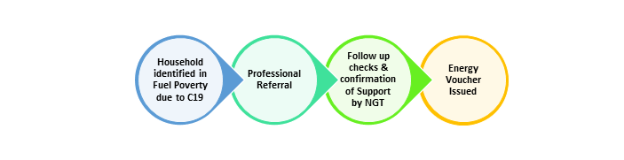
Vouchers available, distributed based on referral form and needs assessment by NGT staff member, each case consider individually:
Gas | Electric
☐ Couple (£35) | ☐ Couple (£35)
☐ Family (£49) | ☐ Family (£49)

Partners to confirm the following with recipients:
- Any Fuel Voucher issued will be for their own personal use i.e. in their household only;
- The voucher will expire in 30 days if not used
- Partner Organisations are required to inform referral that someone from Newground Together will be In touch to confirm the information you have provided and confirm they agree to the processing of their personal data to process their application & report to our funder
- Any inaccurate information provided may mean their voucher application is not processed

Any queries please email: referrals@newground.co.uk or call 07760 568747

