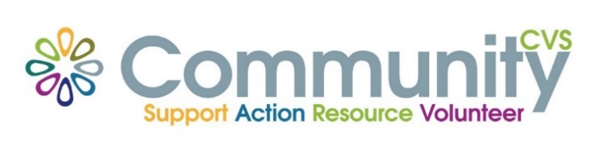

Community CVS Breakfast
Network Meeting
Thursday 17th June 2021
9:30am – 11:30am
Via Zoom
(invitations will be sent out)
Agenda
9.30am Introductions
9:45am Presentation from Bhawna Patel from BwD Adult Learning
10:00am Presentation from Zoe Alimeri from ICANN
10.15am Presentation from Asia Malik from Blackburn College
10:30am Presentation from Callum Barnes from Community CVS
10:45am Any Other Business
For more information please contact Donna Talbot 01254 583957 donna.talbot@CommunityCVS.org.uk

