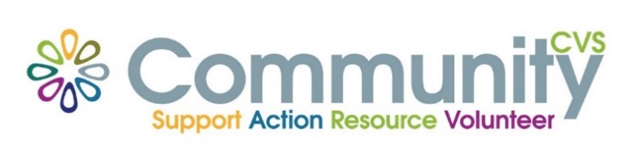

Community CVS Breakfast
Network Meeting
Thursday 22nd April 2021
9:30am – 10:30am
Via Zoom
(invitations will be sent out)

Agenda
9.30am Introductions
9:40am Presentation from Natasha Morris from Brook
9.50am Presentation from Tayyibah Masood from Positive Smiles
10.00am Presentation from Aggie Kweicien from Polish Support
10.10am Presentation from Chris Bell from Mind
10:20am Any Other Business
For more information please contact Donna Talbot 01254 583957 donna.talbot@CommunityCVS.org.uk

