Come and meet HARRI near you!
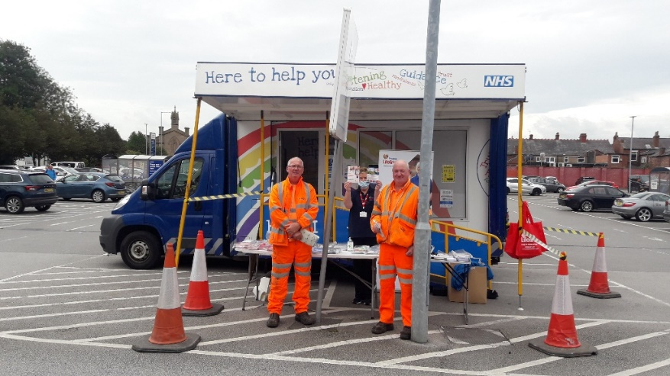
HARRI is our health and wellbeing engagement vehicle, with it we are able to travel around Lancashire to talk with the local communities and individuals.
On board:
• We engage with you; to share our ideas and plans for the future and to gain insight into what your need are.
• We offer simple signposting, advice and guidance to offer the right help at the right time in the right place for you.
On board there will be a mixed group from within the NHS and beyond, which will enable us to offer you a wide range of information on many of the issues you may be facing, such as job advice, quit smoking, diabetic DESMOND, Steady On, My Place, Lancashire Victims support job advice and much more. The vehicle includes a private consulting area with disabled access.
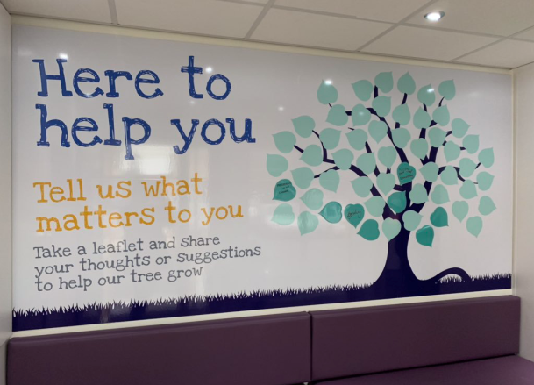
People can visit HARRI at various locations and events throughout the year in Lancashire. For HARRI’s schedule, see the reverse of this leaflet or Lancashire Care Face book and twitter accounts for the latest updates.
HARRI is one of the many ways Lancashire Care NHS Foundation is using to reach out to communities to promote positive aspects of mental health and wellbeing.
We hope to see you with HARRI soon

Book HARRI
HARRI is also available to attend health events and campaigns. It is the perfect vehicle to promote the local services to a wide audience in just a few hours, allowing services to highlight their initiatives, raise awareness and discuss concerns. If you would like to hire HARRI for your next event, please get in touch for availability.
Venue/Event | Date | Times
Leyland Market Northcote St, Leyland PR25 2AA | Tues 6th April 2021 | 10.00 – 3:00
Bickerstaffe Square, Talbot Road, Blackpool, FY1 3AH | Thurs 8th April 2021 | 10:00 – 3:00
Morrison Central Drive, Morecambe LA4 4DA | Tues 13th April 2021 | 10:00 - 3:00
Earnse Bay car park, Barrow-in-furness, LA14 3XZ. | Thurs 15th April 2021 | 10:00 – 3:00
Little harwood health centre car Plane Tree Rd, Blackburn BB1 6PH | Tues 20th April 2021 | 2:00 – 4:00
Morrison Pendle St, Nelson BB9 7TX | Fri 23rd April 2021 | 10:00 – 3:00
Dalton-in-Furness venue TBC | Sat 24th April 2021 | 10:00 – 3:00
Tesco Liverpool Road North Burscough Bridge, Ormskirk L40 0SA | Tues 27th April 2021 | 10:00 – 3:00
Lytham Primary Care Centre. Victoria St Lytham. FY85DZ | Thurs 29th April 2021 | 10:00 – 3:00

 Call us on 01772 695 365 to speak to one of our friendly support team
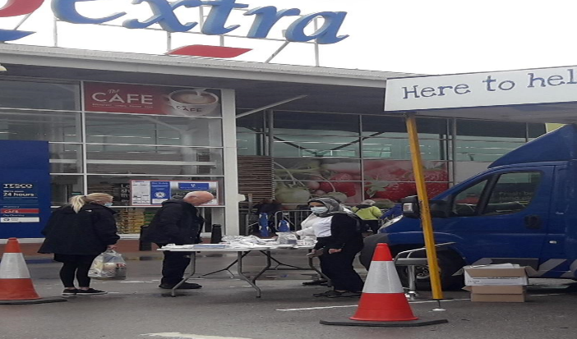
 Email us at HARRI@lancashirecare.nhs.uk
@HARRILSCFT
@LancashireCare

