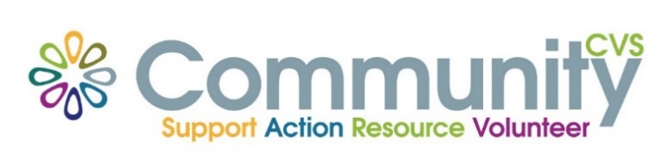

Community CVS Breakfast
Network Meeting
Thursday 25th February 2021
9:30am – 10:30am
Via Zoom
(invitations will be sent out)

Agenda
9.30am Introductions
9:40am Presentation from Maggie Asquith from NHS East Lancs CCG
9.50am Presentation from Lisa Rawcliffe from NWAA
10.00am Presentation from Bev Marsden from Lancashire Women
10.10am Presentation Donna Talbot – LOCAL
10:15am – 10:30am Any Other Business
For more information please contact Donna Talbot 01254 583957 donna.talbot@CommunityCVS.org.uk

