Covid, Faith, and Public Health; dispelling myths and discerning truths

Thursday 4th February, 10.30 - 12.00

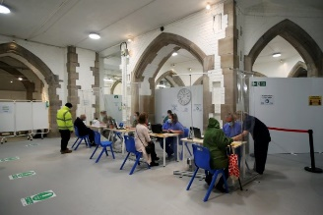
The Covid19 pandemic has brought scientific disciplines, and public health officials centre-stage in the public sphere. While a range of scientists have tried to explain epidemiology and how vaccines work, public health officials have emerged as key figures assessing data, advising statutory authorities, and communicating health messages to a wide audience. Despite all this, there are groups in society who for various reasons are wary of ‘experts’, and reluctant to take part in
Vaccination centre in crypt of Blackburn cathedral

The intention of this webinar, another in a series being run by the Lancashire Forum of Faiths in collaboration with the Lancashire Resilience Forum and Churches Together in Lancashire, is to:
- explain to attendees something around the science of Covid19 and its transmission
- dispel myths around Covid vaccination (and testing)
- discuss the challenges of communicating health messages

At the same time, the intention is to encourage discussion in small break-out groups, and in open forum to explore ways in which religious faith intersects with science and public health. Those contributing are medical / public health professionals and are from different religious traditions.

Contributors

Dr Sakthi Karunanithi - director of public health for Lancashire
Dr Dominic Harrison - director of public health for Blackburn with Darwen
Dr Susan Salt - trainee priest, and consultant in palliative medicine
Dr Abdul Razaq - consultant in public health

To register for the webinar on Zoom please contact Rebecca at RebeccaJoy.Novell@Lancashire.gov.uk

