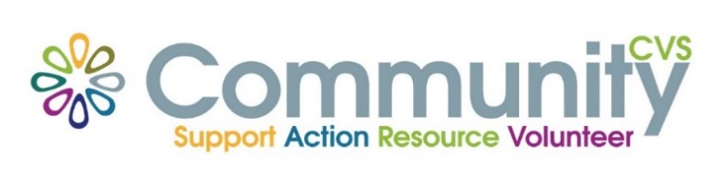

Community CVS Breakfast
Network Meeting
Thursday 24th September 2020
9.00am – 11.00am
Via Zoom
(invitations will be sent out)
Agenda
9.15AM Introductions
9.45am Presentation from Tracy Davies from Game Changers – CBP
10.00am: Presentation from Nina McCallion from Renaissance UK
10.15am: Presentation from Kate Lee from Community CVS
10.30am Any Other Business
For more information please contact Donna Talbot 01254 583957 donna.talbot@CommunityCVS.org.uk

