October’s Volunteer Bulletin
Citizens Advice
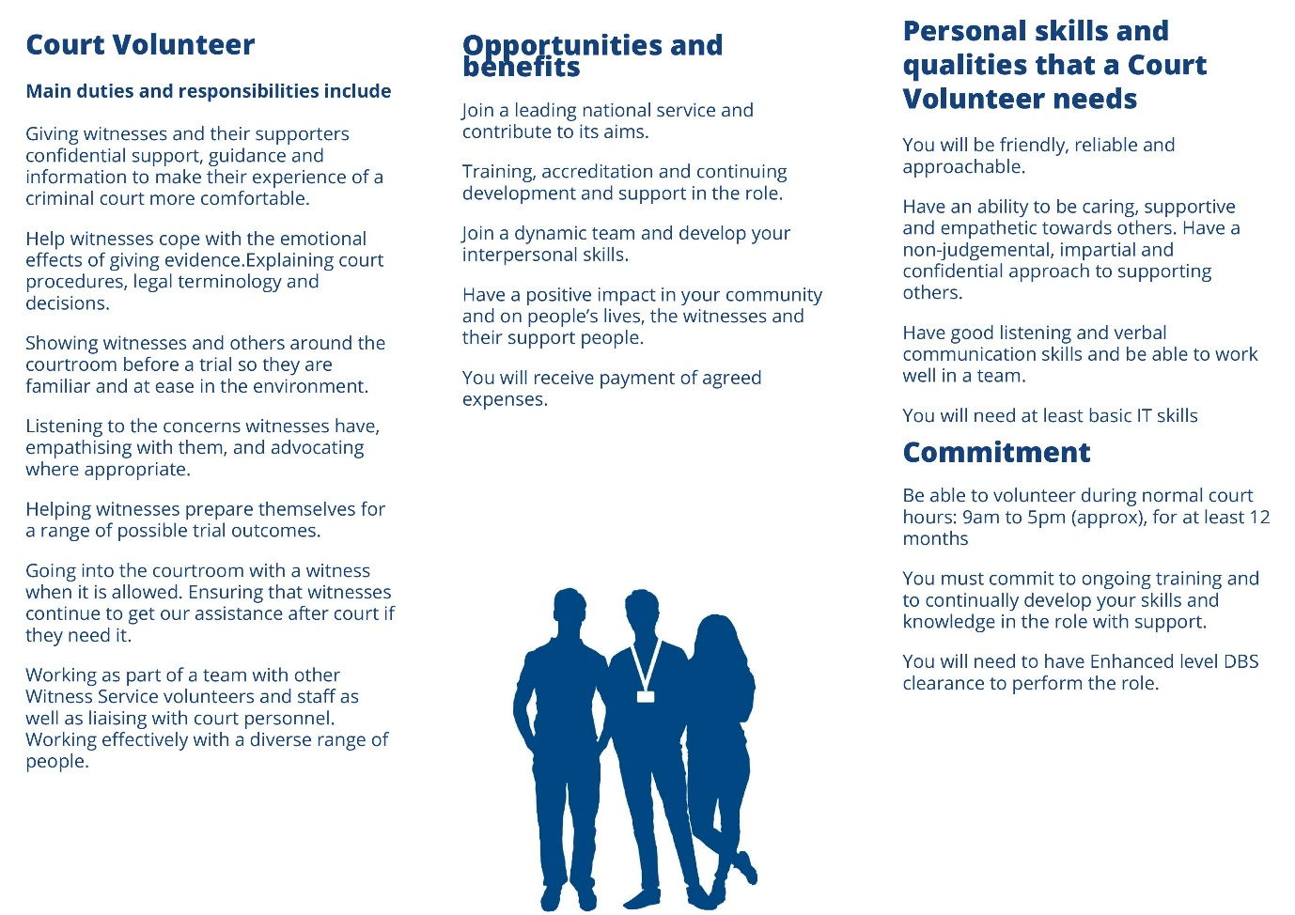
The Witness Service is recruiting volunteers in your area. If you'd like to apply for our core or outreach services please contact:
farida.sidat@citizensadvice.org.uk You can also call 03000 332 1000 to hear about volunteering with the Witness Service.
Community Links Champion
Role Purpose:
To support people in Blackburn with Darwen to access new activities, groups or support services in their area to help improve health and wellbeing.
As a community Links Champion, you will provide tailored individualized support to people to motivate them, build confidence, esteem and encourage people to identify their skills and set goals.
Requirements:
As a Community Links Champion, you will need to have the ability to communicate with a range of people, be reliable, consistent and dependable.
You will be able to work independently in a non-judgmental and respectful way.
Role Outline:
Support people referred from GPs and other agencies to find activities, groups or support services
Be up to date on what activities are available in the area,
Run drop in services in GP surgeries, community centres, other venues
To keep accurate records and client info, collate case studies and feedback and submit this to project officer.
To take part in regular supervision with the project officer
To attend necessary and relevant training in accordance with the role
Undertake any other reasonable duties with regards to the project after consultation with the project co-ordinator
COMMUNITY EMERGENCY RESPONSE VOLUNTEER
ROLE OVERVIEW:
Communities come in all shapes and sizes and we are looking for people with a passion for making their communities safer and to be prepared in the event of an emergency situation, being able to provide support to the emergency services if required.
Community Resilience is about empowering individuals, businesses and community groups to:
• Take collective action to both increase their own resilience and that of others
• Come together to identify and support vulnerable individuals
• Take responsibility for the promotion of individual and business resilience
Sign up to help your community in case there is ever a big local emergency – such as widespread flooding or a large fire.
Community Emergency Response Volunteers (CERV) can help by:
• Being aware of the risks that your community might face
• Having an emergency contacts list for your group so you can keep in touch during an emergency event
• Identifying which members of your community might be vulnerable in an emergency, and be prepared to offer assistance if required
• Developing, or helping to develop, a basic emergency plan for your community which would include key emergency contacts, local contacts who may have skills and equipment that could support an emergency response
You don’t need any experience to be an CERV, we will give you any necessary support and equipment to do your role. You will also be provided with details on how you can support Civil Contingencies Service (CSS) and the Emergency Services and we can support you.
TASKS:
• Act as a key point of contact to receive and cascade information from BwD Civil Contingencies Services (CCS) and emergency services and other CERV members
• Signpost any potential emergency/risk issues to CCS
• Promote personal community resilience within communities
• Develop ‘Community Emergency Response Plans with the assistance from CCS
• Encouragement to sign up to various organisations information especially the Met Office and Environment Agency
REQUIRED QUALITIES:
• Passion for your community
• Caring approach in order to support any vulnerable members of the community
• Good communication and interpersonal skills – links to individual professionals, equipment and resources within the community
• An emergency may happen during anti-social hours and we may need your support, however you must be confident in being able to say no if you cannot support
• If you would naturally feel the urge to help during a major emergency
If you are interested in this opportunity please visit www.lancsvp.org.uk or email: LVP@blackburn.gov.uk – this would be ideal for you
TRAINING:
You do not need any specialist skills, we will provide training where necessary and regular contact will be made between CCS, Emergency Services and volunteers. Links to all relevant websites, social media outlets will be provided.
British Red Cross
Mobility Aids Volunteering – Preston
Our mobility aids teams help hire out wheelchairs and other mobility equipment to people who may have an illness or have suffered an accident, and we are looking to recruit more volunteers in Preston to help run the centre, as well as promote the service to potential beneficiaries.
Typical tasks include
Taking calls and enquiries from people wanting to borrow a wheelchair
Giving information about other Red Cross services, where appropriate
Updating service user records and other administrative tasks using computer based systems
Demonstrating how to use and look after our wheelchairs
Receiving and recording donations
What we are looking for
Someone who:
Is willing to uphold the Fundamental Principles of the International Red Cross and Red Crescent Movement and adhere to the Society's Equal Opportunities Policy
Is willing to act in accordance with our values and behaviours framework
Is willing to uphold people's dignity at all times
Is willing to attend induction and appropriate training
Is willing to use our IT systems and has basic IT skills
Enjoys meeting people and helping them to remain independent
Has good communication skills.
Has been familiarised with any equipment required to carry out the role
The Stroke Association (Darwen)
Stroke Café Supporter
Volunteers will do a two hour shift between 10am and 3pm.
After a stroke many stroke survivors and carers may become socially isolated as they are no longer able to access the activities and groups they did prior to the stroke. As a volunteer you will assist in the running of a coffee group. The group will provide peer and social support for stroke survivors and carers and enable them to share experiences with others in the same situation.
Tasks for this role can include:
Ensuring attendees are able to participate in any activities and conversations.
Assisting attendees to order their own refreshments.
Helping with tasks such as risk assessments and health and safety venue checks.
Collating feedback from attendees and communicating its achievements.
Ensuring emergency contact details of anyone attending are taken.
Working with your designated staff member / supervisor to ensure everything is running smoothly and according to policy and procedures.
Stroke Choir Support
Volunteers will be required Monday 10 to 12 noon.
Stroke survivors, along with their friends and families, can experience social isolation and poor mental health, particularly if their ability to communicate has been affected by stroke. The Pennine Lancs Stroke Choir introduces singing and music to promote positive mental health and beneficial effects of music therapy for people with communication difficulties.
Tasks this role can include:
Supporting the delivery of the sessions by enabling safe access, setting up the room layout, and transfer of instruments and equipment.
Meeting and greeting group members, including supporting new members to be welcomed and supported to participate.
Supporting sessions with preparation of song sheets and co-ordinating transport arrangements.
Preparing and providing refreshments.
Travel Assist Service Ltd
Drivers
Volunteer Drivers are needed to help deliver our Door to Door service for vulnerable people.
Travel Assist's main social objectives to make transport accessible to the people who experience difficulties accessing main stream transport.
Travel Assist provides transport services in the following areas:
Door to Door service for vulnerable people
Patient Transport on behalf of Northwest Ambulance Service Trust in Lancashire and South Lakes.
Urban Registered Bus Routes, Rural Registered Bus Routes.
Accessible Minibuses that can be booked by community based groups for their transport needs - EG days out, trips to the theatre and meetings.
For people who live independently Travel Assist created an Out and About Club which runs trips which individuals can book themselves onto.
By becoming a volunteer with Travel Assist you can be assured that your time will be valued, and all your efforts will make a real difference to the lives of vulnerable people within our community. Generous out of pocket expenses are paid. Those volunteers looking for a useful addition to their CV, Travel Assist offers a real working environment that will provide a meaningful work experience.
The main skill required is a desire to be part of a team that is committed improve public transport for the local community.
Contact James Coulthard at Travel Assist Service Ltd travelassist@btconnect.com
Strengthening Communities – Volunteering in Lancashire
A helping hand to improving Health and Wellbeing and a Passport to Employment
Too many things happening in your life which stop you from getting a job?
We can support you to get the right sort of experience and improve your confidence. So next time you go for a job, you stand a real chance.
We’ll help you to get training, get work experience through volunteering and to feel better about yourself.
To be eligible for support you must:
• Be legally able to reside and work in the UK.
• Are resident in Lancashire
Need a hand? Then call us on 01254 583957 or email yasmin.patel@communitycvs.org.uk
Advisors are available to discuss volunteering opportunities at the drop-in Tuesday 10.30 to 12 noon at the Boulevard Centre 45 Railway Road, Blackburn. BB1 1EZ.
Darwen Drop-in - We are pleased to announce that we are offering potential volunteers and those wishing to gain valuable IT skills to come, join us & get involved.
We'll be holding a weekly drop-in at Darwen Valley Community Centre between 10am & 4pm every Friday, where people can come along and get some advice on volunteering.
This drop in is part of our BBO ReachIT digital inclusion project & Strengthening Communities - Volunteering in Lancashire.

For more details of these opportunities contact:
Community CVS
The Boulevard Centre
45 Railway Road
Blackburn
BB1 1EZ
Tel 01254 583957
office@communitycvs.org.uk

