Course Title | Preferred date
RETURN TO: Inspire Communication, Prevention and Education Team. RegentHasan.Sidat@cri.org.uk

NAME…………………………………………………….

ROLE/FUNCTION………………………………………………………

ORGANISATION / ADDRESS……….……………………………………………………………………………………………………………………….

…………………………………………………………………………………………………………………………………………….

……………………………………………………………………………………………………………………………………………..

TEL……………………………………………………….

EMAIL……………………………………………………………………..

AUTHORISING SIGNATURE

JOB/ROLE

Please note that by signing this form you are agreeing to our booking terms and conditions on the previous page.
Please return the completed form to;
Hasan.
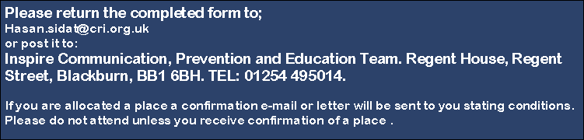
BwDTraining@cgl.org.uk

