Community Volunteer Awards Event 2019
Nomination Form

CONTACT DETAILS OF THE PERSON NOMINATING
Please provide your information:

Name

Contact Number

Email Address

Organisation
(If applicable)

You may be contacted for further information to support the nomination.

THE PERSON OR ORGANISATION BEING NOMINATED
The Person or Organisation which you are nominating:

Name of Individual or
Organisation:

Which Award Category:

Please tell us a little about the background and personal circumstances relating to the individual or organisation being nominated for the award.
(Maximum word count 250 words)

Please tell us about the volunteering or voluntary effort relating to the individual or organisation being nominated for the award. Please include what have they done and how long have they volunteered, how frequently, how many hours, etc.
(Maximum word count 250 words)

What impact has the volunteering or voluntary effort made to the community? What difference has it made particularly relating to the award category heading?
(Maximum word count 500 words)

Please note the deadline for entries is Friday 5th April 2019 5pm

You can return via email to Donna Talbot donna.talbot@communitycvs.org.uk
Post your form to Donna Talbot, Community CVS, the Boulevard Centre 45, Railway Rd, Blackburn BB1 1EZ
Or alternatively you can hand in your nomination form in person at The Boulevard Centre, 45 Railway Road please address envelope to Donna Talbot

CONTACT INFORMATION FOR THE INDIVIDUAL OR ORGANISATION AND THEIR PERMISSION TO BE NOMINATED.
NAME
ORGANISATION
(IF APPLICABLE)
ADDRESS

TELEPHONE
E-MAIL

Data Protection Consent Statement
Data Protection Act 2018. All information you have provided will be held in manual and electronic formats and only be used in line with the Data Protection Act 2018. Your contact details will be used to communicate with you relating to the nominations to the Community Volunteering Awards and any images taken during the Awards Ceremony will be used to promote volunteering within Blackburn with Darwen. We will keep the contact information ‘live’ on our information systems until after the event and the images for a period of five years. You have the right to withdraw consent at any time by contacting Clair Bloomfield details below.
Blackburn with Darwen Council for Voluntary Service is the data controller and is registered on the Data Protection Register (Z1938345). The information on the nomination form will be shared with the nomination panel – which consists of a range of local stakeholders. We will not share or divulge your details to any other third parties without your expressed consent. You have a right to access your information by writing to Clair Bloomfield, Community CVS, Boulevard Centre, 45 Railway Road, Blackburn. BB1 1EZ email clair.bloomfield@communitycvs.org.uk. Tel: 01254 583957.
By signing below, I give explicit consent, to being nominated for the award and for Community CVS to hold my contact details for the purposes of the Community Volunteering Awards and for Community CVS to use the information on the nomination form and any images captured during the awards and on the awards night to promote volunteering within Blackburn with Darwen.
Name | Signature(s)

Community Volunteer Awards
Introduction
There are a total of 21 awards available under 12 categories.

General Criteria
Each nomination will be assessed against three general criteria:
- The background and particular circumstance relating to the individual or organisation and their journey
- The voluntary effort that the individual or organisation has made and is making
- The impact or difference that voluntary effort has made and is making to our communities within Blackburn with Darwen.

Volunteer of the Year Award
Awarded to the volunteer whose enthusiasm and dedication to volunteering has made a real difference to the community within the past year. Anyone can be directly nominated for the Volunteer of the Year Award. However, the awards panel reserve the right to elevate any nomination to the volunteer of the year category if they think the nomination merits receiving the overall award.

Lifetime Achievement Award
Awarded to the volunteer who has demonstrated an exemplary long-term commitment to the voluntary, community and faith sector through sharing their expertise, skill set and knowledge. To qualify for the award the individual must have volunteered or worked within the voluntary, community and faith sector for a minimum of 20 years.

Good Neighbour Award
Awarded to people who go above and beyond for their neighbours and make their communities tick, but don’t expect any reward.

Culture, Leisure & Sporting Life Category
Individual Award
Awarded to any individual volunteer or team of volunteers whose enthusiasm and dedication has made an outstanding voluntary contribution to the culture, leisure and sporting life of Blackburn with Darwen.

Organisational Award
Awarded to an organisation from the voluntary, community and faith sector whose voluntary efforts have made a real difference to the culture, leisure and sporting life of Blackburn with Darwen.

Health & Well Being Category
Individual Award
Awarded to any individual volunteer or team of volunteers whose enthusiasm and dedication has made an outstanding voluntary contribution to improving the health and well-being of residents of Blackburn with Darwen.

Organisational Award
Awarded to an organisation from the voluntary, community and faith sector whose voluntary efforts have made a real difference to improving the health and well-being of residents of Blackburn with Darwen.

Prosperity, Learning & Employment Category
Individual Award
Awarded to any individual volunteer or team of volunteers whose enthusiasm and dedication has made an outstanding voluntary contribution to improving the prosperity, skills or employment prospects of residents of Blackburn with Darwen.

Organisational Award
Awarded to an organisation from the voluntary, community and faith sector whose voluntary efforts have made a real difference to improving the prosperity, skills or employment prospects of residents of Blackburn with Darwen.

Environment Award
Individual Award
Awarded to any individual volunteer or team of volunteers whose enthusiasm and dedication has made an outstanding voluntary contribution to improving the local environment and having a positive impact on people’s lives within Blackburn with Darwen.

Organisational Award
Awarded to an organisation from the voluntary, community and faith sector whose voluntary efforts have made a real difference to improving the local environment and having a positive impact on people’s lives within Blackburn with Darwen.

Integration Award
Individual Award
Awarded to any individual volunteer or team of volunteers whose enthusiasm and dedication has made an outstanding voluntary contribution to bringing together the different communities of Blackburn with Darwen and building a shared understanding between different sections of our community.

Organisational Award
Awarded to an organisation from the voluntary, community and faith sector whose voluntary efforts have made a real difference to bringing together the different communities of Blackburn with Darwen and building a shared understanding between different sections of our community.

Lindsay Dunn Award
This award is awarded in memory of Lindsay Dunn, a volunteer who was passionate about helping the most marginalised people within society.

Individual Award
Awarded to any individual volunteer or team of volunteers whose enthusiasm and dedication has made an outstanding voluntary contribution to improving the lives of people experiencing complex, severe and multiple disadvantage (e.g. suffering from poverty, homelessness, poor mental health, offending background, recovering from alcohol or substance misuse, domestic abuse, etc.)

Organisational Award
Awarded to an organisation from the voluntary, community and faith sector whose voluntary efforts have made a real difference to the lives of people experiencing complex, severe and multiple disadvantage (e.g. suffering from poverty, homelessness, poor mental health, offending background, recovering from alcohol or substance misuse, domestic abuse, etc.)

Young People’s Award
Individual Award
Awarded to any individual volunteer or team of volunteers whose enthusiasm and dedication has made an outstanding voluntary contribution to giving children and young people the best start in life within Blackburn with Darwen.

Organisational Award
Awarded to an organisation from the voluntary, community and faith sector whose voluntary efforts have made a real difference to giving children and young people the best start in life within Blackburn with Darwen.

Grassroots Category
Individual Award
Awarded to any individual who has made an outstanding voluntary contribution to a community group, small charity, social enterprise that is run entirely by volunteers and has an annual income of under £10,000.

Organisational Award
Awarded to any small organisation (income less than £10,000) from the voluntary, community and faith sector whose voluntary efforts have made a real difference to the residents and borough of Blackburn with Darwen.

Community Involvement Category
Individual Award
Awarded to any individual from across the public, commercial or voluntary, community and faith sectors who has made an outstanding voluntary contribution to getting their organisation more involved in the community encouraging fundraising, volunteering, etc.

Organisational Award
Awarded to any organisation from across the public, commercial or voluntary, community and faith sectors whose commitment to social responsibility has made a real difference to the residents and borough of Blackburn with Darwen.
Award Sponsors and Supporters
Many thanks to our award sponsors and supporters without whose support we would be unable to put on the Community Volunteer Awards ceremony.
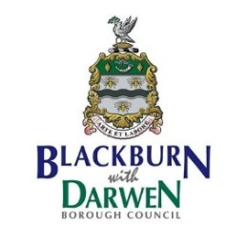

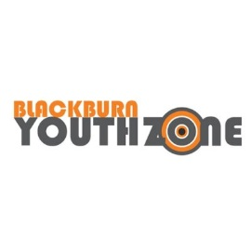
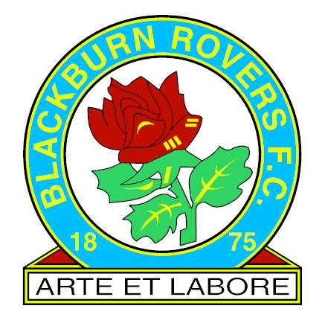 | 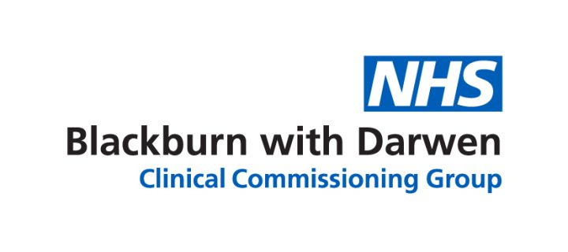 | 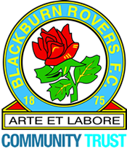
 |  | 