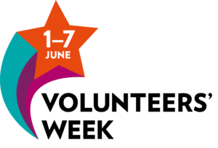
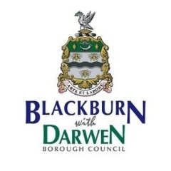
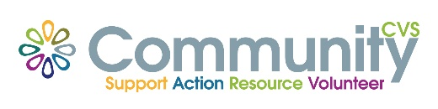

Volunteer Awards - Categories
Categories for awards:
Overall Awards
Volunteer awards to recognise the contribution of a particular volunteer or volunteer team from any organisation across the public, commercial or voluntary, community and faith sectors.
- Volunteer of the Year
- Lifetime Achievement Award

Voluntary, Community and Faith Sector Awards (six)
Volunteer awards to recognise the contribution of a particular volunteer or volunteer team from organisations within the voluntary, community and faith sector.

- Volunteer Award to recognise voluntary contribution to the culture, leisure or sporting life of our local community

- Volunteer Award to recognise voluntary contribution to helping people with learning disabilities, physical disabilities, physical or mental health conditions to lead happier, healthier, independent and better quality lives.

- Volunteer Award to recognise voluntary contribution towards helping residents of any age to develop their skills with education, employment or enterprise.

- Volunteer Award to recognise voluntary contribution towards improving our neighbourhoods, housing and/or environment

- Volunteer Award to recognise voluntary contribution at a grassroots community action

- Volunteer Award to recognise voluntary contribution of bringing communities together to promote cohesion and Integration

Public Sector
Public Service Volunteer of the Year
An award for an individual volunteer or volunteer team – who volunteers to help deliver a public service and has made a significant contribution towards delivering public services for the benefit of Blackburn with Darwen residents.

Commercial Sector
Corporate Social Responsibility Volunteer of the Year Award
An award for an individual volunteer or volunteer team from the commercial or private sector who has made a significant contribution towards the local community.

Special Category: Lindsay Dunn Community Spirit Award (sponsored by VOICE and CGL)
A special award being held in the memory of Lindsay Dunn, who recently passed away, to celebrate the contribution of an individual volunteer, who is supporting people who are in recovery from alcohol or substance misuse and has made a significant contribution to the recovery community or progress within their own volunteer journey.

