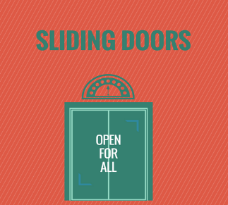
JOHN LEWIS
(second’s)
CURTAIN SALE
Sliding Doors Hub
Mill Hill Community Centre
Sunday 22nd April
10am – 1.00pm
For more information call into hub or phone 07495303224

