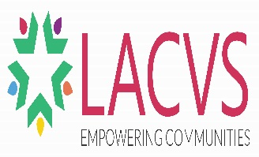

JOB ADVERT: STRENGTHENING COMMUNITIES – VOLUNTEERING IN LANCASHIRE PROJECT KEY WORKER: PRESTON & SOUTH RIBBLE
The Lancashire Association of Councils for Voluntary Service are inviting applications for the post of Strengthening Communities Project Officer with geographical responsibility for the Preston and South Ribble area.
You will engage and carry a case load of people at risk of social exclusion who you will support to utilise volunteering as a stepping stone towards employment, education and enhanced well-being.
This is an exciting Lancashire-wide project, funded by Lancashire County Council and European Social Funds, led by LACVS and delivered through statutory and community infrastructure partners across Lancashire.
We are seeking someone with passion and drive to improve peoples’ well-being, employment and educational prospects by supporting them into volunteering, learning opportunities and employment.

You will be a highly motivated ‘people person’, experienced in supporting vulnerable adults with complex needs, meeting targets and with extensive knowledge of opportunities and initiatives within the surrounding area of Preston and South Ribble.

SALARY: £20,661 (full time equivalent)

WORKING HOURS: 30 hours per week (Mon to Fri) based in Preston

STATUS: Fixed Term Appointment until 30th June 2019

APPLICATION DEADLINE: 17th July 2017

DATE OF INTERVIEW: Monday 24th July 2017

JOB PACK AVAILABLE AT http://www.communitycvs.org.uk/about/vacancies/

Candidates sending in CV’s will not be considered only fully completed application forms will be accepted for this post. .

Please send your completed application form either by post to;
Job Application, Community CVS, Boulevard Centre, Cathedral Quarter, 45 Railway Road, BLACKBURN, BB1 1EZ
Or email to; clair.bloomfield@communitycvs.org.uk with the subject heading : Job Application
If you have further enquiries about the post and/ or the project please contact steve.foden@communitycvs.org.uk Tel: 01254 583957

